aseXML SCHEMA CHANGE REQUEST – CR72

Q1 2023

B2M and B2B schema changes
Change request document for B2M and B2B system enhancements

Version Control
Version | Release date | Changes
0.1 | 17/11/2022 | Schema Changes r43 - Harpreet Kaur
0.2 | 5/12/2022 | Removed PersonName changes for B2B 3.7

Contents
1. Change Proposal 5
1.1 Description of the proposed change 6
1.2 Reason for Change 9
1.3 Supplied Documents 9
1.4 Baseline Schema 10
2. Approval Proposal 11
2.1 Proposed Changes 11
3. Proposal Assessment 34
3.1 Test 34
3.2 Conformance Report 34
4. Issue Register 35
4.1 Status of Issues 35
5. Resolution 35
5.1 ASWG Endorsement 35
Glossary 36

Tables
Table 1 Proposed Changes 7
Table 2 Change Log 13
Table 3 Impact Summary 33
Table 4 Change Proposal Conformance Details 34
Table 5 Issues list 35
Table 6 ASWG Vote Results 35

Figures
No table of contents entries found.

Change Proposal
This Change Proposal is to accommodate changes to the B2M and B2B system related to following requirements:
Function | Initiative | Procedure | Schema Requirement
B2M | MSDR | n/a | New aseXML schema elements to support the reporting via the C1 report to Industry of MSDR introduced enumerations configured in the following MSATS Codes tables:  - MSATS_CODE_GROUPS  - MSATS_CODES  - MSATS_CODES_DATED  - MSATS_CODE_COMBOS
 | CDR Phase 2 | Standing Data for MSATS v5.4  MSATS Procedures - CATS v5.4  MSATS Procedures - WIGS v5.4 | New aseXML schema element to support the CATS NMI Standing Data column ‘Last Consumer Change Date’:  - Addition of a new Change request that would include the column ‘Last Consumer Change Date’ to be maintained against the CATS NMI Data table within MSATS.  - This field would be maintained by retailers when the consumer for an NMI changes, e.g. move-ins and used by AEMO to verify meter data requests for CDR.  - The field can also be updated ad hoc where the retailer has verified the consumer's start date.
 | SAPS | n/a | C1 reporting of MDM table Node Hierarchy to display the new Settlement Indicator column.
 |  |  | New RM51 – Regulated SAPS Generator Reconciliation report
 |  |  | New aseXML schema element to support reporting via C1 of the SAPS added ‘Role Category’ column added to the CATS_PARTICPANT_ROLES table.
B2B | B2Bv3.8 | B2B Procedure One Way Notification Process v3.8 | Creation of a new OWN Shared Fuse One Way Notification transaction type, supporting enumerated values.

AEMO requests that the ASWG commence the formal change process cycle as soon as possible with a view of approving and publishing an updated schema version on 15th March 2023 at the latest. The system changes are scheduled to be deployed into the production environment ahead of the Procedure effective dates of dependent initiatives.

Description of the proposed change
The proposed changes are listed in the following table.
Item# | Change Description | Change Type
1 | MSDR changes to support C1 Report:  - Define following new complex elements in schema for representation of code(s) tables:  - MSATSCodeGroupsRow  - MSATSCodesDatedRow  - MSATSCodeComboRow  - MSATSCodesRow  - Increase length of MSATSCodeValue from 15 to 100  - Update existing version attribute for MSATSCodeValuesRow from r19 to r43. | New
2 | CDR Phase 2:  - Define a new element ‘LastConsumerChangeDate’ of type date.  - Add this element reference to existing ElectricityNMIMasterGroup and ElectricityMasterStandingData elements | New
3 | SAPS:  - Define new complex element ‘NodeHierarchyRow’ in schema for representation of node hierarchy table  - Define new complex element ‘MDMTSettlementCaseDetailsReportParameters’ for the new Regulated SAPS Generator Reconciliation report. The purpose of the RM51 – Regulated SAPS Generator Reconcilation report is to provide MSRP (FRMP) participants with the energy values used to calculate the Generator allocation within a settlement run.  - Define new element as RoleCategory for ParticipantRolesRow | New
4 | B2B Changes  - Add SharedFuseNotification transaction. | New
- Proposed Changes

Change Description
MSDR :
There is currently no C1 replication report for the codes tables (Codes/Codes Dated/Code Combos etc), which is now extensively used for the new enumerations in MSDR project. These tables will be added to schema for being replicated though C1 report.
Schema changes required for MSDR are as follows:
- Define following new complex elements in schema for representation of code(s) tables:
  - MSATSCodeGroupsRow
  - MSATSCodesDatedRow
  - MSATSCodeComboRow
  - MSATSCodesRow
- Increase length of MSATSCodeValue from 15 to 100
- Update version attribute for MSATSCodeValuesRow from r19 to r43.

CDR:
Addition of new field to provide more complete and accurate Standing Data to support CDR.
Schema changes required for CDR are as follows:
- Addition of new field ‘LastConsumerChangeDate’ to existing ElectricityNMIMasterGroup and ElectricityMasterStandingData.
- Update version attribute of following existing elements from r42 to r43:
  - ElectricityNMIMasterRow
  - ElectricityNMIMasterRowBDT
  - ElectricityCATSChangeRequestNMIMasterRow and
  - ElectricityStandingData

SAPS:

Schema changes required for SAPS are as follows:
- Define new complex element ‘NodeHierarchyRow‘ in schema for representation of node hierarchy table
- Define new complex element ‘MDMTSettlementCaseDetailsReportParameters’ for the new Regulated SAPS Generator Reconciliation report

- Define new element as RoleCategory for ParticipantRolesRow

B2B :
As part of B2B Cosulatation v3.8, One Way Notification Process will include a new transaction ‘SharedFuseNotification’ to indicate the current status of a shared fuse arrangement. The Change is focused on delivering uniformity and process efficiencies in B2B communications for shared fuse arrangements to support the Metering Coordinator Planned Interruption (MCPI) rule change, which introduced new obligations for Retailers and MCs to provide information to the DNSP regarding the shared fuse status at a site.
It should be noted that while the B2B Procedures v3.8 describes a set of enumerated values for the shared fuse arrangement describing the state of a NMI, as follows:
• ‘N’ – Not Shared Fuse
• ‘I’ – Shared Fuse but can be isolated independently
• ‘Y’ – Shared Fuse
The Final Determination specifies that “AEMO will create a new aseXML OWN transaction in the schema, to carry this information with any enumerations managed outside the schema”. This Change Request to the ASWG notes that while there are precedents where B2B enumerations are defined in the non-versioned Enumerations.xsd, as the allowed enumerations of the B2M SharedIsolationPointFlag are not managed here, and the Shared Market Protocol eHub does not validate the content of B2B transactions; it is proposed that the outcome of the Final Determination be upheld.

As part of B2B Cosulatation v3.7, Changes to Person Name Given and Person Name Title fields were implemented without modifying the schema. PersonNameTitle and PersonGivenName fields are now optional rather than mandatory. The schema is modified to reflect these changes.

Schema changes required for B2B are as follows:
- Define new transaction SharedFuseNotification with following elements:
  - NMI, NMIChecksum
  - IdentifiedDate
  - SharedIsolationPointFlag

Reason for Change
These changes are made in the interests of improving efficiency, reducing costs and ensuring compliance with the National Electricity Objective. These changes were consulted and agreed upon in various forums.
The new fields added in schema provided an opportunity to ensure MSATS Standing Data reflects the needs of the market by standardising the data and ensuring that data are complete, accurate and useful.
The MC, MP or Retailer will generate the new B2B transaction ‘SharedFuseNotification’ (either via participant market systems or the MSATS browser) with an appropriate code to indicate the status of the Shared Fuse indicator for each NMI.
The purpose of the RM51 – Regulated SAPS Generator Reconcilation report is to provide MSRP (FRMP) participants with the energy values used to calculate the Generator allocation within a settlement run.

Supplied Documents
Not applicable.

Business process document
Currently a number of standing data fields are poorly utilised—the data is incomplete, ‘nonsense’ and as a result, is not useful.
AEMO is proposing that all standing data must be complete, accurate, and useful.
• Complete: No more “optional” fields—only “mandatory” or “required”.
• Accurate: Minimal free text, structured fields.
• Useful: All underutilised fields to be reviewed and/or removed.

Other
Not applicable.

Baseline Schema
The schema used as a basis for this proposal is r42.

Approval Proposal

Proposed Changes

Draft schemas

Change log
The following changes have been implemented in this draft:
Chg # | Item # | Description of change | Filename
1 |  | - Replace version of schema from r42 to r43  - Rename file to r43 version. | aseXML_r43.xsd
2 |  | - Registration of r43 release  - Rename file to r43 version. | Events_r43.xsd
3 | 1,2,3 | - Define following new complex elements in schema for representation of code(s) tables:  - MSATSCodeGroupsRow  - MSATSCodesDatedRow  - MSATSCodeComboRow  - MSATSCodesRow  - NodeHierarchyRow  - Increase length of MSATSCodeValue from 15 to 100  - Update version attribute for MSATSCodeValuesRow from r19 to r43.  - Define new element as RoleCategory for ParticipantRolesRow  - Update version attribute of following existing elements from r42 to r43:  - ElectricityNMIMasterRow  - ElectricityNMIMasterRowBDT  - ElectricityCATSChangeRequestNMIMasterRow  - Rename file to r43 version | CATSTableReplication_r43.xsd
4 | 3 | - Add new element ‘RoleCategory’  - Rename file to r43 version | Common_r43.xsd
5 | 2 | - Update version attribute of following existing elements from r42 to r43:  - ElectricityStandingData  - Rename file to r43 version | Electricity_r43.xsd
6 | 2 | - Add new element ‘LastConsumerChangeDate’ to ElectricityNMIMasterGroup and ElectricityMasterStandingData  - Rename file to r43 version. | ElectricityMasterStandingData_r43.xsd
 | 3 | - Define new complex element ‘MDMTSettlementCaseDetailsReportParameters’ for the new Regulated SAPS Generator Reconciliation report | MDMTReports_r43
7 | 4 | - Define new complex type ‘SharedFuseNotification’ transaction.  - Rename file to r43 version. | OneWayNotification_r43.xsd
8 | 4 | - Add new B2B transaction ‘SharedFuseNotification’ to existing complex type ‘Transaction’  - Rename file to r43 version | Transactions_r43.xsd
- Change Log

Schema change description

aseXml_r43.xsd
- New file to replace aseXML_r42.xsd and include the r423 file versions listed below.

<xsd:schema xmlns="urn:aseXML:r43" xmlns:xsd="http://www.w3.org/2001/XMLSchema" xmlns:xsi="http://www.w3.org/2001/XMLSchema-instance" targetNamespace="urn:aseXML:r43" version="r43" xsi:schemaLocation="urn:aseXML:r43 aseXML_r43.xsd">

<xsd:include schemaLocation="CATSTableReplication_r43.xsd">

<xsd:include schemaLocation="Common_r43.xsd">
<xsd:include schemaLocation="Electricity_r43.xsd">
<xsd:include schemaLocation="ElectricityMasterStandingData_r43.xsd"/>
<xsd:include schemaLocation="Events_r43.xsd">
<xsd:include schemaLocation="MDMTReports_r43.xsd">

<xsd:include schemaLocation="OneWayNotification_r43.xsd">
<xsd:include schemaLocation="Transactions_r43.xsd">

CATSTableReplication_r43.xsd
- Added following new complex elements :
  - MSATSCodeGroupsRow
  - MSATSCodesDatedRow
  - MSATSCodeComboRow
  - MSATSCodesRow
  - NodeHierarchyRow

- Added following simple type elements:
  - MSATSCodeGroup
  - MSATSCodeTableType
  - MSATSCode
- Increase data length of existing element ‘MSATSCodeValue’ from 15 to 100 characters
- Added new element RoleCategory in existing ParticipantRolesRow complex type
- Updated version attribute of following existing elements from r42 to 43:
  - ElectricityNMIMasterRow
  - ElectricityNMIMasterRowBDT
  - ElectricityCATSChangeRequestNMIMasterRow
- Rename file to r43 version.

<!-- MSATS_CODE_GROUPS Row -->
<xsd:complexType name="MSATSCodeGroupsRow">
<xsd:annotation>
<xsd:documentation>
Purpose - Row of the MSATSCodeGroups table
MSATS Data Model Table - MSATS_CODE_GROUPS
Replication Table Name - MSATSCodeGroups
</xsd:documentation>
</xsd:annotation>
<xsd:complexContent>
<xsd:extension base="ReplicationBaseRow">
<xsd:sequence>
<xsd:element name="CodeGroup" type="MSATSCodeGroup"/>
<xsd:element name="Description" type="MSATSCodeValueDescription"/>
<xsd:element name="CodeTable" type="MSATSCodeTableType"/>
<xsd:element name="CodeGroupLastChanged" type="xsd:dateTime" minOccurs="0"/>
</xsd:sequence>
<xsd:attribute name="version" type="r43" use="optional" default="r43"/>
</xsd:extension>
</xsd:complexContent>
</xsd:complexType>

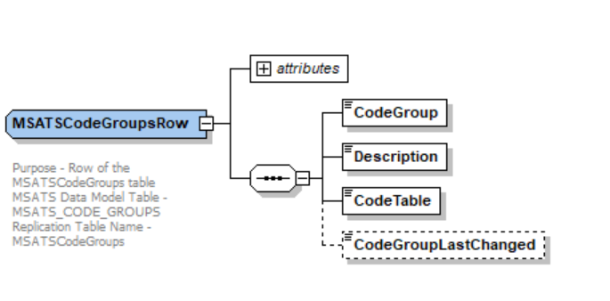

<!-- MSATS_CODES_DATED Row -->
<xsd:complexType name="MSATSCodesDatedRow">
<xsd:annotation>
<xsd:documentation>
Purpose - Row of the MSATSCodesDated table
MSATS Data Model Table - MSATS_CODES_DATED
Replication Table Name - MSATSCodesDated
</xsd:documentation>
</xsd:annotation>
<xsd:complexContent>
<xsd:extension base="ReplicationDateRangeRow">
<xsd:sequence>
<xsd:element name="CodeGroup" type="MSATSCodeGroup"/>
<xsd:element name="Code" type="MSATSCode"/>
<xsd:element name="Value" type="MSATSCodeValue" minOccurs="0"/>
<xsd:element name="Description" type="MSATSCodeValueDescription" minOccurs="0"/>
</xsd:sequence>
<xsd:attribute name="version" type="r43" use="optional" default="r43"/>
</xsd:extension>
</xsd:complexContent>
</xsd:complexType>
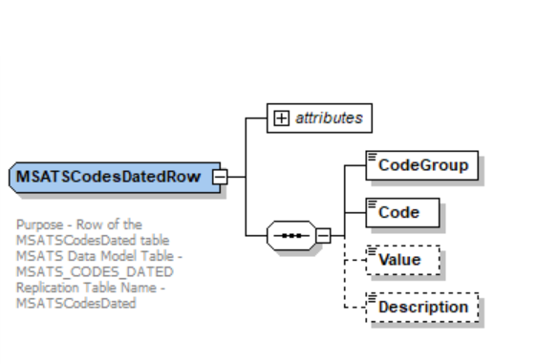

<!-- MSATS_CODE_COMBOS Row -->
<xsd:complexType name="MSATSCodeComboRow">
<xsd:annotation>
<xsd:documentation>
Purpose - Row of the MSATSCodesDated table
MSATS Data Model Table - MSATS_CODE_COMBOS
Replication Table Name - MSATSCodeCombo
</xsd:documentation>
</xsd:annotation>
<xsd:complexContent>
<xsd:extension base="ReplicationDateRangeRow">
<xsd:sequence>
<xsd:element name="CodeGroup" type="MSATSCodeGroup"/>
<xsd:element name="Code1" type="MSATSCode"/>
<xsd:element name="Code2" type="MSATSCode" nillable="true" minOccurs="0"/>
<xsd:element name="Code3" type="MSATSCode" nillable="true" minOccurs="0"/>
<xsd:element name="Code4" type="MSATSCode" nillable="true" minOccurs="0"/>
<xsd:element name="Code5" type="MSATSCode" nillable="true" minOccurs="0"/>
<xsd:element name="Value" type="MSATSCodeValue" minOccurs="0"/>
<xsd:element name="Description" type="MSATSCodeValueDescription" minOccurs="0"/>
</xsd:sequence>
<xsd:attribute name="version" type="r43" use="optional" default="r43"/>
</xsd:extension>
</xsd:complexContent>
</xsd:complexType>

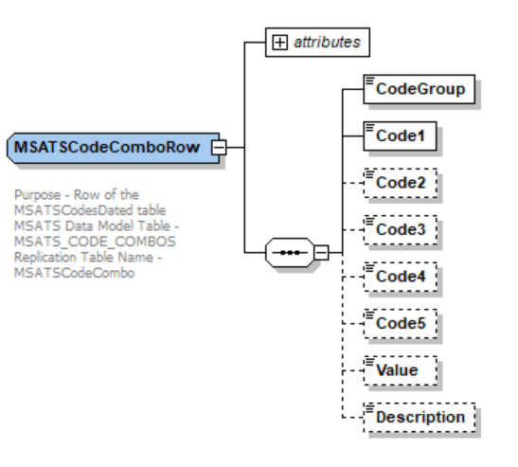

<!-- MSATS_CODES Row -->
<xsd:complexType name="MSATSCodesRow">
<xsd:annotation>
<xsd:documentation>
Purpose - Row of the MSATSCodes table
MSATS Data Model Table - MSATS_CODES
Replication Table Name - MSATSCodes
</xsd:documentation>
</xsd:annotation>
<xsd:complexContent>
<xsd:extension base="ReplicationBaseRow">
<xsd:sequence>
<xsd:element name="CodeGroup" type="MSATSCodeGroup"/>
<xsd:element name="Code" type="MSATSCode"/>
<xsd:element name="Value" type="MSATSCodeValue" minOccurs="0"/>
<xsd:element name="Description" type="MSATSCodeValueDescription" minOccurs="0"/>
</xsd:sequence>
<xsd:attribute name="version" type="r43" use="optional" default="r43"/>
</xsd:extension>
</xsd:complexContent>
</xsd:complexType>

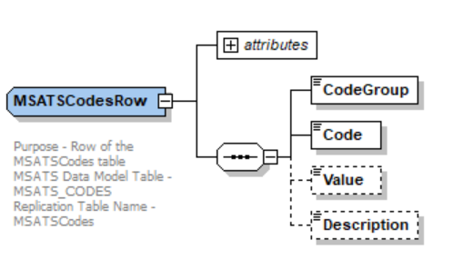

<!-- NODE_HIERARCHY Row -->
<xsd:complexType name="NodeHierarchyRow">
<xsd:annotation>
<xsd:documentation>
Purpose - Row of the NodeHierarchy table
MSATS Data Model Table - NODE_HIERARCHY
Replication Table Name - NodeHierarchy
</xsd:documentation>
</xsd:annotation>
<xsd:complexContent>
<xsd:extension base="ReplicationDateRangeRow">
<xsd:sequence>
<xsd:element name="NodeName" type="xsd:string" nillable="true" minOccurs="0"/>
<xsd:element name="NodeType" type="xsd:string"/>
<xsd:element name="ParentNodeName" type="xsd:string" minOccurs="0"/>
<xsd:element name="ParentNodeType" type="xsd:string" minOccurs="0"/>
<xsd:element name="SettlementIndicator" type="xsd:string" minOccurs="0"/>
</xsd:sequence>
<xsd:attribute name="version" type="r43" use="optional" default="r43"/>
</xsd:extension>
</xsd:complexContent>
</xsd:complexType>

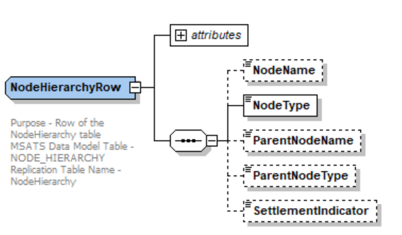

<xsd:simpleType name="MSATSCodeGroup">
<xsd:annotation>
<xsd:documentation>
MSATS Data Model Column - CodeGroup
</xsd:documentation>
</xsd:annotation>
<xsd:restriction base="xsd:string">
<xsd:maxLength value="50"/>
<xsd:minLength value="1"/>
<xsd:whiteSpace value="collapse"/>
</xsd:restriction>

<xsd:simpleType name="MSATSCode">
<xsd:annotation>
<xsd:documentation>
MSATS Data Model Column - MSATSCode
</xsd:documentation>
</xsd:annotation>
<xsd:restriction base="xsd:string">
<xsd:maxLength value="50"/>
<xsd:minLength value="1"/>
<xsd:whiteSpace value="collapse"/>
</xsd:restriction>
</xsd:simpleType>

</xsd:simpleType>

<xsd:simpleType name="MSATSCodeTableType">
<xsd:annotation>
<xsd:documentation>
MSATS Data Model Column - CodeTable
</xsd:documentation>
</xsd:annotation>
<xsd:restriction base="xsd:string">
<xsd:maxLength value="15"/>
<xsd:minLength value="1"/>
<xsd:whiteSpace value="collapse"/>
</xsd:restriction>
</xsd:simpleType>

<xsd:simpleType name="MSATSCodeValue">
<xsd:annotation>
<xsd:documentation>
MSATS Data Model Column - CodeValue
</xsd:documentation>
</xsd:annotation>
<xsd:restriction base="xsd:string">
<xsd:maxLength value="100"/>
<xsd:minLength value="1"/>
<xsd:whiteSpace value="collapse"/>
</xsd:restriction>
</xsd:simpleType>

<xsd:complexType name="ParticipantRolesRow">
<xsd:annotation>
<xsd:documentation>
Purpose - Row of the Participant Roles table
MSATS Data Model Table - CATS_Participant_Roles
Replication Table Name - ParticipantRoles
</xsd:documentation>
</xsd:annotation>
<xsd:complexContent>
<xsd:extension base="ReplicationDateRangeRow">
<xsd:sequence>
<xsd:element name="ParticipantID" type="PartyIdentifier"/>
<xsd:element name="Role" type="RoleIdentifier"/>
<xsd:element name="RoleCategory" type="RoleCategory" minOccurs="0"/>
</xsd:sequence>
</xsd:extension>
</xsd:complexContent>
</xsd:complexType>

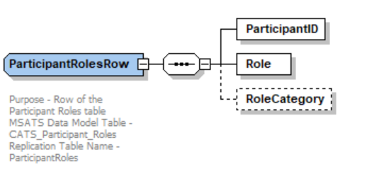

<!-- Electricity NMI Standing Data Replication Row Types -->
<xsd:complexType name="ElectricityNMIMasterRow">
<xsd:annotation>
<xsd:documentation>
Purpose - Row of the Electricity NMI Master Standing Data table
MSATS Data Model Table - CATS_NMI_Data
Replication Table Name - ElectricityNMIMaster
</xsd:documentation>
</xsd:annotation>
<xsd:complexContent>
<xsd:extension base="ReplicationDateRangeRow">
<xsd:sequence>
<xsd:element name="NMI" type="NMIBase"/>
<xsd:group ref="ElectricityNMIMasterGroup"/>
</xsd:sequence>
<xsd:attribute name="version" type="r43" use="optional" default="r43"/>
</xsd:extension>
</xsd:complexContent>
</xsd:complexType>

<!-- BDT Row Types -->
<xsd:complexType name="ElectricityNMIMasterRowBDT">
<xsd:annotation>
<xsd:documentation>
Purpose - Row of the Electricity NMI Master Standing Data table extended by BDTStatus and Event for Bulk Data Tool
MSATS Data Model Table - CATS_NMI_Data
Replication Table Name - ElectricityNMIMaster
</xsd:documentation>
</xsd:annotation>
<xsd:complexContent>
<xsd:extension base="ReplicationDateRangeRow">
<xsd:sequence>
<xsd:group ref="ElectricityNMIMasterGroup"/>
<xsd:element name="BDTStatus" type="BDTStatus" minOccurs="0"/>
<xsd:element name="Event" type="Event" minOccurs="0" maxOccurs="unbounded"/>
</xsd:sequence>
<xsd:attribute name="version" type="r43" use="optional" default="r43"/>
</xsd:extension>
</xsd:complexContent>
</xsd:complexType>

<xsd:complexType name="ElectricityCATSChangeRequestNMIMasterRow">
<xsd:annotation>
<xsd:documentation>
Purpose - Row of the Electricity CATS Change Request NMI Master Standing Data table
MSATS Data Model Table - CATS_Inbound_NMI_Data
Replication Table Name - ElectricityCATSChangeRequestNMIMaster
</xsd:documentation>
</xsd:annotation>
<xsd:complexContent>
<xsd:extension base="ReplicationBaseRow">
<xsd:sequence>
<xsd:element name="RequestID" type="CATSRequestIdentifier"/>
<xsd:group ref="ElectricityNMIMasterGroup"/>
</xsd:sequence>
<xsd:attribute name="version" type="r43" use="optional" default="r43"/>
</xsd:extension>
</xsd:complexContent>
</xsd:complexType>

Common_r43.xsd
- Added new ‘RoleCategory’ element.
- Rename file to r43 version.

<xsd:simpleType name="RoleCategory">
<xsd:annotation>
<xsd:documentation>
Purpose - Identify the role category.
MSATS Data Model Column - Role_Category
</xsd:documentation>
</xsd:annotation>
<xsd:restriction base="xsd:string">
<xsd:maxLength value="15"/>
</xsd:restriction>
</xsd:simpleType>

Electricity_r43.xsd
- Update version attribute of ‘ElectricityStandingData’ from r42 to r43
- Rename file to r43 version

<xsd:complexType name="ElectricityStandingData">
<xsd:annotation>
<xsd:documentation>
Purpose - Standing data associated with an electricity NMI.
Detail - The structure supports multiple data streams, meters and role assignments. Note that because this type is derived from the NMIStandingData type, it begins with the elements defined for that type, notably the NMI.
</xsd:documentation>
</xsd:annotation>
<xsd:complexContent>
<xsd:extension base="NMIStandingData">
<xsd:sequence>
<xsd:element name="MasterData" type="ElectricityMasterStandingData" minOccurs="0"/>
<xsd:element name="RoleAssignments" type="RoleAssignments" minOccurs="0"/>
<xsd:element name="DataStreams" type="ElectricityDataStreams" minOccurs="0"/>
<xsd:element name="MeterRegister" type="ElectricityMeters" minOccurs="0"/>
</xsd:sequence>
<xsd:attribute name="version" type="r43" use="optional" default="r43"/>
</xsd:extension>
</xsd:complexContent>
</xsd:complexType>

ElectricityMasterStandingData_r43.xsd
- Add new element ‘LastConsumerChangeDate’ to ElectricityNMIMasterGroup and ElectricityMasterStandingData
- Rename file to r43 version

<xsd:group name="ElectricityNMIMasterGroup">
<xsd:annotation>
<xsd:documentation>
Purpose - Common NMI Master elements across Standing Data and Change Requests
</xsd:documentation>
</xsd:annotation>
<xsd:sequence>
<xsd:element name="JurisdictionCode" type="JurisdictionCode" nillable="true" minOccurs="0"/>
<xsd:element name="NMIClassificationCode" type="NMIClassificationCode" nillable="true" minOccurs="0"/>
<xsd:element name="TransmissionNodeIdentifier" type="TransmissionNodeIdentifier" nillable="true" minOccurs="0"/>
<xsd:element name="DistributionLossFactorCode" type="DistributionLossFactorCode" nillable="true" minOccurs="0"/>
<xsd:element name="ParentEmbeddedNetworkIdentifier" type="EmbeddedNetworkIdentifier" nillable="true" minOccurs="0"/>
<xsd:element name="ChildEmbeddedNetworkIdentifier" type="EmbeddedNetworkIdentifier" nillable="true" minOccurs="0"/>
<xsd:element name="Address" type="AustralianPartialAddress" nillable="true" minOccurs="0"/>
<xsd:element name="Aggregate" type="YesNo" nillable="true" minOccurs="0"/>
<xsd:element name="Status" type="NMIStatusCode" nillable="true" minOccurs="0"/>
<xsd:element name="FlatOrUnitType" type="AustralianFlatOrUnitType" nillable="true" minOccurs="0"/>
<xsd:element name="FlatOrUnitNumber" type="AustralianFlatOrUnitNumber" nillable="true" minOccurs="0"/>
<xsd:element name="FloorOrLevelType" type="AustralianFloorOrLevelType" nillable="true" minOccurs="0"/>
<xsd:element name="FloorOrLevelNumber" type="AustralianFloorOrLevelNumber" nillable="true" minOccurs="0"/>
<xsd:element name="BuildingOrPropertyName" type="AustralianBuildingOrPropertyName" nillable="true" minOccurs="0"/>
<xsd:element name="BuildingOrPropertyName2" type="AustralianBuildingOrPropertyName" nillable="true" minOccurs="0"/>
<xsd:element name="LocationDescriptor" type="AustralianLocationDescriptor" nillable="true" minOccurs="0"/>
<xsd:element name="HouseNumber" type="AustralianHouseNumber" nillable="true" minOccurs="0"/>
<xsd:element name="HouseNumberSuffix" type="AustralianHouseNumberSuffix" nillable="true" minOccurs="0"/>
<xsd:element name="HouseNumberTo" type="AustralianHouseNumber" nillable="true" minOccurs="0"/>
<xsd:element name="HouseNumberToSuffix" type="AustralianHouseNumberSuffix" nillable="true" minOccurs="0"/>
<xsd:element name="HouseNumber2" type="AustralianHouseNumber" nillable="true" minOccurs="0"/>
<xsd:element name="HouseNumber2Suffix" type="AustralianHouseNumberSuffix" nillable="true" minOccurs="0"/>
<xsd:element name="LotNumber" type="AustralianLotNumber" nillable="true" minOccurs="0"/>
<xsd:element name="SectionNumber" type="SectionNumber" nillable="true" minOccurs="0"/>
<xsd:element name="DPNumber" type="DepositedPlanNumber" nillable="true" minOccurs="0"/>
<xsd:element name="StreetName" type="AustralianStreetName" nillable="true" minOccurs="0"/>
<xsd:element name="StreetType" type="AustralianStreetType" nillable="true" minOccurs="0"/>
<xsd:element name="StreetSuffix" type="AustralianStreetSuffix" nillable="true" minOccurs="0"/>
<xsd:element name="AddressLine1" type="AustralianAddressLine" nillable="true" minOccurs="0"/>
<xsd:element name="AddressLine2" type="AustralianAddressLine" nillable="true" minOccurs="0"/>
<xsd:element name="AddressLine3" type="AustralianAddressLine" nillable="true" minOccurs="0"/>
<xsd:element name="SuburbOrPlaceOrLocality" type="AustralianSuburbOrPlaceOrLocality" nillable="true" minOccurs="0"/>
<xsd:element name="StateOrTerritory" type="AustralianStateOrTerritory" nillable="true" minOccurs="0"/>
<xsd:element name="PostCode" type="AustralianPostCode" nillable="true" minOccurs="0"/>
<xsd:element name="DeliveryPointIdentifier" type="AustralianDeliveryPointIdentifier" nillable="true" minOccurs="0"/>
<xsd:element name="GNAFPID" type="GeocodedNationalAddressFilePersistentIdentifier" nillable="true" minOccurs="0"/>
<xsd:element name="DistanceFromSubstation" type="DistanceFromSubstation" nillable="true" minOccurs="0"/>
<xsd:element name="VoltageType" type="VoltageType" nillable="true" minOccurs="0"/>
<xsd:element name="PoleNumber" type="PoleNumber" nillable="true" minOccurs="0"/>
<xsd:element name="AccessDetails" type="AccessDetail" nillable="true" minOccurs="0"/>
<xsd:element name="FeederClass" type="FeederClass" nillable="true" minOccurs="0"/>
<xsd:element name="CustomerClassificationCode" type="EMSDCustomerClassificationCode" nillable="true" minOccurs="0"/>
<xsd:element name="CustomerThresholdCode" type="EMSDCustomerThresholdCode" nillable="true" minOccurs="0"/>
<xsd:element name="TransmissionNodeIdentifier2" type="TransmissionNodeIdentifier" nillable="true" minOccurs="0"/>
<xsd:element name="SharedIsolationPointFlag" type="SharedIsolationPointFlag" nillable="true" minOccurs="0"/>
<xsd:element name="MeterMalfunctionExemptionNumber" type="MeterMalfunctionExemptionNumber" nillable="true" minOccurs="0"/>
<xsd:element name="MeterMalfunctionExemptionExpiryDate" type="xsd:date" minOccurs="0"/>
<xsd:element name="ConnectionConfiguration" type="ConnectionConfiguration" nillable="true" minOccurs="0"/>
<xsd:element name="LastConsumerChangeDate" type="xsd:date" nillable="true" minOccurs="0"/>
<!-- can be skipped and have the nil value-->
</xsd:sequence>
</xsd:group>

<xsd:complexType name="ElectricityMasterStandingData">
<xsd:annotation>
<xsd:documentation>
Purpose - container for non-repeating standing data associated with an electricity NMI
</xsd:documentation>
</xsd:annotation>
<xsd:sequence>
<xsd:element name="JurisdictionCode" type="JurisdictionCode" nillable="true" minOccurs="0"/>
<xsd:element name="NMIClassificationCode" type="NMIClassificationCode" nillable="true" minOccurs="0"/>
<xsd:element name="TransmissionNodeIdentifier" type="TransmissionNodeIdentifier" nillable="true" minOccurs="0"/>
<xsd:element name="DistributionLossFactorCode" type="DistributionLossFactorCode" nillable="true" minOccurs="0"/>
<xsd:element name="ParentEmbeddedNetworkIdentifier" type="EmbeddedNetworkIdentifier" nillable="true" minOccurs="0"/>
<xsd:element name="ChildEmbeddedNetworkIdentifier" type="EmbeddedNetworkIdentifier" nillable="true" minOccurs="0"/>
<xsd:element name="Address" type="AustralianPartialAddress" nillable="true" minOccurs="0"/>
<xsd:element name="Aggregate" type="YesNo" nillable="true" minOccurs="0"/>
<xsd:element name="Status" type="NMIStatusCode" nillable="true" minOccurs="0"/>
<xsd:element name="DistanceFromSubstation" type="DistanceFromSubstation" nillable="true" minOccurs="0"/>
<xsd:element name="VoltageType" type="VoltageType" nillable="true" minOccurs="0"/>
<xsd:element name="PoleNumber" type="PoleNumber" nillable="true" minOccurs="0"/>
<xsd:element name="AccessDetails" type="AccessDetail" nillable="true" minOccurs="0"/>
<xsd:element name="FeederClass" type="FeederClass" nillable="true" minOccurs="0"/>
<xsd:element name="CustomerClassificationCode" type="EMSDCustomerClassificationCode" nillable="true" minOccurs="0"/>
<xsd:element name="CustomerThresholdCode" type="EMSDCustomerThresholdCode" nillable="true" minOccurs="0"/>
<xsd:element name="ControlEquipments" type="ControlEquipments" nillable="true" minOccurs="0"/>
<xsd:element name="NetworkDevices" type="NetworkDevices" nillable="true" minOccurs="0"/>
<xsd:element name="EnergisationStatus" type="EnergisationStatus" nillable="true" minOccurs="0"/>
<xsd:element name="PrimaryVoltage" type="PrimaryVoltage" nillable="true" minOccurs="0"/>
<xsd:element name="FromDate" type="xsd:date" minOccurs="0"/>
<xsd:element name="ToDate" type="xsd:date" minOccurs="0"/>
<xsd:element name="TransmissionNodeIdentifier2" type="TransmissionNodeIdentifier" nillable="true" minOccurs="0"/>
<xsd:element name="SharedIsolationPointFlag" type="SharedIsolationPointFlag" nillable="true" minOccurs="0"/>
<xsd:element name="MeterMalfunctionExemptionNumber" type="MeterMalfunctionExemptionNumber" nillable="true" minOccurs="0"/>
<xsd:element name="MeterMalfunctionExemptionExpiryDate" type="xsd:date" nillable="true" minOccurs="0"/>
<xsd:element name="ConnectionConfiguration" type="ConnectionConfiguration" nillable="true" minOccurs="0"/>
<xsd:element name="LastConsumerChangeDate" type="xsd:date" nillable="true" minOccurs="0"/>
<!--confirm element name-->
</xsd:sequence>
</xsd:complexType>

Events_r43.xsd
- New file to replace Events_r42.xsd and include the r42 release identifier as below:

<xsd:simpleType name="r43">
<xsd:annotation>
<xsd:documentation>Purpose - Release r43 identifier.</xsd:documentation>
</xsd:annotation>
<xsd:restriction base="ReleaseIdentifier">
<xsd:enumeration value="r43"/>
</xsd:restriction>
</xsd:simpleType>

MDMTReports_r43.xsd
- Define new complex element ‘MDMTSettlementCaseDetailsReportParameters’ for the new Regulated SAPS Generator Reconciliation report

<xsd:complexType name="MDMTSettlementCaseDetailsReportParameters">
<xsd:annotation>
<xsd:documentation>
Purpose - Parameter definition for SAPS Reconciliation
Report Name - RegulatedSAPSGenerationReconcilation
MSATS Reports - RM51
</xsd:documentation>
</xsd:annotation>
<xsd:complexContent>
<xsd:extension base="BaseReportParameters">
<xsd:sequence>
<xsd:element name="SettlementCase" type="MDMSettlementCaseIdentifier"/>
<xsd:element name="ProfileArea" type="ProfileDescription" minOccurs="0"/>
<xsd:element name="TransmissionNodeIdentifier" type="TransmissionNodeIdentifier" minOccurs="0"/>
<xsd:element name="NMI" type="NMIBase" minOccurs="0"/>
</xsd:sequence>
</xsd:extension>
</xsd:complexContent>
</xsd:complexType>

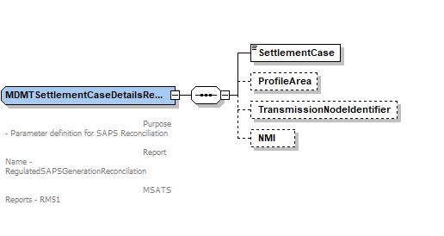

OneWayNotification_r43.xsd
- Add new element ‘SharedFuseNotification’
- Rename file to r43 version

<xsd:complexType name="SharedFuseNotification">
<xsd:sequence>
<xsd:element name="NMI" type="NMI" />

<xsd:element name="IdentifiedDate" type="xsd:date"/>
<xsd:element name="SharedIsolationPointFlag" type="SharedIsolationPointFlag"/>
</xsd:sequence>
<xsd:attribute name="version" type="r43" use="optional" default="r43"/>
</xsd:complexType>

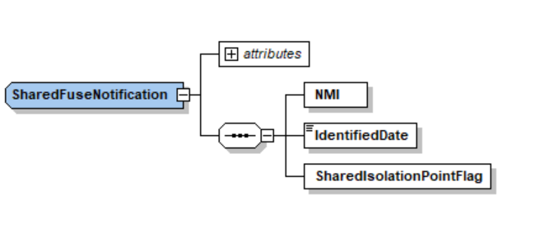

Transactions_r43.xsd
- Added new B2B transaction ‘SharedFuseNotification’ to ‘Transaction’ element.
- Rename file to r43 version

<xsd:complexType name="Transaction">
<xsd:annotation>
<xsd:documentation>
Purpose - Common container for all transactions
Detail - All transactions within aseXML are carried within this container. The transactionID and transactionDate are provided for all transactions. The initiatingTransactionID is only provided on response transactions and represents the transactionID of the initiating transaction.
</xsd:documentation>
</xsd:annotation>
<xsd:choice>
<xsd:element name="ReplicationRequest" type="ReplicationRequest"/>
…
…
…
<xsd:element name="OneWayNotification" type="OneWayNotification"/>
<xsd:element name="SharedFuseNotification" type="SharedFuseNotification"/>
…
…
…
<xsd:element name="LifeSupportNotification" type="LifeSupportNotification"/>
<xsd:element name="LifeSupportRequest" type="LifeSupportRequest"/>
</xsd:choice>
<xsd:attribute name="transactionID" type="TransactionIdentifier" use="required"/>
<xsd:attribute name="transactionDate" type="xsd:dateTime" use="required"/>
<xsd:attribute name="initiatingTransactionID" type="TransactionIdentifier" use="optional"/>
</xsd:complexType>

Impact Summary
This table identifies the files, transactions and versioned types that are potentially impacted as the result of these changes, where:
- Modified types - is a full list of types changed by this Change Request
- Derived types – is a list of any types that are derived from a modified type, and are therefore also modified by default
- Versioned types affected – is a list of all versioned types that will need to have the version attribute updated as a result of this Change Request
- Transactions potentially affected – is a list of all transactions that contain a modified type, either directly or via a type substitution
- Schema files affected – is a list of schema files that will be changed in some way as a result of this Change Request.

Modified types | Derived types | Versioned types affected | Transactions potentially affected | Schema files affected
 |  |  |  | aseXML_r43.xsd
R43 |  |  |  | Events_r43.xsd
ParticipantRolesRow |  |  | ReplicationNotification | CATSTableReplication_r43.xsd
ElectricityNMIMasterGroup  ElectricityMasterStandingData | ElectricityCATSChangeRequestNMIMasterRow  ElectricityNMIMasterRowBDT  ElectricityNMIMasterRow | ElectricityStandingData | NMIStandingDataResponse  ReportResponse  CATSChangeRequest | ElectricityMasterStandingData_r43.xsd
MDMTSettlementCaseDetailsReportParameters |  |  |  | MDMTReports_r43.xsd
SharedFuseNotification |  | SharedFuseNotification | SharedFuseNotification | OneWayNotification_r43.xsd
- Impact Summary

Developer Test

Test Platforms
The new schema has been tested using the following platforms as advised by ASWG:
- XMLSpy 2014

Test Cases
To be completed post development

Proposal Assessment

Test
The ASWG ensures that all recommended parsers on relevant platforms can successfully validate the proposed schema.

Test Platforms
Supplied samples have been tested using the following parsers:
- MSXML 4.0 SP1
- Xerces 1.4.1
- Xerces 2.2.1
- XMLSpy 2004

Test Cases
As per section 0.

Test Results
No issues.

Conformance Report
The ASWG completes the conformance report validating each proposed new schema file against the published aseXML guidelines.
Schema Filename | Impacted by Item # | Conformance Details
aseXML_r*.xsd |  | Conforms
- Change Proposal Conformance Details

Issue Register
This section describes any issues that have arisen and any modifications that are made to the original proposal during the Change Process

Status of Issues
Issue# | Item# | Description and Discussion | Status | Resolution
1
- Issues list

Resolution
The ASWG votes for endorsement of the options identified in section 2, and the voting results are forwarded to AEMO for approval. When 75% of those ASWG members who voted endorse a specific option, this represents an ASWG Recommendation for that option. AEMO will not reject an ASWG Recommendation without first consulting with the ASWG.

ASWG Endorsement
The results of the ASWG vote are as follows:
Date of Vote:

Option | # Votes | % Vote
Approved | 0 | 0
Rejected | 0
Abstained | 0
Total Members Present | 0
- ASWG Vote Results

Glossary
Term | Definition
AEMO | Australian Energy Market Operator
ASWG | aseXML Standards Working Group
B2B | Business-to-Business
MXN | Meter Exchange Notification
PIN | PlannedInterruptionNotification
SO | Service Orders

Change Type can be one of - New - Enhancement, or - Bug Fix
Either ‘Open’ or ‘Closed’

