| aseXML SCHEMA CHANGE REQUEST – CR70 |
| --- |

Q1 2021

P2115 B2B v3.5 Enhancements

Change request document for B2B system enhancements

Version Control

| Version | Release date | Changes |
| --- | --- | --- |
| 0.1 | 12/01/2021 | Initial request - Jordan Daly, Meghan Bibby, John Mcilwaine |
| 0.2 | 22/01/2021 | Schema Changes r41 - Harpreet Kaur |
| 0.3 | 25/02/2021 | Updates to schema r41 for Enumerations – Harpreet Kaur |
| 0.4 | 17/03/2021 | Enumeration changes as discussed in ASWG meeting – Harpreet Kaur |

Contents

1. Change Proposal 5

1.1 Description of the proposed change 5

1.2 Reason for Change 16

1.3 Supplied Documents 16

1.4 Baseline Schema 16

2. Approval Proposal 17

2.1 Proposed Changes 17

3. Proposal Assessment 21

3.1 Test 21

3.2 Conformance Report 21

4. Issue Register 22

4.1 Status of Issues 22

5. Resolution 22

5.1 ASWG Endorsement 22

Glossary 23

Tables

Table 1 Proposed Changes 5

Table 2 Change Log 7

Table 3 Impact Summary 10

Table 4 Change Proposal Conformance Details 11

Table 5 Issues list 12

Table 6 ASWG Vote Results 12

Figures

**No table of contents entries found.**

# Change Proposal

This Change Proposal is to accommodate changes to the B2B system related to the B2B v3.5 consultation.

AEMO requests that the ASWG commence the formal change process cycle as soon as possible with a view of approving and publishing an updated schema version on 15th March 2021. The system changes are scheduled to be deployed into the production environment on 10th November, 2021

## Description of the proposed change

The proposed changes are listed in the following table.

|  |  |  |
| --- | --- | --- |
| **Item#** | **Change Description** | **Change Type[1]** |
| 1 | PlannedInterruptionNotification (PIN) Enhancements:   * Add ServiceOrderID field to PIN transaction * Update existing ‘ReasonforInter’ field in PIN transaction to add new values to enumeration * PIN Uses - Configuration | New |
| 2 | 7 new fields to be added to Service Orders (SO) | New |
| 3 | New Customer Type Value | Enhancement |

1. Proposed Changes

### PlannedInterruptionNotification (PIN) Enhancements

The PIN is a One Way Notification. The enhancements to the PIN allow the streamlining of existing processes.

#### Add ServiceOrderID field to PIN transaction

A new field in the former transaction must be introduced in order to link Planned Interruption Notices with their associated Service Orders. This field will require a new field to be added to the schema.

The new field is described below:

|  |  |  |  |
| --- | --- | --- | --- |
| **Field** | **Format** | **Use** | **Definition** |
| *ServiceOrderID* | VARCHAR (15) | R | A defined reference, used for reference and tracking.  Format must exactly match that used in the ServiceOrderRequest (including leading or trailing zeros and spaces). |

#### PIN Uses – Configuration

The B2B consultation proposes several configuration changes to the uses of several fields in the Planned Interruption Notification transaction. The changes to the fields are described below.

It is preferred that the changes requested for the Planned Interruption Notification are made non-versioned enumerated to be future-configurable. This means if further changes such as the use of fields, or the content of the string values should be able to be updated without a schema change.

|  |  |  |  |
| --- | --- | --- | --- |
| **Field** | **Format** | **Use** | **Definition** |
| *ReasonForInter* | VARCHAR(50) | M~~O~~ | The reason for planned interruption.  Allowed values:  Meter Exchange - Individual  Meter Exchange - Rollout  Meter Replacement – Family Maintenance  Meter Test  Meter Fault Investigation  Distribution Works  Meter Installation – Additional  Install Controlled Load  Remove Meter  Move Meter  Meter Reconfiguration  Other |

The Use field is defined in the One Way Notification Process document as correlating to the following:

M = Mandatory (must be provided in all situations).   
R = Required (must be provided if this information is available or has changed).   
O = Optional (may be provided and should be used if provided).   
N = Not required (not required and may be ignored if provided).

**So, the schema changes for PIN are as follows:**

* **Addition of new field ServiceOrderID**
* **Update existing enumeration ‘*ReasonForInter*’ to add new values.**
* **Update the version attribute of PlannedInterruptionNotification from r36 to r41**

### 7 new fields to be added to Service Orders (SO)

The fields to be added to the Service Order Requests and their corresponding Service Orders are described in the table below. As above, these fields should be future-configurable, in that changing them in the future should not require a schema change.

|  |  |  |  |  |  |  |  |  |  |
| --- | --- | --- | --- | --- | --- | --- | --- | --- | --- |
| **Field** | **Format** | **Definition** | **Metering Service Works Install Meter** | **Metering Service Works Move Meter** | **Metering Service Works Exchange Meter** | **Metering Service Works Remove Meter** | **Metering Service Works Install Controlled Load** | **Metering Service Works Meter Reconfiguration** | **Metering Service Works**  **Meter Investigation - All**  **AND Reseal Device andChangeTimeSwitch** |
| *RegClassification* | VARCHAR(40) | Use to indicate whether it is customer Initiated and regulatory timeframes apply, or not.   * Customer Initiated * Malfunction * New Meter Deployment * Shared Fuse * Other   Not Required when a Distributor is the Recipient of a ServiceOrderRequest.  If ‘Other’ is selected, it is Mandatory to provide details in SpecialInstructions. | O/N | N | O/N | N | N | N | N |
| *PurposeOfRequest* | VARCHAR(40) | Used to clearly indicate the purpose of visit – allowable values   * New connection, * Additional Meter, * Part of BTS Temp to Perm, * Part of supply alteration, * Bidirectional flows at premises * Bypassed Customer * Communications Remove * Communications Install * Revenue Protection * Site Abolishment * Family Failure * Fault * Retailer Led * None * Other   Not Required when a Distributor is the Recipient of a ServiceOrderRequest.  If ‘None’ or a blank entry or ‘Other’ are selected, it is Mandatory to provide details in SpecialInstructions. | O/N | O/N | O/N | N | N | O/N | O/N |
| *CustomerNotificationMethod* | VARCHAR(40) | This is the method by which the notice of interruption to the customer is to be delivered. This is used when the Recipient is to issue the notice on behalf of the Initiator. Allowable values are:   * Post * Email * SMS * Waiver * Phone   Not Required when a Distributor is the Recipient of a ServiceOrderRequest.  If ‘Email’ is selected, it is Mandatory to provide details in *CustomerNotificationEmail*. If ‘Post’ is selected, it is Mandatory to provide details in *CustomerNotificationAddress*. If ‘Phone’ or ‘SMS’ are selected, it is Mandatory to provide details in *CustomerContactTelephoneNumber.* If ‘Waiver’ is selected, it is Mandatory to populate*CustomerAgreedStartDate*and &*CustomerAgreedEndDate*or*CustomerPreferredDate* | O/N | O/N | O/N | O/N | O/N | O/N | O/N |
| *Escalation* | VARCHAR(40) | Used to indicate the Service Order is to be prioritised over other Service Orders. Initiator and Recipient must agree the circumstances and indicator to be used. Allowable values are:   * Complaint * Ombudsman * VIP * No Supply * Other   Where “Other” is used ,*SpeciaIlinstructions* should contain a code that is agreed between the Initiator and Recipient e.g. [PRIORITY=abc]  If the field is unpopulated, it should be assumed that the escalation level of the transaction is ‘Normal’.  Not Required when a Distributor is the Recipient of a ServiceOrderRequest.  If ‘Other’ is selected, it is Mandatory to provide details in*SpecialInstructions*. | O/N | O/N | O/N | O/N | O/N | O/N | O/N |
| *ExemptionCode* | VARCHAR(40) | AEMO assigned malfunction exemption code. Used to communicate the exemption code that the MC has been allocated to the MP.  Not Required when a Distributor is the Recipient of a ServiceOrderRequest. | N | O/N | O/N | N | N | N | N |
| *CustomerAgreedStartDate* | DATE | The earliest date for the provision of the service as agreed between the Initiator and customer.  Not Required when a Distributor is the Recipient of a ServiceOrderRequest. | O/N | O/N | O/N | O/N | O/N | O/N | O/N |
| *CustomerAgreedEndDate* | DATE | The last date for the provision of the service as agreed between the Initiator and customer.  Not Required when a Distributor is the Recipient of a ServiceOrderRequest. | O/N | O/N | O/N | O/N | O/N | O/N | O/N |

To summarise the above table, the aforementioned fields are to be added as Optional fields to the Service Order Request transactions:

**Schema changes required are as follows:**

* **Addition of 5 new fields as enumerated list with allowed values**
* **Addition of 2 new fields as Date type.**
* **Update version attribute for ServiceOrderRequest from r36 to r41**

**Note**: CustomerNotificationAddress is another new element specified in the B2B procedures, but will be just the ***PostalAddress*** of the ***ContactDetail*** ( which is derive from CustomerDetail complex Type). Ie no schema change required.

### New Customer Type Value

The CustomerType field in the Service Order transaction requires a new enumeration so that an Allocate NMI request for a non-contestable unmetered load (NCONUML) can be communicated. This new enumeration is NCONUML.

**Schema changes required are as follows:**

* **Move the existing enumeration form versioned xsd file CustomerDetails_rXX.xsd to ElectricityEnumerations.xsd**
* **Add the new value NCONUML to existing enumeration ‘CustomerType’**

## Reason for Change

These changes are made in the interests of improving efficiency, reducing costs and ensuring compliance with the National Electricity Objective. These changes were consulted and agreed upon in 2020.

The addition of 8 new fields to the Service Order transaction supports better communication between Initiators and Recipients of transactions by ensuring higher quality of data and automating existing manual processes. Currently this information is being communicated using special instructions in the service order (SO).

The enhancement of the PIN and removal of the MXN will streamline existing processes and link outages to the Service Orders that prompt them.

The NCONUML CustomerType Value is being introduced to facilitate the implementation of Global Settlement.

For further information about this proposal please see the Final Report consultation paper published on AEMO website. Click [here](https://aemo.com.au/en/consultations/current-and-closed-consultations/b2b-procedures-v3-4-consultation) to view these papers.

## Supplied Documents

### Business process document

### Other

## Baseline Schema

The schema used as a basis for this proposal is v40.

# Approval Proposal

## Proposed Changes

### Draft schemas



### Change log

The following changes have been implemented in this draft:

|  |  |  |  |
| --- | --- | --- | --- |
| **Chg #** | **Item #** | **Description of change** | **Filename** |
| 1 |  | * Replace version of schema from r40 to r41 * Rename file to r41 version. | aseXML_r41.xsd |
| 2 |  | * Registration of r41 release * Rename file to r41 version. | Events_r41.xsd |
| 3 | 2 | * Add new enumeration element ‘CustomerNotificationMethod’ to existing ‘AppointmentDetail’ complex type. * Add 2 new Date type elements to existing ‘AppointmentDetail’ complex type : CustomerAgreedStartDate, CustomerAgreedEndDate * Rename file to r41 version. | Common_r41.xsd |
| 4 | 3 | * Remove existing enumeration ‘CustomerType’ -> moved to ElectricityEnumeration.xsd * Rename file to r41 version. | CustomerDetails_r41.xsd |
| 5 | 2 | * Add 3 new enum elements to existing complex type ‘ElectricityServiceOrderDetails’ element : RegClassification, PurposeOfRequest, Escalation * Add new String type element to existing complex type ‘ElectricityServiceOrderDetails’ element : ExemptionCode * Updated the version attribute of ‘ServiceOrderRequest’ from 36 to r41 * Rename file to r41 version | Electricity_r41.xsd |
| 6 | 1,2,3 | * Update existing element ‘ReasonForInter’ enumeration to add new allowed values. * Add ‘CustomerType’ enumeration * Update ‘CustomerType’ enumeration to add new allowed value. * Add new enumerations :  RegClassification,   PurposeOfRequest,  CustomerNotificationMethod  Escalation | ElectricityEnumerations.xsd |
| 8 | 1 | * Add ‘ServiceOrderNumber’ to existing complex type ‘PlannedInterruptionNotification’ element. * Updated the version attribute of ‘PlannedInterruptionNotification’ from 36 to r41 * Rename file to r41 version. | OneWayNotification_r41.xsd |
| 9 | 2 | * Updated the version attribute of ‘ServiceOrderRequest’ from 36 to r41 * Rename file to r41 version | ServiceOrder_r41.xsd |

1. Change Log

### Schema change description

#### aseXml_r41.xsd

* New file to replace aseXML_r40.xsd and include the r41 file versions listed below.

<xsd:schema xmlns="urn:aseXML:r41" xmlns:xsd="http://www.w3.org/2001/XMLSchema" xmlns:xsi="http://www.w3.org/2001/XMLSchema-instance" targetNamespace="urn:aseXML:r41" version="r41" xsi:schemaLocation="urn:aseXML:r41 aseXML_r41.xsd">

<xsd:include schemaLocation="Events_r41.xsd">

<xsd:include schemaLocation="Electricity_r41.xsd">

<xsd:include schemaLocation="Common_r41.xsd">

<xsd:include schemaLocation="CustomerDetails_r41.xsd">

<xsd:include schemaLocation="ServiceOrder_r41.xsd">

<xsd:include schemaLocation="OneWayNotification_r41.xsd">

#### Common_r41.xsd

* Added new enumeration element to existing ‘AppointmentDetail’ complex type : **CustomerNotificationMethod**.
* Added 2 new Date type elements to existing ‘AppointmentDetail’ complex type : **CustomerAgreedStartDate**, **CustomerAgreedEndDate**
* Rename file to r41 version.

<xsd:complexType name="AppointmentDetail">

<xsd:annotation>

<xsd:documentation>Schema - Appointments</xsd:documentation>

</xsd:annotation>

<xsd:sequence>

<xsd:element name="Reference" type="UniqueIdentifier" minOccurs="0"/>

<xsd:element name="ScheduledDate" type="xsd:date" minOccurs="0"/>

<xsd:element name="Preferred" type="AppointmentDateTime" minOccurs="0"/>

<xsd:element name="CustomerNotificationMethod" type="CustomerNotificationMethod" minOccurs="0"/>

<xsd:element name="CustomerAgreedStartDate" type="xsd:date" minOccurs="0"/>

<xsd:element name="CustomerAgreedEndDate" type="xsd:date" minOccurs="0"/>

</xsd:sequence>

</xsd:complexType>

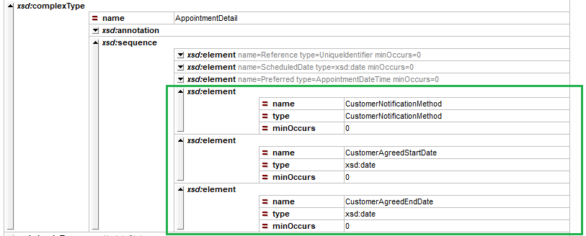

#### Events_r41.xsd

* New file to replace Events_r40.xsd and include the r41 release identifier as below:

<xsd:simpleType name="r41">

<xsd:annotation>

<xsd:documentation>Purpose - Release r41 identifier.</xsd:documentation>

</xsd:annotation>

<xsd:restriction base="ReleaseIdentifier">

<xsd:enumeration value="r41"/>

</xsd:restriction>

</xsd:simpleType>

#### CustomerDetails_r41.xsd

* Move existing enumeration ‘CustomerType’ to ElectricityEnumeration.xsd

#### Electricity_r41.xsd

* Added 3 new enumeration list elements to existing complex type ‘ServiceOrderRequestData’ element : RegClassification, PurposeOfRequest, Escalation
* Added new string type element to existing complex type ‘ServiceOrderRequestData’ element : ExemptionCode
* Updated the version attribute of ‘ElectricityServiceOrderDetails’ from 36 to r41
* Rename file to r41 version.

<xsd:complexType name="ElectricityServiceOrderDetails">

<xsd:annotation>

<xsd:documentation>Purpose - Defines the data type for new connection and meter additions and alterations

v36.1. WL. Change LifeSupport to be optional field.

</xsd:documentation>

</xsd:annotation>

<xsd:complexContent>

<xsd:extension base="ServiceOrderRequestData">

<xsd:sequence>

<xsd:element name="CustomerConsultationRequired" type="xsd:boolean"/>

<xsd:element name="InstallationType" type="InstallationType" minOccurs="0"/>

<xsd:element name="SupplyPhase" type="SupplyPhase" minOccurs="0"/>

<xsd:element name="AverageDailyLoad" type="AveragedDailyLoad" minOccurs="0"/>

<xsd:element name="CustomerType" type="CustomerType" minOccurs="0"/>

<xsd:element name="MeteringType" type="MeteringType" minOccurs="0"/>

<xsd:element name="OffPeakRequirements" type="SpecialComments" minOccurs="0"/>

<xsd:element name="MaximumDemand" type="MeterDemand" minOccurs="0"/>

<xsd:element name="ServiceTime" type="ServiceTimeType" minOccurs="0"/>

<xsd:element name="SwitchingServiceRequired" type="SwitchingServiceRequired" minOccurs="0"/>

<xsd:element name="ConfirmedDe-energisation" type="xsd:boolean" minOccurs="0"/>

<xsd:element name="License" type="License" minOccurs="0"/>

<xsd:element name="MeterLicense" type="License" minOccurs="0"/>

<xsd:element name="De-energisationReason" type="De-energisationReason" minOccurs="0"/>

<xsd:element name="LifeSupport" type="YesNo" minOccurs="0"/>

<xsd:element name="Co-ordinationRequired" type="YesNo" minOccurs="0"/>

<xsd:element name="RegClassification" type="RegClassification" minOccurs="0"/>

<xsd:element name="PurposeOfRequest" type="PurposeOfRequest" minOccurs="0"/>

<xsd:element name="Escalation" type="Escalation" minOccurs="0"/>

<xsd:element name="ExemptionCode" type="xsd:string" minOccurs="0"/>

</xsd:sequence>

<xsd:attribute name="version" type="r41" use="optional" default="r41"/>

</xsd:extension>

</xsd:complexContent>

</xsd:complexType>

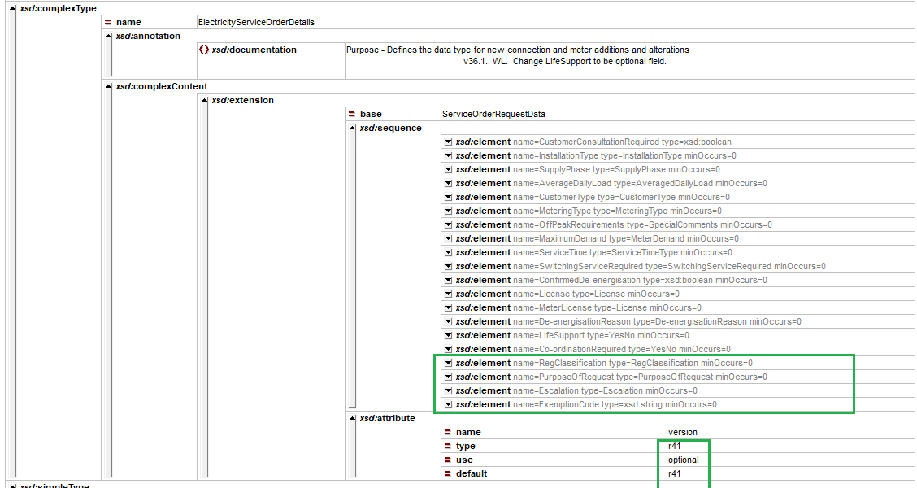

#### ElectricityEnumerations.xsd

* Update existing enumeration ‘ReasonForInter’ to add new allowed values.
* Moved existing enumeration ‘CustomerType’ from CustomerDetails_rXX.xsd
* Update existing enumeration ‘CustomerType’ to add new allowed value.
* Added new enumeration list elements : RegClassification, PurposeOfRequest, CustomerNotificationMethod and Escalation.

<xsd:simpleType name="CustomerType">

<xsd:annotation>

<xsd:documentation>Purpose - Defines a list of valid customer types</xsd:documentation>

</xsd:annotation>

<xsd:restriction base="xsd:string">

<xsd:enumeration value="Industrial"/>

<xsd:enumeration value="Commercial"/>

<xsd:enumeration value="Residential"/>

<xsd:enumeration value="Farm"/>

<xsd:enumeration value="Lighting"/>

<xsd:enumeration value="NCONUML"/>

</xsd:restriction>

</xsd:simpleType>

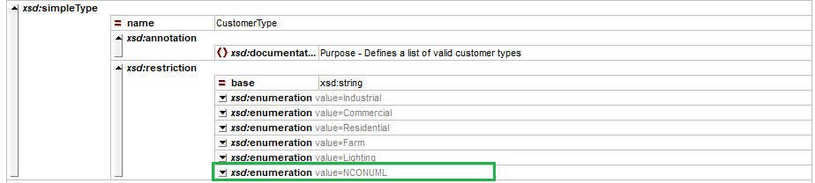

<xsd:simpleType name="ReasonForInter">

<xsd:annotation>

<xsd:documentation>

Purpose - Define the fixed Reasons for interruption

Version 1.0 additions

- Meter Exchange - Individual

- Meter Exchange - Rollout

- Meter Replacement - Family Maintenance

- Meter Test

- Meter Fault Investigation

- Distribution Works

- Meter Installation – Additional

- Install Controlled Load

- Remove Meter

- Move Meter

- Meter Reconfiguration

- Other

Version 1.1 update

- Replace en dash in Meter Replacement - Family Maintenance with proper hyphen due to UTF-8 limitation.

Version 1.2 update

- Addition of new enum values as per B2B v3.4 and v3.5 Consultation.

</xsd:documentation>

</xsd:annotation>

<xsd:restriction base="xsd:string">

<xsd:maxLength value="50"/>

<xsd:enumeration value="Meter Exchange - Individual"/>

<xsd:enumeration value="Meter Exchange - Rollout"/>

<xsd:enumeration value="Meter Replacement - Family Maintenance"/>

<xsd:enumeration value="Meter Test"/>

<xsd:enumeration value="Meter Fault Investigation"/>

<xsd:enumeration value="Distribution Works"/>

<xsd:enumeration value="Meter Installation – Additional"/>

<xsd:enumeration value="Install Controlled Load"/>

<xsd:enumeration value="Remove Meter"/>

<xsd:enumeration value="Move Meter"/>

<xsd:enumeration value="Meter Reconfiguration"/>

<xsd:enumeration value="Other"/>

</xsd:restriction>

</xsd:simpleType>

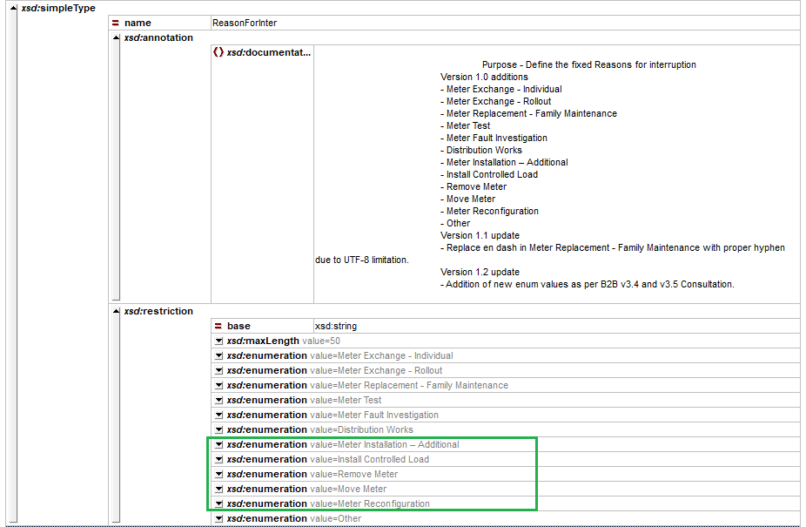

<xsd:simpleType name="RegClassification">

<xsd:annotation>

<xsd:documentation>

Purpose - Use to indicate whether it is customer Initiated and regulatory timeframes apply, or not.

Version 1.0 additions

- Customer Initiated

- Malfunction

- New Meter Deployment

- Shared Fuse

- Other

</xsd:documentation>

</xsd:annotation>

<xsd:restriction base="xsd:string">

<xsd:maxLength value="40"/>

<xsd:enumeration value="Customer Initiated"/>

<xsd:enumeration value="Malfunction"/>

<xsd:enumeration value="New Meter Deployment"/>

<xsd:enumeration value="Shared Fuse"/>

<xsd:enumeration value="Other"/>

</xsd:restriction>

</xsd:simpleType>

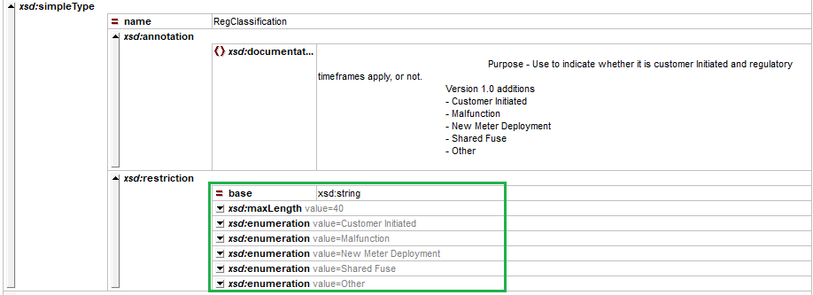

<xsd:simpleType name="PurposeOfRequest">

<xsd:annotation>

<xsd:documentation>

Purpose - Used to clearly indicate the purpose of visit

Version 1.0 additions

- New connection

- Additional Meter

- Part of BTS Temp to Perm

- Part of supply alteration

- Bidirectional flows at premises

- Bypassed Customer

- Communications Remove

- Communications Install

- Revenue Protection

- Site Abolishment

- Family Failure

- Fault

- Retailer Led

- None

- Other

</xsd:documentation>

</xsd:annotation>

<xsd:restriction base="xsd:string">

<xsd:maxLength value="40"/>

<xsd:enumeration value="New connection"/>

<xsd:enumeration value="Additional Meter"/>

<xsd:enumeration value="Part of BTS Temp to Perm"/>

<xsd:enumeration value="Part of supply alteration"/>

<xsd:enumeration value="Bidirectional flows at premises"/>

<xsd:enumeration value="Bypassed Customer"/>

<xsd:enumeration value="Communications Remove"/>

<xsd:enumeration value="Communications Install"/>

<xsd:enumeration value="Revenue Protection"/>

<xsd:enumeration value="Site Abolishment"/>

<xsd:enumeration value="Family Failure"/>

<xsd:enumeration value="Fault"/>

<xsd:enumeration value="Retailer Led"/>

<xsd:enumeration value="None"/>

<xsd:enumeration value="Other"/>

</xsd:restriction>

</xsd:simpleType>

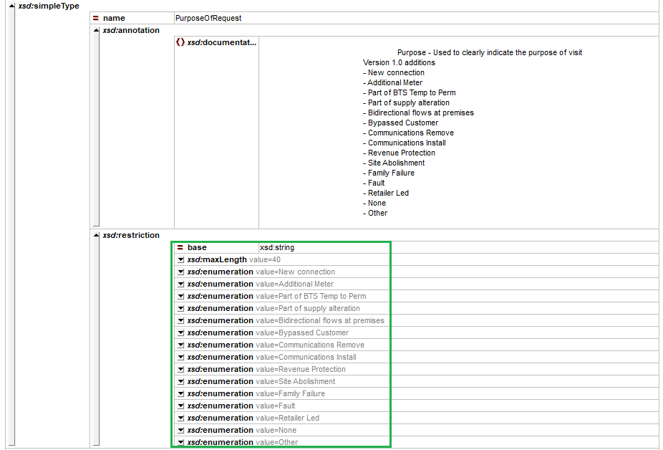

<xsd:simpleType name="CustomerNotificationMethod">

<xsd:annotation>

<xsd:documentation>

Purpose - Used to clearly indicate the method by which the notice of interruption to the customer is to be delivered.

Version 1.0 additions

- Post

- Email

- SMS

- Waiver

- Phone

</xsd:documentation>

</xsd:annotation>

<xsd:restriction base="xsd:string">

<xsd:maxLength value="40"/>

<xsd:enumeration value="Post"/>

<xsd:enumeration value="Email"/>

<xsd:enumeration value="SMS"/>

<xsd:enumeration value="Waiver"/>

<xsd:enumeration value="Phone"/>

</xsd:restriction>

</xsd:simpleType>

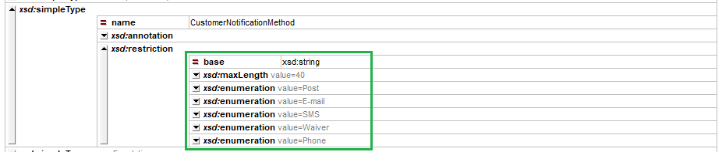

<xsd:simpleType name="Escalation">

<xsd:annotation>

<xsd:documentation>

Purpose - Used to indicate the Service Order is to be prioritised over other Service Orders.

Version 1.0 additions

- Complaint

- Ombudsman

- VIP

- No Supply

- Other

</xsd:documentation>

</xsd:annotation>

<xsd:restriction base="xsd:string">

<xsd:maxLength value="40"/>

<xsd:enumeration value="Complaint"/>

<xsd:enumeration value="Ombudsman"/>

<xsd:enumeration value="VIP"/>

<xsd:enumeration value="No Supply"/>

<xsd:enumeration value="Other"/>

</xsd:restriction>

</xsd:simpleType>

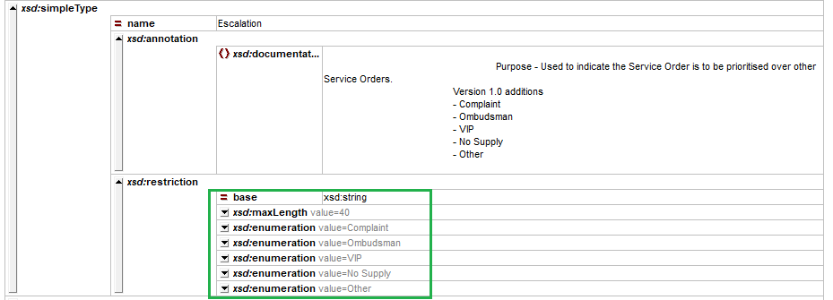

#### OneWayNotification_r41.xsd

* Added ‘ServiceOrderNumber’ to existing complex type ‘PlannedInterruptionNotification’ element.
* Updated the version attribute of ‘PlannedInterruptionNotification’ from 36 to r41
* Rename file to r41 version.

<xsd:complexType name="PlannedInterruptionNotification">

<xsd:sequence>

<xsd:element name="NMI" type="NMI"/>

<xsd:element name="ServiceOrderNumber" type="UniqueIdentifier" minOccurs="0"/>

<xsd:element name="StartDate" type="xsd:date"/>

<xsd:element name="StartTime" type="xsd:time"/>

<xsd:element name="EndDate" type="xsd:date" minOccurs="0"/>

<xsd:element name="Duration" type="Duration"/>

<xsd:element name="ReasonForInter" type=" ReasonForInter" minOccurs="0"/>

<xsd:element name="Notes" type="NotificationNotes" minOccurs="0"/>

</xsd:sequence>

<xsd:attribute name="version" type="r41" use="optional" default="r41"/>

</xsd:complexType>

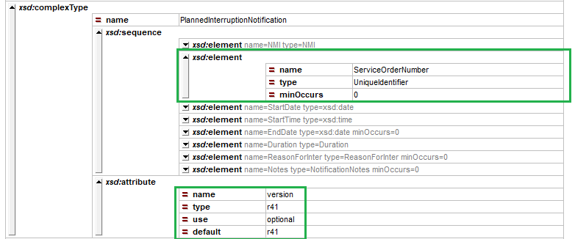

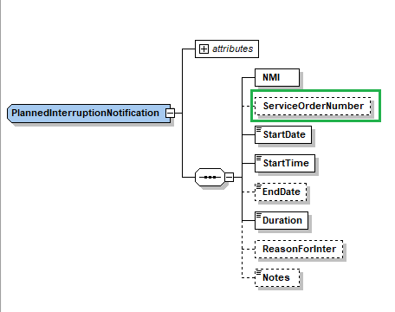

#### ServiceOrder_r41.xsd

* Updated the version attribute of ‘ServiceOrderRequest’ from 36 to r41
* Rename file to r41 version

<xsd:complexType name="ServiceOrderRequest">

<xsd:annotation>

<xsd:documentation>

Application - Service Order

TransactionExchange -

TransactionGroup - SORD

Priority - Medium

Purpose - Submit Service Order Request to the Service Provider

</xsd:documentation>

</xsd:annotation>

<xsd:sequence>

<xsd:element name="ServiceOrder" type="ServiceOrderHeader"/>

<xsd:element name="ServicePoint" type="ServicePoint" minOccurs="0"/>

<xsd:element name="ContactDetail" type="CustomerDetail" minOccurs="0"/>

<xsd:element name="CustomerDetail" type="CustomerDetail" minOccurs="0"/>

<xsd:element name="Co-ordinatingContactDetail" type="CustomerDetail" minOccurs="0"/>

<xsd:element name="AppointmentDetail" type="AppointmentDetail" minOccurs="0"/>

<xsd:element name="RequestData" type="ServiceOrderRequestData" minOccurs="0"/>

<xsd:element name="NotifiedParties" type="NotifiedParties" minOccurs="0"/>

</xsd:sequence>

<xsd:attribute name="version" type="r41" use="optional" default="r41"/>

<xsd:attribute name="actionType" type="ActionType" default="New"/>

</xsd:complexType>



### Impact Summary

This table identifies the files, transactions and versioned types that are potentially impacted as the result of these changes, where:

* Modified types - is a full list of types changed by this Change Request
* Derived types – is a list of any types that are derived from a modified type, and are therefore also modified by default
* Versioned types affected – is a list of all versioned types that will need to have the version attribute updated as a result of this Change Request
* Transactions potentially affected – is a list of all transactions that contain a modified type, either directly or via a type substitution
* Schema files affected – is a list of schema files that will be changed in some way as a result of this Change Request.

|  |  |  |  |  |
| --- | --- | --- | --- | --- |
| **Modified types** | **Derived types** | **Versioned types affected** | **Transactions potentially affected** | **Schema files affected** |
|  |  | Events_r41.xsd,  Electricity_r41.xsd,  Common_r41.xsd,  CustomerDetails_r41.xsd,  ServiceOrder_r41.xsd,  OneWayNotification_r41.xsd | * ServiceOrders * Metering Service Works * Re-energisation * De-energisation * Special Read * Miscellaneous * OneWayNotification * PlannedInterruptionNotification | aseXML_r41.xsd |
| R41 |  |  |  | Events_r41.xsd |
| ElectricityServiceOrderDetails - RegClassification, PurposeOfRequest, Escalation, ExemptionCode |  | ElectricityServiceOrderDetails | * ServiceOrders * Metering Service Works | Electricity_r41.xsd |
| AppointmentDetail – CustomerNotificationMethod,  CustomerAgreedStartDate,  CustomerAgreedEndDate |  |  | * ServiceOrders * Re-energisation * De-energisation * Special Read * Miscellaneous * Metering Service Works | Common_r41.xsd |
| CustomerType |  |  | * ServiceOrders * Metering Service Works | CustomerDetails_r41.xsd |
| ReasonForInter |  |  | * PlannedInterruptionNotification | ElectricityEnumerations.xsd |
| ServiceOrderRequest |  | ServiceOrderRequest | * ServiceOrders * Metering Service Works | ServiceOrder_41.xsd |
| PlannedInterruptionNotification –  ServiceOrderNumber,  ReasonForInter |  | PlannedInterruptionNotification | * PlannedInterruptionNotification | OneWayNotification_r41.xsd |

1. Impact Summary

### Developer Test

#### Test Platforms

The new schema has been tested using the following platforms as advised by ASWG:

* XMLSpy 2014

#### Test Cases

To be completed post development

# Proposal Assessment

## Test

The ASWG ensures that all recommended parsers on relevant platforms can successfully validate the proposed schema.

### Test Platforms

Supplied samples have been tested using the following parsers:

* MSXML 4.0 SP1
* Xerces 1.4.1
* Xerces 2.2.1
* XMLSpy 2004

### Test Cases

As per section 0.

### Test Results

No issues.

## Conformance Report

The ASWG completes the conformance report validating each proposed new schema file against the published aseXML guidelines.

|  |  |  |
| --- | --- | --- |
| **Schema Filename** | **Impacted by Item #** | **Conformance Details** |
| aseXML_r*.xsd |  | Conforms |
|  |  |  |

1. Change Proposal Conformance Details

# Issue Register

This section describes any issues that have arisen and any modifications that are made to the original proposal during the Change Process

## Status of Issues

|  |  |  |  |  |
| --- | --- | --- | --- | --- |
| **Issue#** | **Item#** | **Description and Discussion** | **Status[2]** | **Resolution** |
| 1 |  |  |  |  |

1. Issues list

# Resolution

The ASWG votes for endorsement of the options identified in section 2, and the voting results are forwarded to AEMO for approval. When 75% of those ASWG members who voted endorse a specific option, this represents an ASWG Recommendation for that option. AEMO will not reject an ASWG Recommendation without first consulting with the ASWG.

## ASWG Endorsement

The results of the ASWG vote are as follows:

Date of Vote:

|  |  |  |
| --- | --- | --- |
| **Option** | **# Votes** | **% Vote** |
| Approved | 0 | 0 |
| Rejected | 0 |  |
| Abstained | 0 |  |
| Total Members Present | 0 |  |

1. ASWG Vote Results

Glossary

|  |  |
| --- | --- |
| Term | Definition |
| AEMO | Australian Energy Market Operator |
| ASWG | aseXML Standards Working Group |
| B2B | Business-to-Business |
| MXN | Meter Exchange Notification |
| PIN | PlannedInterruptionNotification |
| SO | Service Orders |

1. Change Type can be one of

   New

   Enhancement, or

   Bug Fix
2. Either ‘Open’ or ‘Closed’