High resolution data information guide

The folder “Sample_19Hz_Oscillations_data” contains high resolution (20ms) data for 8 events captured at Red-Cliffs Transmission Station (RCTS).
The naming of the folders for each event is as follows:
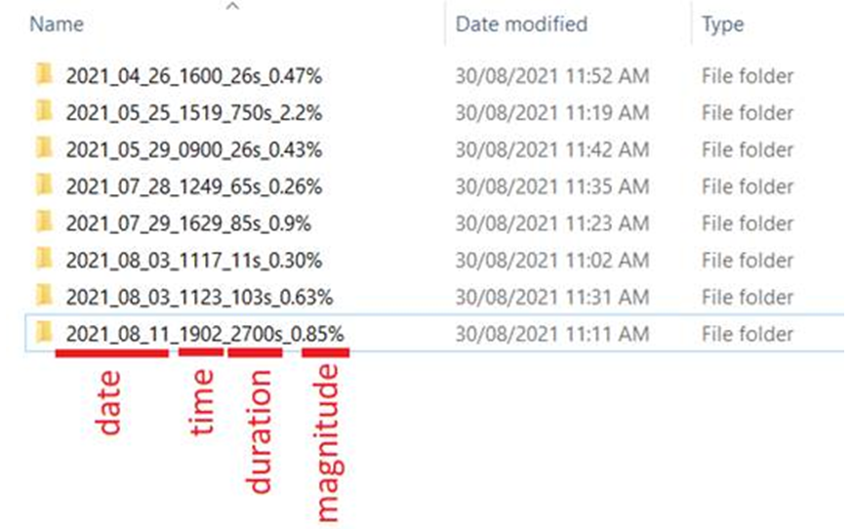
Inside each folder, there are .csv files (depending on data availability), which include high resolution (20ms) data for available channels around RCTS. The .csv files in each folder can be any (or all) of the following files:
- Date_time_VIC_RCTS_RCTS_1_2
- Date_time_VIC_RCTS_RCTS_2_1
- Date_time_VIC_RCTS_RCTS_2_2
- Date_time_VIC_RCTS_RCTS_3_1

The .csv file with the general name of Date_time_VIC_RCTS_RCTS_X_Y includes the following data (each channel name corresponds to one column of the .csv file)

A- Date_time_VIC_RCTS_RCTS_1_2

Channel Name Channel Description
~ 22KV PSel RphVT Phase 1 to ground RMS voltage at 22kV bus
~ 22KV PSel WphVT Phase 2 to ground RMS voltage at 22kV bus
~ 22KV PSel BphVT Phase 3 to ground RMS voltage at 22kV bus
~ TR1A 22KV RphCT Phase 1 RMS current of 1A 220/22kV transformer
~ TR1A 22KV WphCT Phase 2 RMS current of 1A 220/22kV transformer
~ TR1A 22KV BphCT Phase 3 RMS current of 1A 220/22kV transformer
~ TR2A 22KV RphCT Phase 1 RMS current of 2A 220/22kV transformer
~ TR2A 22KV WphCT Phase 2 RMS current of 2A 220/22kV transformer
~ TR2A 22KV BphCT Phase 3 RMS current of 2A 220/22kV transformer
~ TR3A 22KV RphCT Phase 1 RMS current of 3A 220/22kV transformer
~ TR3A 22KV WphCT Phase 2 RMS current of 3A 220/22kV transformer
~ TR3A 22KV BphCT Phase 3 RMS current of 3A 220/22kV transformer
~ #1 22KVCAP RphCT Phase 1 RMS current of 22kV cap-bank
~ #1 22KVCAP WphCT Phase 2 RMS current of 22kV cap-bank
~ #1 22KVCAP BphCT Phase 3 RMS current of 22kV cap-bank
P3 TR1A 22KV 3-Phase active power of 220/22kV transformer 1A
Q3 TR1A 22KV 3-Phase reactive power of 220/22kV transformer 1A
P3 TR2A 22KV 3-Phase active power of 220/22kV transformer 2A
Q3 TR2A 22KV 3-Phase reactive power of 220/22kV transformer 2A
P3 TR3A 22KV 3-Phase active power of 220/22kV transformer 3A
Q3 TR3A 22KV 3-Phase reactive power of 220/22kV transformer 3A
P3 #1 22KV Cap Bank 3-Phase active power through 22kV cap-bank
Q3 #1 22KV Cap Bank 3-Phase reactive power through 22kV cap-bank
PPS ~V TR1A 22KV Posit. Sequence Voltage at 22kV transformer 1A
PPS ^V TR1A 22KV Posit. Sequence Phase Angle at 22kV transformer 1A
PPS ~V TR2A 22KV Posit. Sequence Voltage at 22kV transformer 2A
PPS ^V TR2A 22KV Posit. Sequence Phase Angle at 22kV transformer 2A
Frq. TR1A 22KV Frequency at 22kV bus

B- Date_time_VIC_RCTS_RCTS_2_1

Channel Name Channel Description
~ 66KV PSel RphVT Phase 1 to ground RMS voltage at 66kV bus2
~ 66KV PSel WphVT Phase 2 to ground RMS voltage at 66kV bus2
~ 66KV PSel BphVT Phase 3 to ground RMS voltage at 66kV bus2
~ MBN 66KV L RphCT Phase 1 RMS current towards MBN load
~ MBN 66KV L WphCT Phase 2 RMS current towards MBN load
~ MBN 66KV L BphCT Phase 3 RMS current towards MBN load
~ MDA#1 66KV RphCT Phase 1 RMS current towards MDA1 load
~ MDA#1 66KV WphCT Phase 2 RMS current towards MDA1 load
~ MDA#1 66KV BphCT Phase 3 RMS current towards MDA1 load
~ MDA#2 66KV RphCT Phase 1 RMS current towards MDA2 load
~ MDA#2 66KV WphCT Phase 2 RMS current towards MDA2 load
~ MDA#2 66KV BphCT Phase 3 RMS current towards MDA2 load
P3 MBN 66KV Line 3-Phase active power of MBN load
Q3 MBN 66KV Line 3-Phase reactive power of MBN load
P3 MDA#1 66KV Line 3-Phase active power of MDA1 load
Q3 MDA#1 66KV Line 3-Phase reactive power of MDA1 load
P3 MDA#2 66KV Line 3-Phase active power of MDA2 load
Q3 MDA#2 66KV Line 3-Phase reactive power of MDA2 load
PPS ~V MBN 66KV Line Positive Sequence Voltage at MBN 66kV
PPS ^V MBN 66KV Line Positive Sequence Phase Angle at MBN 66kV
PPS ~V MDA#1 66KV Line Positive Sequence Voltage at MDA1 66kV
PPS ^V MDA#1 66KV Line Positive Sequence Phase Angle at MDA1 66kV
Frq. MBN 66KV Line Frequency at MBN 66kV

C- Date_time_VIC_RCTS_RCTS_2_2

Channel Name Channel Description
~ 66KV PSel RphVT Phase 1 to ground RMS voltage at 66kV bus1
~ 66KV PSel WphVT Phase 1 to ground RMS voltage at 66kV bus1
~ 66KV PSel BphVT Phase 1 to ground RMS voltage at 66kV bus1
~ RVL 66KV L RphCT Phase 1 RMS current towards Robinvale
~ RVL 66KV L WphCT Phase 2 RMS current towards Robinvale
~ RVL 66KV L BphCT Phase 3 RMS current towards Robinvale
~ HTH 66KV L RphCT Phase 1 RMS current towards Hattah
~ HTH 66KV L WphCT Phase 2 RMS current towards Hattah
~ HTH 66KV L BphCT Phase 3 RMS current towards Hattah
P3 RVL 66KV Line 3-Phase active power Toward Robinvale
Q3 RVL 66KV Line 3-Phase reactive power Toward Robinvale
P3 HTH 66KV Line 3-Phase active power Toward Hattah
Q3 HTH 66KV Line 3-Phase reactive power Toward Hattah
PPS ~V RVL 66KV Line Positive Sequence Voltage at Robinvale 66kV
PPS ^V RVL 66KV Line Positive Sequence Phase Angle at Robinvale 66kV
PPS ~V HTH 66KV Line Positive Sequence Voltage at Hattah 66kV
PPS ^V HTH 66KV Line Positive Sequence Phase Angle at Hattah 66kV
Frq. RVL 66KV Line Frequency at Robinvale 66kV

D- Date_time_VIC_RCTS_RCTS_3_1

Channel Name Channel Description
~ BSS&WETS/KGTS RV Ph1-G RMS voltage at the connection to BSS&WETS
~ BSS&WETS/KGTS WV Ph2-G RMS voltage at the connection to BSS&WETS
~ BSS&WETS/KGTS BV Ph3-G RMS voltage at the connection to BSS&WETS
~ BSS #1B 220KV RI Phase 1 RMS current from 220kV bus1 to BSS
~ BSS #1B 220KV WI Phase 2 RMS current from 220kV bus1 to BSS
~ BSS #1B 220KV BI Phase 3 RMS current from 220kV bus1 to BSS
~ BSS #2B 220KV RI Phase 1 RMS current from 220kV bus2 to BSS
~ BSS #2B 220KV WI Phase 2 RMS current from 220kV bus2 to BSS
~ BSS #2B 220KV BI Phase 3 RMS current from 220kV bus2 to BSS
~ WETS/KGTS #1B RI Phase 1 RMS current from 220kV bus1 to WETS/KGTS
~ WETS/KGTS #1B WI Phase 2 RMS current from 220kV bus1 to WETS/KGTS
~ WETS/KGTS #1B BI Phase 3 RMS current from 220kV bus1 to WETS/KGTS
P3 BSS L #1B 220KV 3-Ph active power from 220kV bus1 into OX1 line
Q3 BSS L #1B 220KV 3-Ph reactive power from 220kV bus1 into OX1 line
P3 BSS L #2B 220KV 3-Ph active power from 220kV bus2 into OX1 line
Q3 BSS L #2B 220KV 3-Ph reactive power from 220kV bus2 into OX1 line
P3 WETS_KGTS L #1B 3-Ph active power from 220kV bus1 into WETS/KGTS
Q3 WETS_KGTS L #1B 3-Ph reactive power from 220kV bus1 to WETS/KGTS
PPS ~V BSS L #1B 220KV Positive Sequence Voltage at 220kV bus1
PPS ^V BSS L #1B 220KV Positive Sequence Phase Angle at 220kV bus1
PPS ~V BSS L #2B 220KV Positive Sequence Voltage at 220kV bus2
PPS ^V BSS L #2B 220KV Positive Sequence Phase Angle at 220kV bus2
Frq. BSS L #1B 220KV Frequency at 220kV bus1

