Competitive Tender Discussion Guide
Interactive Online Session – 7 February 2022
AEMO Services Limited (AEMO Services) has been appointed as the NSW Consumer Trustee, with various planning, advisory and procurement functions under the Electricity Infrastructure Investment Act 2020 (NSW).

AEMO Services (acting as the NSW Consumer Trustee) will conduct competitive tenders to deliver an efficient rollout of electricity infrastructure. AEMO Services must act independently and in the long-term financial interest of NSW electricity consumers, working openly and transparently with proponents, consumers, communities, and other key stakeholders to achieve this outcome.

AEMO Services intends to achieve optimum value for NSW electricity consumers by encouraging genuine competition between the proponents tendering for LTESAs (Long-term energy service agreement) and REZ (Renewable Energy Zone) access rights.

AEMO Services will only recommend LTESAs to the Scheme Financial Vehicle (SFV) where it assesses that projects will deliver value to NSW consumers.

Purpose of this discussion guide
This is an overview of the proposed tender process and the proposed eligibility and merit criteria ahead of an interactive online session in February 2022.
Since the LTESA and REZ access right are new products in the NSW electricity market, it will take time for developers, equity investors and debt financiers to familiarise themselves with the competitive tender process and products.

The online interactive session is the first step in an ongoing process to work closely with proponents and other stakeholders, to facilitate feedback and an understanding of AEMO Services’ planned approach to competitive tenders so that they can produce high quality, competitive proposals. To ensure that stakeholder feedback can be properly considered ahead of the first tender, this process will operate in lieu of a consultation paper.

Tenders - what to expect
As outlined in the IIO report the first tender will be called in the second quarter, 2022 for eligible generation and LDS projects. AEMO Services will publish detailed Tender Guidelines at least four weeks in advance.

The Tender 1 generation target is smaller than subsequent tenders to build market understanding and to refine the competitive tender process.

While future competitive tenders for LTESA and REZ access rights will typically be combined into a single process, an exception has been made for Tender 1, due to the ongoing design and planning for the Central-West Orana (CWO) REZ.

Proponents that require an access right and a LTESA for a project must obtain these in a single competitive tender round therefore, proponents who require both an LTESA and an access right may wish to wait until the first combined competitive tender round which includes the relevant REZ access right.
Table 1: The size and scope of Tender 1
Tender 1 - Q2 2022
Product | Capacity | Location
Generation LTESA | 200MW/552 GWh p.a. | All NSW
LDS LTESA | 600 MW | All NSW
REZ Access Right | Nil | N/A

The Tender and Assessment Process
The planned tender and assessment process has eight defined stages intended to be consistent across all tenders. The pre-accreditation step will be available in between tenders to allow proponents to register at any time. It is helpful for all potential project proponents to understand these stages and what AEMO Services requires of you at each stage. The defined stages are:
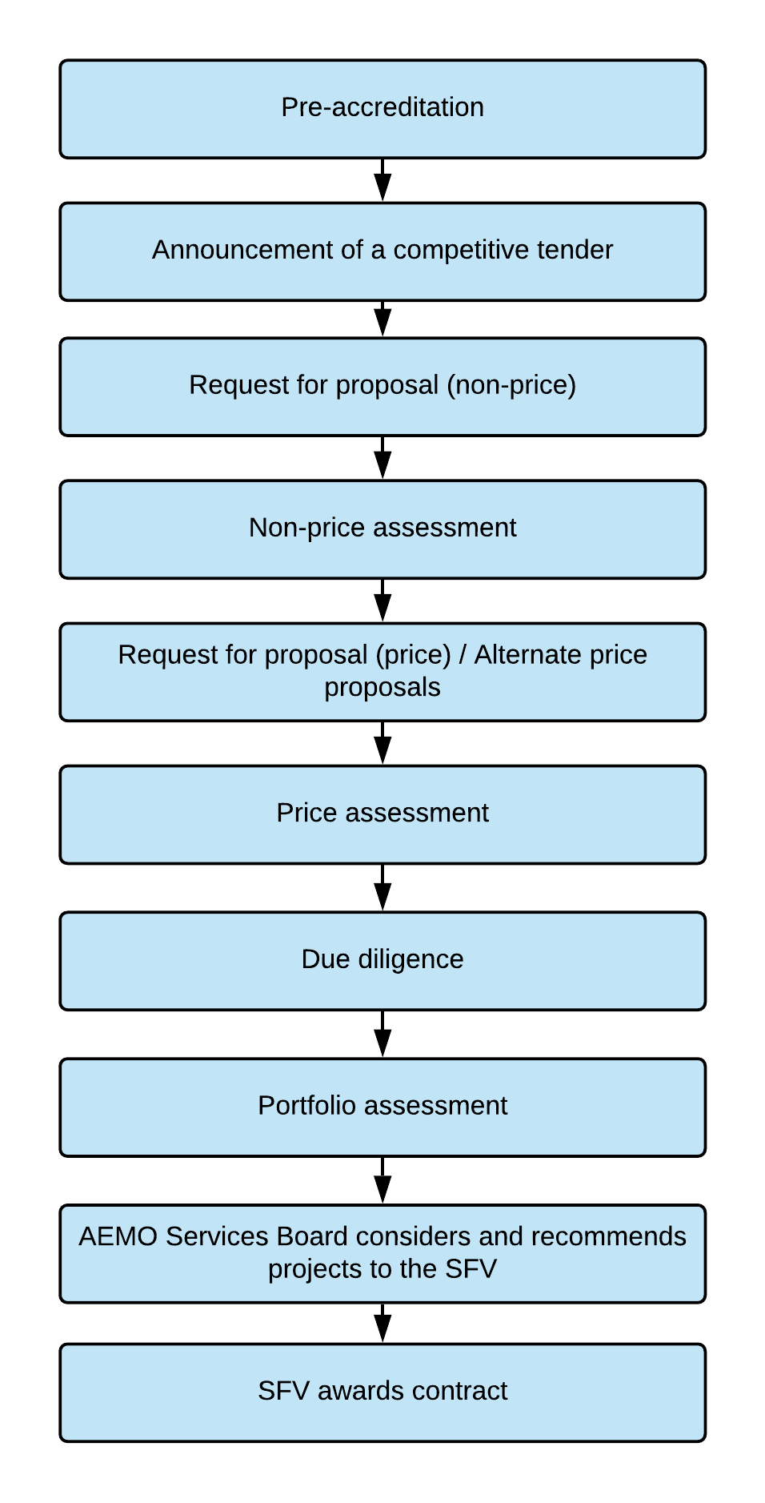
Pre-accreditation
Pre-accreditation allows participants to provide information that supports the assessment of their eligibility. Once proponents become ‘pre-accredited’ they are not required to re-submit this information across multiple competitive tender rounds, saving time and effort.
Information on how you can become pre-accredited will be released on AEMO Services’ website prior to Tender 1.

Announcing a competitive tender
As outlined in the IIO Report, AEMO Services will notify the market of all tenders no later than:
- four weeks before the publication of a request for proposals; and
- eight weeks before the closing of proposals.

Request for proposal (non-price)
Once a request for proposals is announced, the following documents will be made available on the AEMO Services website:
- Tender Rules – includes rules governing the conduct of all tenders, including selection criteria which will be updated from time to time. These will be gazetted in the NSW Government Gazette.
- Tender Guidelines – guidelines outlining detailed instructions and supporting information for proponents to submit a compliant proposal. These will be updated and published prior to each tender round.
- Tender process deed – a legal agreement, setting out the terms under which proposed projects and proponents can take part in the competitive tender round.
- Returnable schedules – documents and/or online forms that proponents are required to complete to participate in the tender.

Non-price proposals will be sought through the AEMO Services website. These will be assessed and shortlisted, with proponents notified before moving to the next stages of price proposals and assessment.

For non-price proposals to advance to the next stage, they must include sufficient information to allow AEMO Services to undertake an assessment of the proposed project against the non-price selection criteria outlined in Table 5 below.

Non-price assessment
Non-price assessment is conducted for all submitted proposals and includes:
- an eligibility criteria assessment of both proponent and project; and
- a merit criteria assessment to determine which projects are shortlisted to progress to the price proposal and assessment stage.

AEMO Services will assess and determine which proposals will be shortlisted to progress to the price proposal stage.

Request for proposal (price)
Shortlisted proponents will be invited to move to the next stage and submit a price proposal.

It is important that proponents understand that price proposals must include contractual offers capable of acceptance and include all the information specified in tender guidelines. If all the specified information is not provided in the format required, AEMO Services may seek supplementary information or clarification from proponents; or it may assess the proposal as unsuccessful.

Price assessment
AEMO Services will conduct price assessments on all submitted price proposals. The assessment process includes a merit criteria assessment to determine which projects will be shortlisted for due-diligence and portfolio assessment.

Project proposals that are not located within the geographic bounds of a declared REZ must demonstrate ‘outstanding merit’. The ‘outstanding merit’ test is applied at the price assessment stage. Financial value is the primary consideration for AEMO Services when recommending LTESAs and will therefore be its primary consideration when shortlisting project proposals for due-diligence and portfolio assessment (EII Act s 48(2)).

A final shortlist of proposals is developed ahead of the portfolio assessment stage, based on overall merit and the tender volume guidance detailed in the IIO Report and Tender Guidelines for each tender.

Portfolio assessment
Portfolio assessment examines the cumulative impacts of a shortlisted set of proposals. It is conducted after the individual assessment of proposals and is designed to mitigate any aggregated adverse effects that arise from the shortlisted proposals.

To maintain transparency in the portfolio assessment process, Table 2 (below) outlines how the portfolio-level adverse outcomes will be considered in this step.

Table 2: How issues identified in the portfolio assessment stage are addressed
Issue | Where this may impact a shortlisted project | How this is considered in the portfolio assessment step
1. Adverse network effects | Where multiple shortlisted projects are in a similar geographic location. | Generation limits may be imposed at specific locations to avoid adverse network impacts because of the tender. These limits will be developed and applied by the Consumer Trustee at the portfolio assessment step, based on the proposals shortlisted.
2. Adverse community effects | Where multiple shortlisted projects without planning approval are in a similar geographic location. | This condition is applied to avoid cumulative impacts from multiple projects which have the potential to significantly affect community support.
3. Supplier concentration risk | Where multiple shortlisted projects are proposing to use the same contractors or original equipment manufacturers. | This will initially be assessed at the project level under Merit Criteria 4 – capacity to deliver.  At the portfolio assessment step, more information may be sought by the Consumer Trustee to address any aggregate supplier capacity effects. The Consumer Trustee would reserve the right to not recommend lower ranked proposals.
4. Counterparty concentration risk | Where several shortlisted projects are proposed by the same proponent, creating a material counterparty risk as determined by the Consumer Trustee. | A limitation on the number of proposals a proponent can put forward in each round will be detailed in the Tender Guidelines.  In addition, the portfolio assessment step may consider aggregated risks associated with multiple contracts with a single counterparty including related entities.
5. Total Financial Value | Where overly concurrent generation across the shortlisted and existing contracted projects decreases financial value to consumers, as determined by the Consumer Trustee. | The assessment of financial value will also consider the collective value of proposals. This collective financial assessment will be applied at the portfolio assessment step.
6. Other adverse effects | Where a shortlisted project has a material detrimental effect to a higher ranked project, as determined by the Consumer Trustee. | The Consumer Trustee will retain discretion to rule out projects where they have material adverse impacts on other, higher scored shortlisted projects.

Recommendation to Scheme Financial Vehicle
Following the portfolio assessment, the AEMO Services Board will consider and recommend final selection of proposals to the Scheme Financial Vehicle.

It is important to note that AEMO Services has the discretion to deviate from the tender volume guidance in the IIO Report and Tender Guidelines, if doing so is in the best long-term financial interests of NSW electricity consumers. This may result in more, or less volume contracted in any given tender.

Scheme Financial Vehicle Awards LTESA
The Scheme Financial Vehicle is the counterparty to LTESAs, risk management agreements and responsible for all payment obligations. It can hold property rights, enter commercial contracts, receive and make payments and enforce obligations. All of the Scheme Financial Vehicle’s shares are held on trust by the Financial Trustee.

In accordance with the EII Act, the Scheme Financial Vehicle will establish and maintain the Electricity Infrastructure Fund to manage the cash inflows and outflows. It will have a statutory right to receive contributions from distribution network service providers. While the Scheme Financial Vehicle will not have recourse to the State’s funds or balance sheet, it is expected to have a sovereign, or near sovereign, credit rating due to its ability to collect contributions from the distribution network service providers.
Figure 1: LTESA contract structure and cash flows
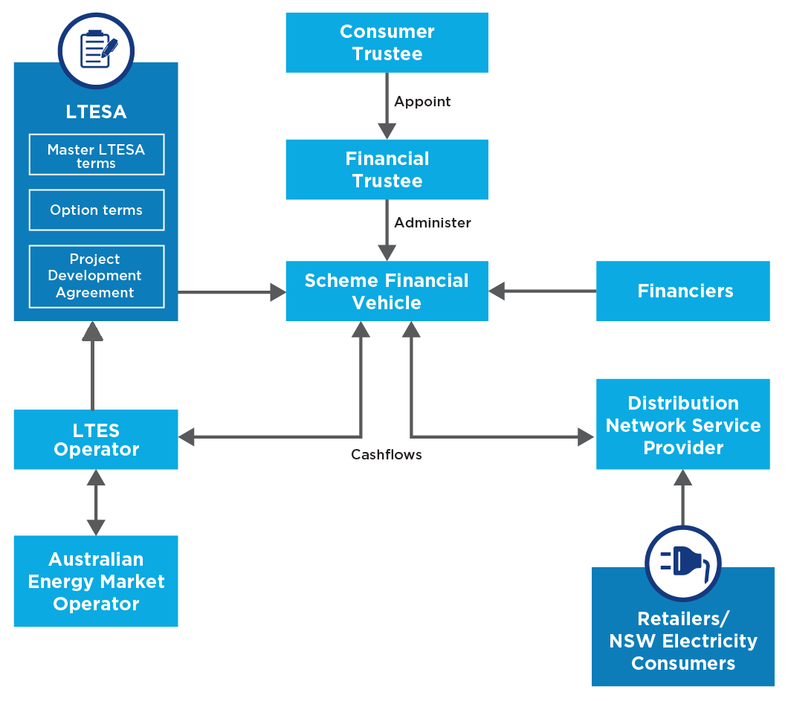

Proposed Eligibility and Merit Criteria-
Proponents and their projects must satisfy both the eligibility criteria and the merit criteria for generation and LDS LTESAs.

Eligibility criteria
The eligibility criteria for proposals consist of two sets of requirements. One set for the proposed project elements and the other for the proponents themselves.

The tables below outline the separate criteria that must be met.
Table 3: Proposed project eligibility criteria
Item | Criteria | Gen. | LDS | Firming
EC1 | Project must involve generation from a renewable energy source. | ✓
EC2 | Project must have a generation capacity of not less than 30 megawatts and must not have previously been awarded an LTESA. | ✓
EC3 | Project consists of storage units that can be dispatched for at least eight hours at its registered capacity. |  | ✓
EC4 | The project is registered or must state in its application that it intends to register, with AEMO as scheduled or semi-scheduled (generation) in the NSW region of the NEM. | ✓ | ✓ | ✓
EC5 | Project is not identified as committed or existing in a generation information page published by AEMO on or before 14 November 2019. | ✓ | ✓ | ✓
EC6 | Project must have received a Secretary’s Environmental Assessment Requirements (SEARs) approval in relation to the project. | ✓ | ✓ | ✓
EC7 | Projects must be in receipt of a connection agreement or connection enquiry or be intending to rely on an access right for connection. | ✓ | ✓ | ✓
EC8 | Project must provide a binding community participation plan as part of its submission. | ✓ | ✓ | ✓
EC9 | The project is not in receipt of financial support in the form of project/revenue underwriting from prescribed programs.  Note: projects in receipt of financial support for pre-investment activities are eligible. Prescribed Programs will be updated by the Consumer Trustee in the Tender Guidelines. | ✓ | ✓ | ✓
EC10 | The project must not be subject to an order prohibiting connection to network infrastructure made under s29 of the EII Act. | ✓ | ✓ | ✓
EC11 | The project must provide a binding Industry and Aboriginal participation plan. | ✓ | ✓ | ✓
EC12 | The proponent must have all necessary rights to use any intellectual property required to carry out the project. | ✓ | ✓ | ✓

Table 4: Proponent eligibility criteria
Item | Criteria
EC13 | The proponent must hold an Australian Business Number (ABN) and must be:  - an Australian entity duly incorporated under the Corporations Act 2001 (Cth and hold and comply with all necessary authorisations that are material to the conduct of the business of the Applicant, or  - a Commonwealth entity under section10 of the Public Governance, Performance and Accountability Act 2013 (Cth), or  - an Australian local government or council.  Note: In some limited circumstances, a legal entity other than those listed above may be accepted as an eligible proponent. Any other entity that wants to participate must seek approval with the Consumer Trustee prior to submitting a response, per the contact listed on the Consumer Trustee website.
EC14 | The proponent must not be named as an organisation on the list of persons and entities on the Australian Department of Foreign Affairs and Trade sanctions list.
EC15 | The proponent must propose one contracted entity to be legally responsible for the proponent’s Response and LTESA.
EC16 | The proponent and/or the contracted entity must not be, or become, bankrupt, insolvent, or be in, or enter into, administration, receivership or liquidation, or take advantage of any statute for the relief of insolvent debtors at any time during the competitive tender.
EC17 | The proponent and/or the contracted entity must not have had a judicial decision relating to employee entitlements made against it (not including decisions under appeal) and not have paid the claim.
EC18 | The proponent and/or the contracted entity must not have been named as an organisation that has not complied with the Workplace Gender Equality Act 2012 (Cth).
EC19 | The proponent must materially comply with:  - obligations under employment contracts, industrial agreements, and awards  - codes of conduct and practice relevant to conditions of service and to the relations between the proponent and the employees employed by the proponent, and applicable Workplace Health and Safety legislation.
EC20 | The proponent must hold all insurances required by law.
EC21 | The proponent has not, within the previous 10 years, been subject to an inquiry by the NSW Independent Commission Against Corruption (or an equivalent body in a jurisdiction in Australia) where a finding has been made against the proponent, or the opinion has been reached that that the proponent has engaged in corrupt conduct.
EC22 | The proponent has registered a Modern Slavery statement with the Australian Border Force.

Merit criteria
Proponents must demonstrate the merit of their proposed project by submitting evidence that satisfies the merit criteria.

The tables below outline the non-price criteria that must be met.
Table 5: Merit criteria (MC) – non price
# | Criteria | Description
MC3 | Impact on the electricity system | Impact of the project on the operation of the NSW electricity system, including material adverse effects on other generation plant connected or expecting to connect prior to the project, or impact on a planned REZs.
MC4 | Pathway to commercial operation | - Credibility of pathway to:  - secure debt and equity funding  - reach key development approvals  - obtain market registration, a connection agreement from the relevant network service provider and meet the relevant Generator Performance Standards  - secure key project construction and operations contracts
MC5 | Organisational capacity to deliver project and other characteristics | - Capacity of the company and key people to:  - Deliver the project, engage constructively with the Government, coordinating bodies and the relevant communities and operate the project in accordance with industry best practice.  - Capability and capacity of suppliers and contractors to meet timeframes.  - Credit worthiness of the organisations delivering the project, including financiers.
MC6 | Land use considerations | Evidence of consideration of potential land use and environmental constraints and opportunities in the site selection process that is generally consistent with applicable NSW Government guidelines, including the Large-scale solar energy guideline, Wind Energy Guideline, and relevant documents in the Rapid Assessment Framework.
MC7 | Community engagement and shared benefits | - Evidence of meaningful efforts to engage with local communities and stakeholders to foster local community support that is generally consistent with applicable guidelines in the NSW Rapid Assessment Framework, including Undertaking Engagement Guidelines for State Significant Projects and the Social Impact Assessment Guideline.  - Initiatives to share the financial benefits of the project with local communities.
MC8 | Regional economic development | Demonstration and/or commitments to:  - Local supply chain inputs  - Supporting investment, local innovation, and commercialisation opportunities in NSW  - Maximising local employment, skills development, and knowledge transfer  - First Nations focused skills development opportunities and economic participation working with First Nations people  - Ensuring fair and ethical practice in the workforce and supply chain  - Promoting environmentally sustainable procurement throughout the supply chain.

Table 6: Merit criteria – price
# | Criteria | Description
MC1 | Financial value | Financial cost measured by the:  - projected impact of the LTESA payments on the costs and liabilities of the Scheme Financial Vehicle, considering the LTESA bid terms  - impact of REZ access fee contributions. See details on REZ access fees.  - cost of network infrastructure, including REZ network infrastructure projects, required to support the project; and costs of other services associated with power system security  - financial benefit to consumers in the form of reduced wholesale market prices.
MC2 | Commercial Terms | Materiality of departures from default contractual terms.

Proposed Bid bonds
Competitive tenders require proponents to make significant contractual commitments and AEMO Services will require these commitments to be collateralised by financial bonding. The objective of this is to ensure the integrity of the tender process.

The bonding is expected to be sized to protect against the AEMO Services, Energy Corporation of NSW (EnergyCo NSW) and the Scheme Financial Vehicle’s losses should a project not meet a legal commitment under a binding tender bid, LTESA or REZ access right. The sizing of the bonding will reflect the commitments of the parties and the characteristics of the rights granted.

The key project commitments are expected to be based on the following milestones:

Price proposal stage – bonding to be provided at the price proposal stage to ensure a project achieves contract close.

Development and construction period - bonding to be provided at signing of the LTESA and/or REZ access right for a dual purpose to secure against reaching financial close and commercial operation date.

Operating period – bonding to be provided at the exercise of each option.

Next steps
AEMO Services will host an online interactive session on 7 February 2022 to discuss and seek feedback on the topics in this discussion guide.

Please use this link to register for the online session. Webinar registration
For further information on subjects relating to the competitive tender process please contact stakeholderengagement@aemoservices.com.au

2021 Infrastructure Investment Objectives Report
2021 Infrastructure Investment Objectives Report
Electricity Infrastructure Investment Act 2020
For example: if significant amounts of coincident generation were shortlisted for a given area in a tender, the Consumer Trustee may establish a geographical limit based on technical advice. This constraint would then limit the amount of new generation capacity in the area.
Or where a project is proposed by a party that has several awarded LTESAs.
as defined by s43.1(a) of the EII Act. We note this definition will be elaborated upon in the Tender Rules, which may specify technologies as eligible or ineligible.
For projects that use multiple sites, each site must be a minimum of 30MW. Projects can aggregate multiple generating units to be a single generating unit above 30 MW to meet this criterion however, aggregation approval is required from AEMO in accordance with NER clause 3.8.3.
This requirement may be removed for demand-response projects.
This requirement may be removed for demand-response projects.
The intent of this criterion is to exclude projects that have already received a form of ongoing revenue support similar in nature to an LTESA. Prescribed programs will be detailed and updated in the Tender Guidelines.
In accordance with the Aboriginal Procurement Policy January 2021 (nsw.gov.au)

