B2B Working Group Notes
MEETING: | B2B Working Group
DATE: | Monday 22 August 2016
 | Tuesday 23 August 2016
LOCATION: | AEMO Office Melbourne
Attendees:
Attendees | Company | Location
Andrew Suwignjo | AEMO | Melbourne
Chris Cormack | AEMO | Melbourne
Paul LeFavi | AEMO | Melbourne
Karly Train | Energy Australia | Melbourne
Aakash Sembey | Momentum Energy | Melbourne
Brett McLean | United Energy | Melbourne
Charles Coulson | Metropolis Metering | Melbourne
Darren Bailey | Origin Energy | Melbourne
David Sales | Tasnetworks | Melbourne
Paul Greenwood | Vector AMS | Melbourne
Mara Tenis | Lumo/ Red Energy | Melbourne
Mark Riley | AGL | Melbourne
Shaun Cupitt | Acumen Metering | Melbourne
Anna Russo | Endeavour Energy | Melbourne
David Woods | SA Power Networks | Melbourne
1. Welcome and introductions
- Chris Cormack (AEMO) welcomed B2B WG participants and summarised the focus for Monday’s workshop is New Connections and Adds and Alts. On Tuesday consider Physical De-Energisation - Re-Energisation, Customer and Site Details Notification, Notice of Works and Meter Replacement, time permitting.
2. Workshop recap
- Chris briefly recapped the previous workshop and the basic Communication model for Procedure development based on Remote Re-energisation worked example.
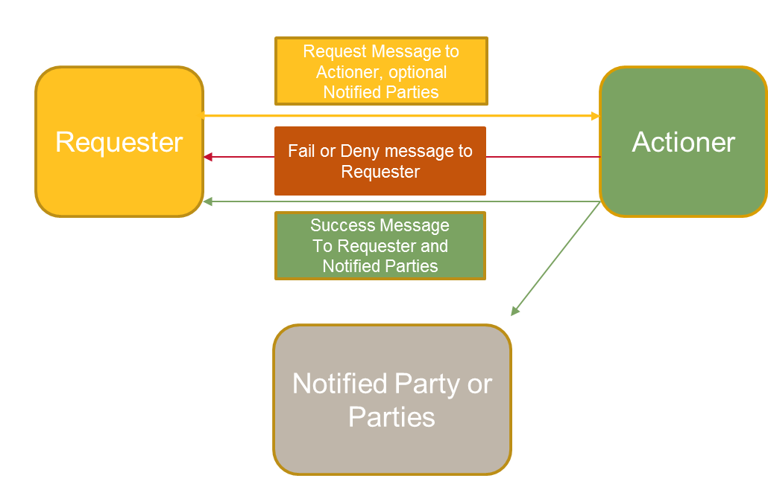

- Process for development of Transactions/Procedures:
  - Collect a description of the transaction and its typical or common use.
  - Build Communications model based on common usage of transaction.
  - Using Communications model to create as many possible scenarios in which the Communication can be used
  - If scenario does not fit into communications model then adapt the model
  - Define the content of the Requesting Message, Success Message and Fail/Deny message – mark fields or data inputs as optional or mandatory
  - Define any timing requirements
  - Define any drafting requirements – merge with other transactions or procedures where possible
  - Add notes on each transaction where use of the transaction is governed by:
    - the Rules (NER),
    - other legal requirements (incl. jurisdictional requirements, NERR, NECF, Safety regulations etc.),
    - other procedures.
  - Reference each of the NER or legal requirements in work notes.
  - Business Rules that do not specifically reference legal or other procedural requirements may need to be collected in a separate document.
3. New Connections Review
- Workshop opened with New Connections and Adds and Alts B2B communications, with the aim of capturing message contents and any legal or jurisdictional issues associated with the use of these Service Orders.
- Issue of Safety checks for Meter Installations was discussed noting there had been a meeting of state and federal Safety administrators and Energy industry representatives the week before.
  - In each state there are a different set of safety regulations relating to the safety checks required on site. In Victoria, the 5 DNSPs have had legal advice that responsibility for all safety checks relating to site energisation will stay with them unless the ESV changes local safety regulations. In NSW, the Accredited Service Provider (ASP) scheme allows energisation and final safety checks to be performed by appropriately accredited electricians. TasNetworks indicated they will most likely follow the Victorian DNSP position of safety check responsibility.
- The B2BWG recognised that the new connections procedures should allow participants to complete required safety checks and energisation in whichever order meets there regulatory requirements or contractual arrangements.
- There was considerable discussion on the need for LNSPs to continue to perform the pre-Connection Technical assessment. In some cases significant work may need to be performed by the LNSP (at a customer's cost) for a connection to the electricity network to be performed, for example, provide extra cabling, sub-stations, transformers etc. In all jurisdictions this is a function performed by the LNSP via an application process run directly with the LNSP or through an online portal.
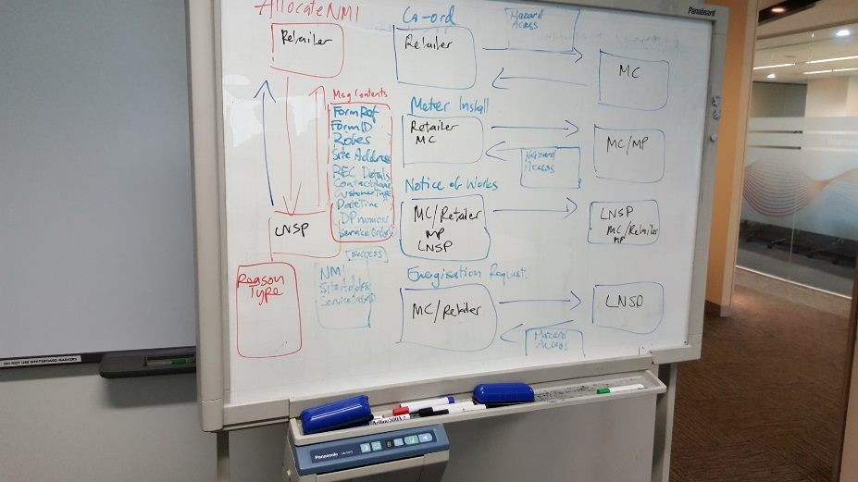
- In discussing the use of the Allocate NMI request in other jurisdictions it proposed this should be sent after Network connection had been granted by the LNSP. However, in NSW the Allocate NMI is required before an electrician/customer/retailer can apply for a Permission to Connect to the network. The B2B Working group in its analysis of the New connections process has put forward the concept the Allocate NMI request would succeed the Permission to Connect step for all jurisdictions. In NSW the NMI is currently a required field in its Permission to Connect form. The suggestion was tabled if the NSW DBs could use a 10 digit number at the point at which the initial Permission to Connect stage and then allocate this same number to a NMI with all roles etc. identified at the time the new service order is received - similar to a Direct Connect or LNSP initiated connection process. Endeavour agreed to take this matter back to the NSW DBs to see if this change is acceptable.
- Retailers will still need to ensure all required paper work has been completed by the customer or customer's electrician for a new connection to proceed.
- The Allocate NMI request to include fields to reference to paper work to be attached. If the LNSP is not satisfied that the required paperwork and grid connection work has been completed it will send a rejection response to the Retailer (using appropriate exception codes) to inform the customer that further work is required.
- In discussing the whether the new connection process could accommodate the NSW process an issue of role change post Allocate NMI transaction was raised. If for some reason the Retailer or FRMP role associated with the NMI needed to be changed this could not be done in MSATs without a meter read. In addition, in the case where a Retailer may need to change the MC or MP role post the Allocate NMI request is completed - i.e. where MC/MP cannot perform the Meter installation. There was some concern that this would not be possible to change MC/MP roles in MSATS. AEMO indicated that roles would still be mandatory on NMI creation, and that roles could be retrospectively changed post Allocate NMI and prior to the New Connection Request. Participants with concerns on role changes in MSATS can review the final determination of package 1 changes in on Wed 31 August
- The issue of Metering Installation Technical Data was raised as this data is currently being collected by the LNSP with respect to New Connections. Metering Providers will now require a set of technical data at the time of meter installation to allow for the efficient installation of meters. For example, this includes items such as No. of Phases, Maximum Demand and Controlled Load, Solar PV etc.
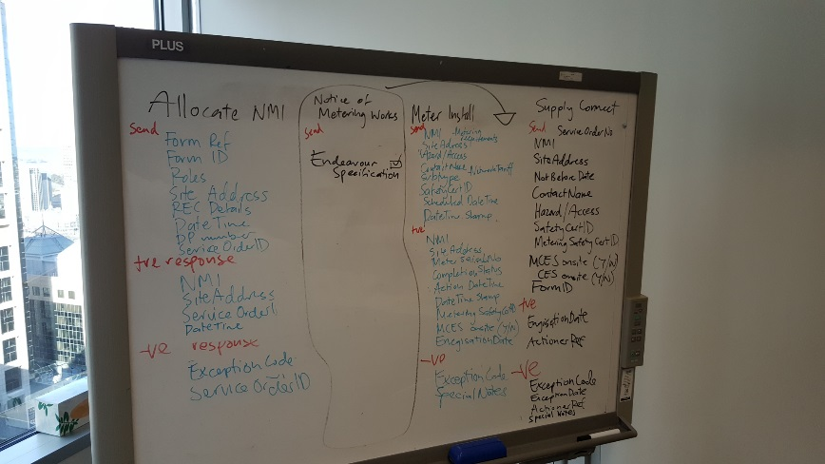
- Technical detail required by the Meter provider from the EWR (VIC), NOSWR (NSW), Form A (SA) or other jurisdictional or LNSP specific document is to be passed on to the Meter Provider as part of any Meter Installation request.
- Question of whether the B2B e-Hub will contain certain functionality was raised - will the new b2B E-Hub have a Web service portal or API/Client to allow participants to access B2B transactional data? AEMO to seek advice and get an answer back to the working group.
- Future work program was raised as an issue. AEMO mentioned that the High and Medium items where the focus of the B2B Working Group over the next 5-6 weeks, with the Low items to be completed in a Phase 2. The working group then went back through all items to reprioritise and ensure no important items captured as ‘Low’ priority would be missed in the first round of changes.
- Adds and Alts, Physical Re-En and De-En (along with Remote Re-En and De-En, Customer site Details Notification, Meter Replacement, Planned Interruption and NMI connection status to be discussed at upcoming Workshops. Miscellaneous was upped to medium priority to also be discussed at further workshops.
- Site Abolishment, Meter Data (MDFF) Notification, Provide Meter Data and Verify Meter Data as well as Remote Meter Read – Scheduled and On-Demand, Remote Meter Re-configuration to be drafted by AEMO for review by the B2BWG at future workshops.
- UED to provide the Victorian DBs proposed specification for Remote NMI enquiry.
- Acumen Metering to provide basic memo template for Pre-Installation query – this was updated as a medium priority.
- One Way Notification for power outages was added to the list of services as a Low priority.
- Extra workshop dates were added to the calendar for B2B working group meetings in order to work through these items. AEMO to send out meeting requests for these dates.
5. Next steps
- AEMO to
- Send out meeting notes for workshops
- Update and send out communications model and message contents for New Connections and Notice Metering of Works.
- Send out a issues register containing items identified during workshop
- Any additional meeting requests for additional workshops

