B2B Working Group Workshop Notes
MEETING: | B2B Working Group
DATE: | Tuesday 16 August 2016
TIME: | 10:00 AM - 3:30 Pm
LOCATION: | AEMO Office Melbourne
Attendees:
Attendees | Company | Location
Andrew Suwignjo | AEMO | Melbourne
Chris Cormack | AEMO | Melbourne
Paul LeFavi | AEMO | Melbourne
Karly Train | Energy Australia | Melbourne
Brett McLean | United Energy | Melbourne
Charles Coulson | Metropolis Metering | Melbourne
Darren Bailey | Origin Energy | Melbourne
David Sales | Tasnetworks | Melbourne
Dean Van Gerrevink | Vector AMS (morning) | Melbourne
Paul Greenwood | Vector AMS | Melbourne
Mara Tenis | Lumo/ Red Energy | Melbourne
Mark Riley | AGL | Melbourne
Shaun Cupitt | Acumen Metering | Melbourne
Dino Ou | Endeavour Energy | Melbourne
David Woods | SA Power Networks | Melbourne
1. Welcome and introductions
- Chris Cormack (AEMO) welcomed participants to B2B WG meeting and noted the following changes. Paul Greenwood (Vector AMS) will be replacing Dean Van Gerrevink (Vector AMS) and Karly Train (Energy Australia) is stepping in for Aakash Semby (Momentum Energy) for the immediate future.
- Anna Russo (Endeavour Energy) was an apology for this meeting, Dino Ou stepping in. Michael Cruse (Active Stream) was an apology.
2. Previous minutes
- Attendees raised comments regarding 3 August meeting minutes. AEMO acknowledged comments received from UED and AGL and briefly walked through changes. AEMO to re-circulate updated change-marked minutes from 3 August meeting.
3. Workshop recap
- Chris briefly recapped work done by the working group at the last meeting to prioritise list of services/transaction sets. Seven high priority, eleven medium priority and fifteen low priority. Refer to B2B procedures priorities XL spreadsheet circulated to the working group 11 August 2016.
- Key objective for this workshop was discussed focusing on following items for each of the identified new services:
- Communication Requirements
- Parties for communication
- Routing or system requirements for the new B2B eHub
- Back-up to communication
- B2B communication process maps
- Timing requirements
- Allow parties to meet other regulatory requirements
- AEMO to circulate a paper presented to the transitional IEC in relation to technology capabilities for new B2B eHub. The paper is also available on the AEMO website. AEMO to consider arranging a technology presentation to the B2b WG or relevant industry group.
- The working group was presented with an example scenario for remote re-energisation B2B communication per slide 8 of the workshop presentation (refer to image 1 for whiteboard notes).
- After lunch the working group attempted to model the B2B communication scenario for a New Connections (refer to image 2).
- The group work-shopped themes like who needs to receive the b2b communication and why?, when is communication required by (timing to and from)?, what information is required in this communication?, etc.
- Discussion topic included Message Content (NMI, Address, other identifying data ie customer reference number, etc), the Actioning Party – usually MC or MP, Notifying Parties – DNSP, MC, MP, MDP or Retailer (if 3rd party initiated for example), a Date/Time stamp, a Free text or Message Field and Response (ie, Successful Re-energisation (Y/N)).
Image 1 Remote re-energisation scenario
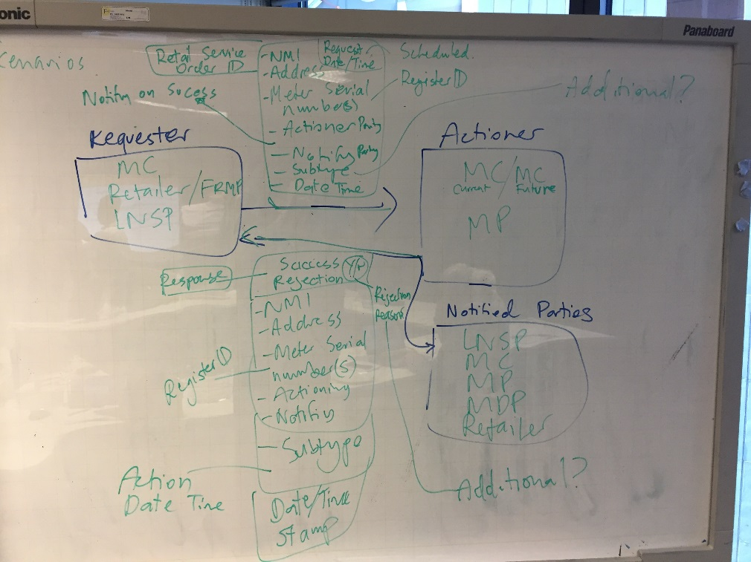

Image 2 New connection scenario
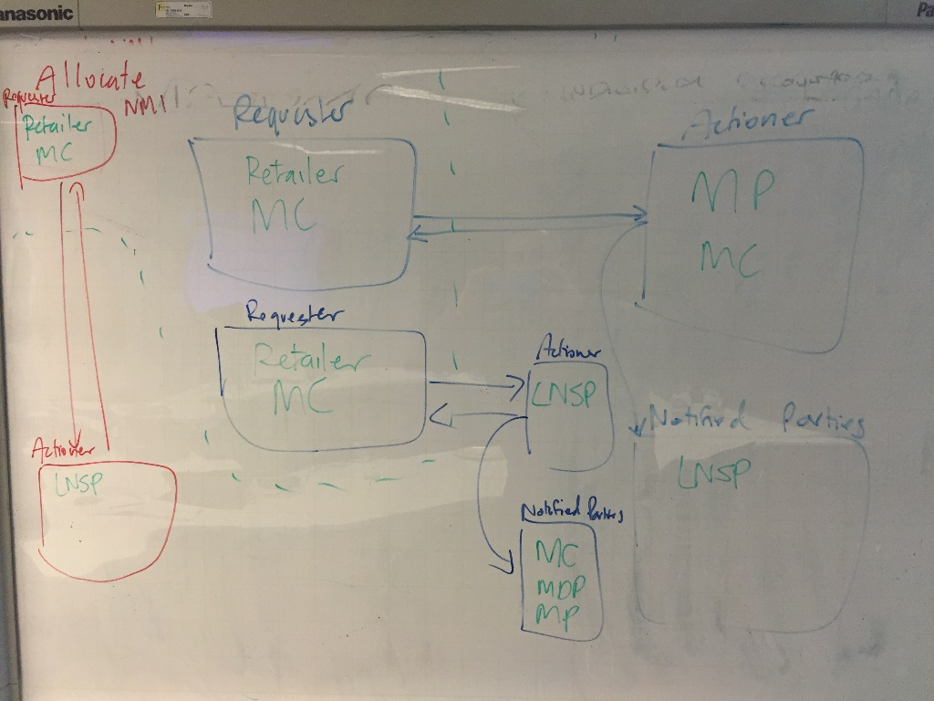

- The working group also discussed the general approach moving forward to identify requirements for B2B communication:
- Review current B2B material to see what is useful moving forward
- Identify B2B communication scenarios impacted by POC changes
- Build communication model
- Outline message definition.
5. Next steps
- AEMO to
- re-send amended (marked-up) minutes for 3 August meeting
- send workshop notes for Re-energisation and New Connections processes
- send paper submitted to IEC in relation to Technology Solution for SMP
- consider arranging a Technology presentation to B2BWG or relevant industry group
- update B2BWG workshop schedule
- Organise 2 further workshop meetings in week of 29 August.

