Schema Release
AseXML Schema Working Group
(ASWG)

Release R34

Draft Release Date: 15/01/2015

Final Release Date: 13/02/2015

Document History
Version | Date | Authors | Comments
0.1 | 31/1/15 | Andrew Screen | Initial draft based upon review of version 1.5
0.2 | 10/2/15 | Andrew Screen | Draft based upon review of version 1.7
0.3 | 13/2/15 | Andrew Screen | Final Draft based upon r34 1v7_1 schema
 |  |  | Updated to reflect ASWG endorsement and Final Approval

Contents

Document History 2
Contents 3
1. Introduction 4
2. Change Requests 4
3. Impact Summary 5
3.1. Modified Types 5
3.2. New Types 7
3.3. Tracability 9
4. File Changes 10
4.1. aseXML 10
4.2. Summary of Changes 11
4.3. Schema change description 15
4.3.1 asexml_r34.xsd 15
4.3.2 Gas_r34.xsd 15
New Enumerations 15
Additional Simple types: 16
Complex Type Modifications 19
New Base Types 26
New Complex Types 28
4.3.3 Enumerations.xsd 37
4.3.4 Events_r34.xsd 38
4.3.5 Common_r34.xsd 38
4.3.6 Reports_r34.xsd 39
New Simple types: 39
New complex types 40
4.3.7 Header_r34.xsd 48
Additional Enumerations 48
4.3.8 NetworkBilling _r34.xsd 49
4.3.9 CustomerDetails_r34.xsd 50
New Complex Type 50
4.3.10 GasMarketWholesale_r34.xsd 51
New Simple Types 51
New Complex types: 53
5. Schema Manifest 58
6. Schema Test 59
6.1. Test Platforms 59
6.2. Test 59
6.2.1 Test Platforms 59
6.2.2 Test Cases 59
6.2.3 Test Process 59
6.2.4 Test Results 60
6.2.5 Character Classification 60
7. ASWG Endorsement 60
8. AEMO Approval 61

Introduction
Version r33 of the aseXML schema has been used as the baseline schema for this change. This schema release is presented to aseXML Subscribers and Industry Participants for review and to AEMO for approval, in accordance with the ASWG Terms of Reference.

Change Requests
The following ASWG Change Requests have been included in the release of this version of the enumerations file:

CR# | Description
57 (version 6) | This Change Proposal deals with modifications required for the implementation of NSWGas changes as part of the NSW / ACT Retail Gas Harmonisation (NARGH) Project. The changes reflect the requirements specified in PBP5 which identified the differences specific to NSW / ACT compared to Vic. One of the Major differences is that for NSW NMI can have multiple meters associated with them which requires a different NMI Standing Data construct to be used.  Note  The PBP5 version used for the analysis was: Participant_Build_Pack_5_-_NSW-ACT_v_1_2_draft_for_IIR(no_markup) new feedback.docx. This was the latest official version at time of testing.  Only some minor issues (i.e. MeterInletPressure was still being refereneced instead of KPAValue) were picked up throughout the review and these items have been feed back into the schema and the Buildpack will be updated to reflect the changes  At the time of testing the revised CR 57 (version 7) had not been issues, but it is not expected that the new version of the CR will generate any unexpected changes as the changes have been reflected into the schema ahead of the CR.

This Change Request is available from the ASWG workgroup site at the following location

https://link.aemo.com.au/aswg/Shared%20Documents/aseXML%20Schemas/Schema%20Change%20Requests/Drafts/aseXML_Schema_Change_Request_57_v1.7.2.zip

for review by all impacted parties. Note to access via the ASWG website requires access to AEMO Link site. A copy of the CR is embedded here:

Impact Summary

Modified Types

This table identifies the files, transactions and versioned types that are changed in this schema, where:

- Modified types - is a full list of types changed in this schema
- Derived types – is a list of any types that are derived from a modified type, and are therefore also modified by default
- Versioned types affected – is a list of all versioned types that will need to have the version attribute updated to use this schema
- Transactions potentially affected – is a list of all transactions that contain a modified type, either directly or via a type sustitution
- Schema files affected – is a list of schema files that have been changed in some way for this schema.

Modified types | Derived types | Versioned types affected | Transactions potentially affected | Schema files affected
GasMeterFixCertification | GasMeterFix ->  MeterFix ->  GasServiceDetails  (not the MeterFix as part of GasMeterNotification) | GasServiceOrderDetails | ServiceOrderRequest | Gas_r34.xsd
GasMeterNotification |  | GasMeterNotification | GasMeterNotification | Gas_r34.xsd
GasServiceOrderDetails |  | GasServiceOrderDetails | ServiceOrderRequest  SpecialReadRequest | Gas_r34.xsd
ServiceOrderGasMeterData |  | GasServiceOrderNotificationData | ServiceOrderResponse | Gas_r34.xsd
ServiceOrderGasCompletionData |  | GasServiceOrderNotificationData | ServiceOrderResponse | Gas_r34.xsd
GasMasterStandingData (due to networkID and possibility of being used in backwards compatible mode. Originally it was only expected to be forwards compatable!) |  | GasStandingData | MeterReadInputNotification  NMIStandingDataUpdateNotification  AccountCreationNotification  AmendMeterRouteDetails  CATSChangeRequest  CATSDataRequest  CATSNotification  NMIDiscoveryResponse  NMIStandingDataResponse  ServiceOrderResponse | Gas_r34.xsd
NetworkDUoSBillingNotification |  | NetworkDUoSBillingNotification | NetworkDUoSBillingNotification | NetworkBilling_r34.xsd
NetworkID |  | GasStandingData | AccountCreationNotification  AmendMeterRouteDetails  CATSChangeRequest  CATSDataRequest  CATSNotificatio  MeterReadInputNotification  NMIDiscoveryResponse  NMIStandingDataRequest  NMIStandingDataResponse  NMIStandingDataUpdateNotification  ServiceOrderRequest  ServiceOrderResponse | Common_r34.xsd
Transaction |  |  | All Transactions | Transaction_r34.xsd

New Types

This table identifies the files, transactions and versioned types that are impacted in this schema based upon the sample files in use. Due to the way types are inherited in the schema a exhustive listing is difficult to create as not all variations are possible to determine. The intention is to show where the impact of the the new type will be. This is primarily based upon their appearance in the sample files.

- New types - New Complex types in this schema
- Versioned types affected – is a list of all versioned types will use or inherit the new type
- Transactions potentially affected – is a list of all transactions that may use the new type, either directly or via a type sustitution
- Schema files affected – is a list of schema files that have been changed in some way for this schema.

New types | Types / Versioned types affected | Transactions potentially affected
ServiceOrderMultiMeterData | GasServiceOrderNotificationData | ServiceOrderResponse
GasMultiMeterReadDataType  HWMultiMeterReadDataType  (both extended from BaseMultiMeterReadDataType) | GasMultiMeterStandingData  GasServiceOrderDetails  GasServiceOrderNotificationData | ServiceOrderResponse  AccountCreationData  NMIDiscoveryResponse  NMIStandingDataResponse  ServiceOrderRequest  MeterReadInputNotification
GasMultiMeterStandingData  (versioned element!) | MIRNStatusUpdate  GasMultiMeterStandingData  GasMeterNotification  MeterReadInputNotification  CATSNotification  CATSDataRequest  CATSChangeRequest  AccountCreationNotification  NMIStandingDataResponse  NMIDiscoveryResponse | GasMeterNotification  ServiceOrderRequest  GasMeterNotification  MeterReadInputNotification  CATSNotification  CATSDataRequest  CATSChangeRequest  AccountCreationNotification  NMIStandingDataResponse  NMIDiscoveryResponse
GasMultiMeterMasterStandingDataType | GasMultiMeterStandingData | See GasMultiMeterStandingData  Specifically ServiceOrderRequest
GasMultiMeterStandingDataType  See (GasMultiMeterMasterStandingData) | ServiceOrderMultiMeterData  MultiMeterSiteAccessDetails | NMIDiscoveryResponse  ServiceOrderRequest  MeterReadInputNotification
GasBasicMultiMeterStandingData | GasMultiMeterStandingDataType | AmendMeterRouteDetails
GasMultiMeterStandingDataUpdate |  | NMIStandingDataUpdateNotification
GasMeterVerifyRequestWithMSNData |  | MeterDataVerifyRequest
GasMeterVerifyResponseWithMSNData |  | MeterDataVerifyResponse
For MarketReports (XML)  - TotalGasInjectedNotification  - LinepackAndUnaccountedForGasNotification  - ParticipantCLPandUAGNotification  - MatchedAllocationsDataNotification  - DailyImbalanceNotification  - ImbalanceTradeRequest  - ParticipantImbalanceAmountRequest |  | New Transactions for Wholesale (ERFT & IAIT):  - MarketReports (XML)  - ParticipantImbalanceAmountRequest  - ImbalanceTradeRequest  - TotalGasInjectedNotification  - LinepackAndUnaccountedForGasNotification  - ParticipantCLPandUAGNotification"  - MatchedAllocationsDataNotification  - DailyImbalanceNotification
MarketReports (CSV)  - MRBlockParameterType  - MRMissingBlockParameters  - MarketReport  - MatchedImbalanceTradeRpt  - ExpiredImbalanceTradeRpt  - ParticipantImbalanceAmountRpt  - RevisedImbalanceRpt  - EstimationResultsDataType |  | MarketReports  - (ERFT & IAIT ) Reports  - IntXXX reports  - Other (complete mirn listing etc)

Tracability
Find attached a spreadsheet that traces the changes in Schema back to the CR and PBP5 that has been developed for the NSW/ ACT Retail Harmonisation Project.

File Changes
The following file changes are implemented to create the r34 schema version

aseXML
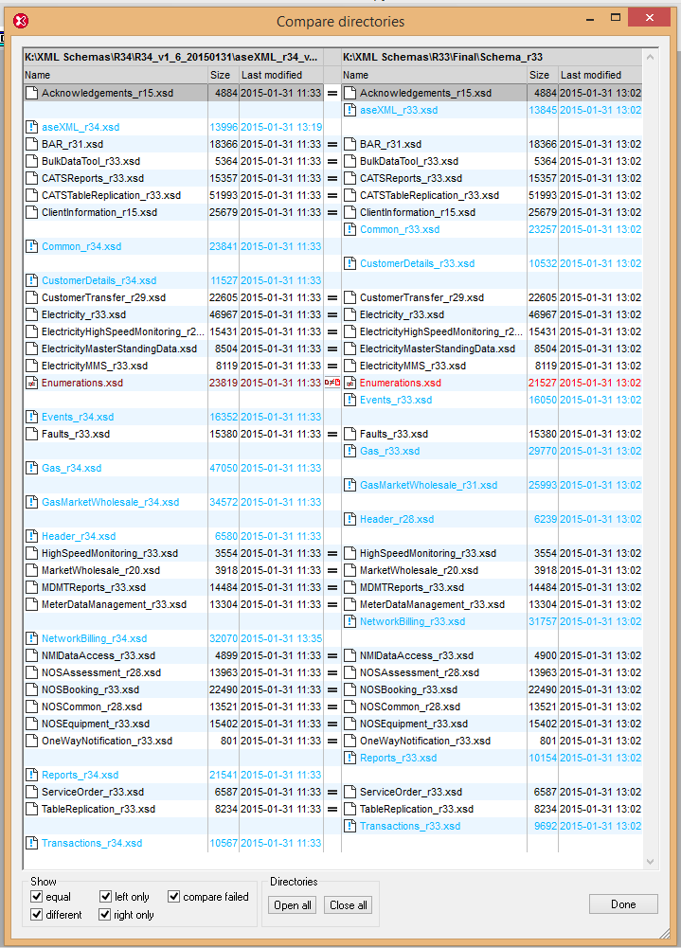

Summary of Changes

Chg # | Item # | Description of change | Filename
 | 1 | Updated schema namespace to urn:aseXML:r34 for xmlns, TargetNamespace , version and schema location.  File version changed from r33 to r34. | asexml_r34xsd
 | 2 | Updated following file to r34 in the aseXML_r34.  - Events  - Common  - CustomerDetails  - Gas  - GasMarketWholesale  - Header  - NetworkBilling  - Reports  - Transactions  Note: as enumerations file is not versioned it doesn’t appear here.
 | 3 | Addition of Network ID which is used in reports | Common_r34.xsd
 | 4 | Additional IndexInvestigationCodes:  - Cross Meter CR57  - MDL Out of Alignment
 | 5 | New Complex Type MultiMeterSiteAccessDetails extended with base NMIStandingData. Also element Meter based on GasMultiMeterStandingDataType | CustomerDetails_r34.xsd
 | 6 | New simple type r34 | Event_r34.xsd
 | 7 | New GasJobCompletionCode3 enumeration “99”  New GasMeterReadFrequency enumeration “Daily”  New MIRNStatus enumeration “Unclaimed”  New JobEnquiryCode enumerations:  - CONI  - DTCO  - ILAT  - MNEX  - MTLO  - RFSO  - STCD  - XMTR  - SREQ  - SUPE | Gas_r34.xsd
 | 8 | Additional Simple types:  KPAValueType  MeterInstallationType  MeterMeasurementUnitType  BillingMethodType  DistanceType  MeterMultiplierType  ConsumptionLitresType  ConsumptionFactorType  CommonFactorType  MeterType  GasConnectionType  SupplyPointID  NetworkTariffCodeType  GasInstallationType  StartWorkNoticeNumber
 | 11 | Complex Type Modifications  - GasMeterFixCertification  Addition of PlumberContactDetail  Addition of StartWorkNoticeNumber to simple meter  - GasServiceOrderDetails  Addition of QuoteReference & ConnectionType  - GasServiceOrderNotificationData  update version from r13 to r34  - ServiceOrderGasMeterData  Change to add complex content & extend from base BaseServiceOrderGasMeterData)  - ServiceOrderGasCompletionData  extend MeterData with BaseServiceOrderGasMeterData.  - GasMasterStandingData  change to NetworkID type definition.  - GasMeterNotification  Change Meter Fix to inherit from NMIStandingData rather than GasStandingData to allow for multimeter standingdata selection. Update version from r9 to r34  - GasStandingData.  Update version to R34 to accommodate change to NetworkID type
 | 12 | New Base Types:  - BaseServiceOrderGasMeterData  - BaseMultiMeterReadDataType (With corresponding elements. i.e. AdjustmentReasonCode, ConsumedEnergy etc
 | 13 | New Complex Types  - ServiceOrderMultiMeterData (extend from base BaseServiceOrderGasMeterData  - GasMultiMeterReadDataType (extend from BaseMultiMeterReadDataType)  - HWMultiMeterReadDataType (extend from BaseMultiMeterReadDataType)  - GasMultiMeterMasterStandingDataType (with associated std data elements)  - GasBasicMultiMeterStandingData  - GasMultiMeterStandingDataType  - GasMultiMeterStandingData (versioned element!)  - GasMultiMeterStandingDataUpdate  To allow for StandingData update transaction to work with multimeter standing data  - GasMeterVerifyRequestWithMSNData  - GasMeterVerifyResponseWithMSNData
 | 14 | New Complex types:  TotalGasInjectedNotification  LinepackAndUnaccountedForGasNotification  ParticipantCLPandUAGNotification  MatchedAllocationsDataNotification  DailyImbalanceNotification  ImbalanceTradeRequest  ParticipantImbalanceAmountRequest  MeterReadingFrequencyType | GasMarketWholesale_r34.xsd
 | 15 | New Simple types  NetworkReceiptPointID  MeterReadingFrequencyTypeBase  ApportionmentPercentage  TradeType  QuantityOfGasMJ  Description
 | 16 | New Transaction Groups enumerations:  ERFT  IAIT  New EnergyMarket enumeration  NSWACTGas | Header_r34.xsd
 | 17 | New selections for NetworkDUoSBillingNotification:  CSVNetworkDUoSDataTariffA  CSVNetworkDUoSDataTariffB  Updated version attribute to r34 from r13 | NetworkBilling_r34.xsd
 | 18 | New Simple Types  ReportType  PipelineID | Reports_r34.xsd
 | 19 | New Complex Types  MRBlockParameterType  MRMissingBlockParameters  MarketReport  EstimationResultsRpt  MatchedImbalanceTradeRpt  ExpiredImbalanceTradeRpt  ParticipantImbalanceAmountRpt  RevisedImbalanceRpt  EstimationResultsDataType
 | 20 | New Transactions  MarketReport  ParticipantImbalanceAmountRequest  ImbalanceTradeRequest  TotalGasInjectedNotification  LinepackAndUnaccountedForGasNotification  ParticipantCLPandUAGNotification"  MatchedAllocationsDataNotification  DailyImbalanceNotification | Transactions_r34.xsd
 | 21 | Change Documentation version to 7.0  Addition of MarketReportNamesType (80 char) with following enumerations  DPRExtractRpt  BasicConsumptionRpt  MeterReadingToUserRpt  MeterReadingToUserNonSTTMRpt  ChangeOfStandingDataRpt  CustomerChurnRpt  EstimationResultsToUserRpt  RevisedEstimationResultsToUserRpt  ReconciliationResultsRpt  ForecastingDataRpt  ApportionmentPercentageRpt  DailyNSLRpt  STTMPipelineAllocationDataRpt  DailyToSTTMRpt  DailyToUserRpt  WeeklyToSTTMRpt  MonthlyToSTTMRpt  PreMonthlyToSTTMRpt  FinMonthlyToSTTMRpt  RevMonthlyToSTTMRpt  MonthlyToUserRpt  TotalGasInjectedRpt  WeeklyToUserRpt  EstimationResultsToNWORpt  RevisedEstimationResultsToNWORpt  MatchedImbalanceTradeRpt  ExpiredImbalanceTradeRpt  ParticipantImbalanceAmountRpt  RevisedImbalanceRpt  T298NewStreetListingRpt  T299CompleteMIRNListingRpt  T900CustomerSiteDetailsMonthlyRpt  T2125AncillaryChargeListingRpt  T2130HeatingValueDailyRpt  T2131PublishedHeatingValueDailyRpt  T2145HaulageRightsRpt  T2270TotalCLPRpt  T2275TotalCLPRpt  T2305EffectiveDegreeDayRpt  T2420QuotationStatusRpt  T2421QuotationSubmissionRpt  T2422QuotationNotificationRpt  T2423QuotationAcceptedRpt  T2424QuotationAvailableRpt | Enumerations.xsd
Table 2-1 Change Log

Schema change description
Description of the changes and normally a diagram showing the elements in context.

asexml_r34.xsd
Normal changes associated with updating the schema to reflect the namespaces and filename changes in the schema.

Normal changes associated with updating the schema to reflect the namespaces and filename changes in the schema.
Updated:
<xsd:schema xmlns="urn:aseXML:r33"
xmlns:xsd="http://www.w3.org/2001/XMLSchema"
xmlns:xsi="http://www.w3.org/2001/XMLSchema-instance"
targetNamespace="urn:aseXML:r33" version="r33"
xsi:schemaLocation="urn:aseXML:r33 aseXML_r33.xsd">
To
<xsd:schema xmlns="urn:aseXML:r34"
xmlns:xsd="http://www.w3.org/2001/XMLSchema"
xmlns:xsi="http://www.w3.org/2001/XMLSchema-instance"
targetNamespace="urn:aseXML:r34" version="r34"
xsi:schemaLocation="urn:aseXML:r34 aseXML_r34.xsd">

Modified include file references for modified files to be:
- Common_r34.xsd
- CustomerDetails_r34.xsd
- Events_r34.xsd
- Gas_r34.xsd
- GasMarketWholesale_r34.xsd

Header_r34.xsd
- NetworkBilling_r34.xsd
- Reports_r34.xsd
- Transactions_r34.xsd

Note: since the Enumerations.xsd file is non versioned it doesn’t appear as a change but it has been modified.

Gas_r34.xsd

New Enumerations

GasJobCompletionCode3 enumeration “99”
<xsd:simpleType name="GasJobCompletionCode3">
<xsd:annotation>
<xsd:documentation>Schema - Gas</xsd:documentation>
</xsd:annotation>
<xsd:restriction base="xsd:string">
<xsd:enumeration value="31"/>
<xsd:enumeration value="33"/>
<xsd:enumeration value="34"/>
<xsd:enumeration value="37"/>
<xsd:enumeration value="42"/>
<xsd:enumeration value="44"/>
<xsd:enumeration value="45"/>
<xsd:enumeration value="47"/>
<xsd:enumeration value="51"/>
<xsd:enumeration value="52"/>
<xsd:enumeration value="53"/>
<xsd:enumeration value="55"/>
<xsd:enumeration value="58"/>
<xsd:enumeration value="59"/>
<xsd:enumeration value="63"/>
<xsd:enumeration value="72"/>
<xsd:enumeration value="99"/>
</xsd:restriction>
</xsd:simpleType>

GasMeterReadFrequency enumeration “Daily”
<xsd:simpleType name="GasMeterReadFrequency">
<xsd:annotation>
<xsd:documentation>Schema - Gas</xsd:documentation>
</xsd:annotation>
<xsd:restriction base="xsd:string">
<xsd:enumeration value="Bi Monthly"/>
<xsd:enumeration value="Monthly"/>
<xsd:enumeration value="Quarterly"/>
<xsd:enumeration value="Daily"/>
</xsd:restriction>
</xsd:simpleType>

MIRNStatus enumeration “Unclaimed”

<xsd:simpleType name="MIRNStatus">
<xsd:restriction base="xsd:string">
<xsd:enumeration value="Commissioned"/>
<xsd:enumeration value="Decommissioned"/>
<xsd:enumeration value="Deregistered"/>
<xsd:enumeration value="Registered"/>
<xsd:enumeration value="Unclaimed"/>
</xsd:restriction>
</xsd:simpleType>

Additional Simple types:

KPAValueType

<xsd:simpleType name="KPAValueType">
<xsd:restriction base="xsd:decimal">
<xsd:totalDigits value="9"/>
<xsd:fractionDigits value="4"/>
</xsd:restriction>
</xsd:simpleType>

MeterInstallationType

<xsd:simpleType name="MeterInstallationType">
<xsd:annotation>
<xsd:documentation>
NSW/ACT Meter Installation Types
O - Ordinary
M - Master Meter
S - Sub-meter linked to a master meter
</xsd:documentation>
</xsd:annotation>
<xsd:restriction base="xsd:string">
<xsd:length value="1"/>
<xsd:enumeration value="O"/>
<xsd:enumeration value="M"/>
<xsd:enumeration value="S"/>
</xsd:restriction>
</xsd:simpleType>

MeterMeasurementUnitType

<xsd:simpleType name="MeterMeasurementUnitType">
<xsd:annotation>
<xsd:documentation>
NSW/ACT Meter Measurement Unit Types
M - Metric
I - Imperial
</xsd:documentation>
</xsd:annotation>
<xsd:restriction base="xsd:string">
<xsd:length value="1"/>
<xsd:enumeration value="M"/>
<xsd:enumeration value="I"/>
</xsd:restriction>
</xsd:simpleType>

BillingMethodType

<xsd:simpleType name="BillingMethodType">
<xsd:annotation>
<xsd:documentation>
NSW/ACT Meter Billing Method Types
O - Ordinary billing
C - Central hot water system billing
D - Deduct meter billing
</xsd:documentation>
</xsd:annotation>
<xsd:restriction base="xsd:string">
<xsd:length value="1"/>
<xsd:enumeration value="O"/>
<xsd:enumeration value="C"/>
<xsd:enumeration value="D"/>
</xsd:restriction>
</xsd:simpleType>

DistanceType

<xsd:simpleType name="DistanceType">
<xsd:restriction base="xsd:decimal">
<xsd:totalDigits value="4"/>
<xsd:fractionDigits value="1"/>
</xsd:restriction>
</xsd:simpleType>

MeterMultiplierType

<xsd:simpleType name="MeterMultiplierType">
<xsd:restriction base="xsd:decimal">
<xsd:totalDigits value="5"/>
<xsd:fractionDigits value="2"/>
</xsd:restriction>
</xsd:simpleType>

ConsumptionLitresType

<xsd:simpleType name="ConsumptionLitresType">
<xsd:restriction base="xsd:decimal">
<xsd:totalDigits value="24"/>
<xsd:fractionDigits value="2"/>
</xsd:restriction>
</xsd:simpleType>

ConsumptionFactorType

<xsd:simpleType name="ConsumptionFactorType">
<xsd:annotation>
<xsd:documentation>
A factor based on the calculation of HV * Volume Correction Factor
</xsd:documentation>
</xsd:annotation>
<xsd:restriction base="xsd:decimal">
<xsd:totalDigits value="11"/>
<xsd:fractionDigits value="6"/>
</xsd:restriction>
</xsd:simpleType>

CommonFactorType

<xsd:simpleType name="CommonFactorType">
<xsd:annotation>
<xsd:documentation>
A factor applicable to hot water meter installations – Energy/Total Litres Heated
</xsd:documentation>
</xsd:annotation>
<xsd:restriction base="xsd:decimal">
<xsd:totalDigits value="11"/>
<xsd:fractionDigits value="6"/>
</xsd:restriction>
</xsd:simpleType>

MeterType

<xsd:simpleType name="MeterType">
<xsd:annotation>
<xsd:documentation>
NSW/ACT Meter Types
G - Gas
W - Hot Water
</xsd:documentation>
</xsd:annotation>
<xsd:restriction base="xsd:string">
<xsd:enumeration value="G"/>
<xsd:enumeration value="W"/>
</xsd:restriction>
</xsd:simpleType>

GasConnectionType

<xsd:simpleType name="GasConnectionType">
<xsd:annotation>
<xsd:documentation>
NSW/ACT Connection Types
N - New Home
E - Existing Home
H - Hot Water Breakdown
</xsd:documentation>
</xsd:annotation>
<xsd:restriction base="xsd:string">
<xsd:enumeration value="N"/>
<xsd:enumeration value="E"/>
<xsd:enumeration value="H"/>
</xsd:restriction>
</xsd:simpleType>

SupplyPointID

<xsd:simpleType name="SupplyPointID">
<xsd:annotation>
<xsd:documentation>A unique identifier for a Supply Point</xsd:documentation>
</xsd:annotation>
<xsd:restriction base="xsd:string">
<xsd:minLength value="1"/>
<xsd:maxLength value="13"/>
</xsd:restriction>
</xsd:simpleType>

NetworkTariffCodeType

<xsd:simpleType name="NetworkTariffCodeType">
<xsd:annotation>
<xsd:documentation>A unique identifier for Network Tariff Code</xsd:documentation>
</xsd:annotation>
<xsd:restriction base="xsd:string">
<xsd:minLength value="1"/>
<xsd:maxLength value="10"/>
</xsd:restriction>
</xsd:simpleType>

GasInstallationType

<xsd:simpleType name="GasInstallationType">
<xsd:annotation>
<xsd:documentation>
NSW Gas InstallationType. This is different to the Electricity Installation Type.
</xsd:documentation>
</xsd:annotation>
<xsd:restriction base="xsd:string">
<xsd:maxLength value="4"/>
<xsd:minLength value="4"/>
<xsd:whiteSpace value="collapse"/>
</xsd:restriction>
</xsd:simpleType>

StartWorkNoticeNumber

<xsd:simpleType name="StartWorkNoticeNumberType">
<xsd:annotation>
<xsd:documentation>Schema - Gas</xsd:documentation>
</xsd:annotation>
<xsd:restriction base="xsd:string">
<xsd:maxLength value="6"/>
</xsd:restriction>
</xsd:simpleType>

Complex Type Modifications

GasMeterFixCertification
Addition of PlumberContactDetail
Addition of StartWorkNoticeNumber to simple meter

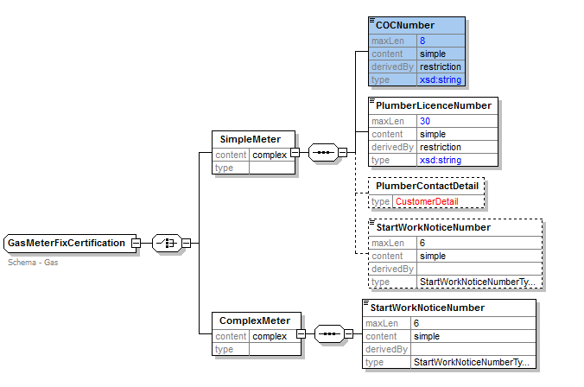

<xsd:complexType name="GasMeterFixCertification">
<xsd:annotation>
<xsd:documentation>Schema - Gas</xsd:documentation>
</xsd:annotation>
<xsd:choice>
<xsd:element name="SimpleMeter">
<xsd:complexType>
<xsd:sequence>
<xsd:element name="COCNumber">
<xsd:simpleType>
<xsd:restriction base="xsd:string">
<xsd:maxLength value="8"/>
</xsd:restriction>
</xsd:simpleType>
</xsd:element>
<xsd:element name="PlumberLicenceNumber">
<xsd:simpleType>
<xsd:restriction base="xsd:string">
<xsd:maxLength value="30"/>
</xsd:restriction>
</xsd:simpleType>
</xsd:element>
<xsd:element name="PlumberContactDetail" type="CustomerDetail"
minOccurs="0"/>
<xsd:element name="StartWorkNoticeNumber"
type="StartWorkNoticeNumberType" minOccurs="0"/>
</xsd:sequence>
</xsd:complexType>
</xsd:element>
<xsd:element name="ComplexMeter">
<xsd:complexType>
<xsd:sequence>
<xsd:element name="StartWorkNoticeNumber" type="StartWorkNoticeNumberType"/>
</xsd:sequence>
</xsd:complexType>
</xsd:element>
</xsd:choice>
</xsd:complexType>

GasServiceOrderDetails
Addition of QuoteReference & ConnectionType

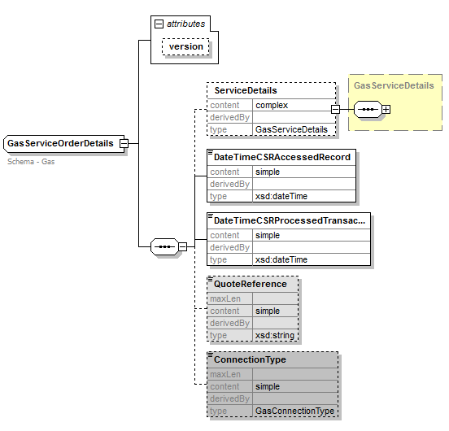
<xsd:complexType name="GasServiceOrderDetails">
<xsd:annotation>
<xsd:documentation>Schema - Gas</xsd:documentation>
</xsd:annotation>
<xsd:complexContent>
<xsd:extension base="ServiceOrderRequestData">
<xsd:sequence>
<xsd:element name="ServiceDetails" type="GasServiceDetails" minOccurs="0"/>
<xsd:element name="DateTimeCSRAccessedRecord" type="xsd:dateTime"/>
<xsd:element name="DateTimeCSRProcessedTransaction"
type="xsd:dateTime"/>
<xsd:element name="QuoteReference" type="xsd:string" minOccurs="0"/>
<xsd:element name="ConnectionType" type="GasConnectionType"
minOccurs="0"/>
</xsd:sequence>
<xsd:attribute name="version" type="r34" use="optional" default="r34"
</xsd:extension>
</xsd:complexContent>
</xsd:complexType>

GasServiceOrderNotificationData
update version from r13 to r34
<xsd:complexType name="GasServiceOrderNotificationData">
<xsd:annotation>
<xsd:documentation>Schema - Gas</xsd:documentation>
</xsd:annotation>
<xsd:complexContent>
<xsd:extension base="ServiceOrderNotificationData">
<xsd:sequence>
<xsd:choice>
<xsd:element name="ServiceOrderCompletion"
type="ServiceOrderGasCompletionData"/>
<xsd:element name="NoAccess"
type="ServiceOrderGasNoAccessData"/>
</xsd:choice>
<xsd:sequence>
<xsd:element name="JobCompletionCodes"
type="ServiceOrderGasJobCompletionCodes" minOccurs="0"/>
</xsd:sequence>
</xsd:sequence>
<xsd:attribute name="version" type="r34" use="optional" default="r34"/>
</xsd:extension>
</xsd:complexContent>
</xsd:complexType>/>

ServiceOrderGasMeterData
Change to add complex content & extend from base BaseServiceOrderGasMeterData)

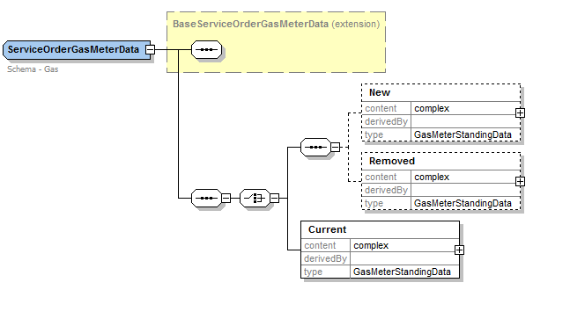

<xsd:complexType name="ServiceOrderGasMeterData">
<xsd:annotation>
<xsd:documentation>Schema - Gas</xsd:documentation>
</xsd:annotation>
<xsd:complexContent>
<xsd:extension base="BaseServiceOrderGasMeterData">
<xsd:sequence>
<xsd:choice>
<xsd:sequence>
<xsd:element name="New" type="GasMeterStandingData"
minOccurs="0"/>
<xsd:element name="Removed"
type="GasMeterStandingData" minOccurs="0"/>
</xsd:sequence>
<xsd:element name="Current" type="GasMeterStandingData"/>
</xsd:choice>
</xsd:sequence>
</xsd:extension>
</xsd:complexContent>
</xsd:complexType>

ServiceOrderGasCompletionData
extend MeterData with BaseServiceOrderGasMeterData Instead off ServiceOrderGasMeterData"

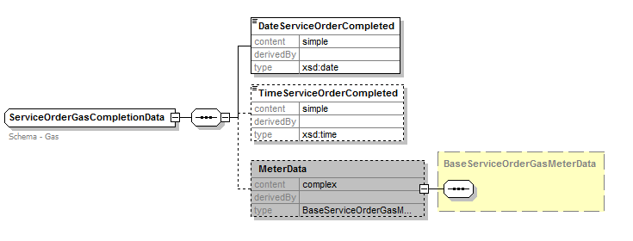

<xsd:complexType name="ServiceOrderGasCompletionData">
<xsd:annotation>
<xsd:documentation>Schema - Gas</xsd:documentation>
</xsd:annotation>
<xsd:sequence>
<xsd:element name="DateServiceOrderCompleted" type="xsd:date"/>
<xsd:element name="TimeServiceOrderCompleted" type="xsd:time" minOccurs="0"/>
<xsd:element name="MeterData" type="BaseServiceOrderGasMeterData" minOccurs="0"/>
</xsd:sequence>
</xsd:complexType>

GasMasterStandingData
change due to making NetworkID derived from an explicitly defined simple type definition.
It was previously defined as against GasMasterStandingData as
<xsd:element name="NetworkID" minOccurs="0">
<xsd:simpleType>
<xsd:restriction base="xsd:string">
<xsd:length value="2"/>
</xsd:restriction>
</xsd:simpleType>

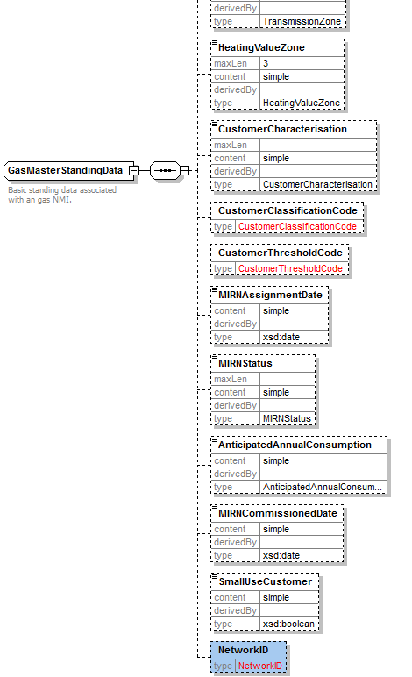
Note : In Fig above Have not copied all of the items. Only showing change

<xsd:complexType name="GasMasterStandingData">
<xsd:annotation>
<xsd:documentation>Basic standing data associated with an gas NMI.</xsd:documentation>
</xsd:annotation>
<xsd:sequence>
<xsd:element name="AustralianPostCode" type="AustralianPostCode" nillable="true"
minOccurs="0"/>
<xsd:element name="PrimaryCustodyTransferMeter" type="NMIWithChecksum" minOccurs="0"/>
<xsd:element name="BaseLoad" type="BaseLoad" nillable="true" minOccurs="0"/>
<xsd:element name="TemperatureSensitivityFactor" type="TemperatureSensitivityFactor"
nillable="true" minOccurs="0"/>
<xsd:element name="DistributionTariff" type="DistributionTariff" minOccurs="0"/>
<xsd:element name="TransmissionZone" type="TransmissionZone" minOccurs="0"/>
<xsd:element name="HeatingValueZone" type="HeatingValueZone" minOccurs="0"/>
<xsd:element name="CustomerCharacterisation" type="CustomerCharacterisation"
minOccurs="0"/>
<xsd:element name="CustomerClassificationCode" type="CustomerClassificationCode"
nillable="true" minOccurs="0"/>
<xsd:element name="CustomerThresholdCode" type="CustomerThresholdCode" nillable="true"
minOccurs="0"/>
<xsd:element name="MIRNAssignmentDate" type="xsd:date" nillable="true" minOccurs="0"/>
<xsd:element name="MIRNStatus" type="MIRNStatus" minOccurs="0"/>
<xsd:element name="AnticipatedAnnualConsumption" type="AnticipatedAnnualConsumption"
minOccurs="0"/>
<xsd:element name="MIRNCommissionedDate" type="xsd:date" minOccurs="0"/>
<xsd:element name="SmallUseCustomer" type="xsd:boolean" minOccurs="0"/>
<xsd:element name="NetworkID" type="NetworkID" minOccurs="0"/>
<!-- Fields to be determined -->
</xsd:sequence>
</xsd:complexType>

See new simple type in common_r34.xsd for the definition of NetworkID

GasMeterNotification
Change Meter Fix to inherit from NMIStandingData rather than GasStandingData to allow for multimeter standingdata selection. Update version from r9 to r34

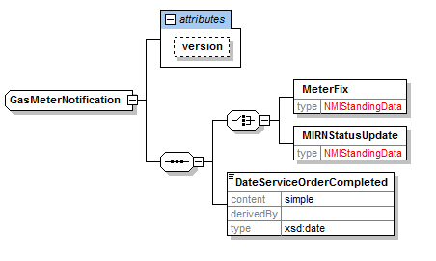
<xsd:complexType name="GasMeterNotification">
<xsd:sequence>
<xsd:choice>
<xsd:element name="MeterFix" type="NMIStandingData"/>
<xsd:element name="MIRNStatusUpdate" type="NMIStandingData"/>
</xsd:choice>
<xsd:element name="DateServiceOrderCompleted" type="xsd:date"/>
</xsd:sequence>
<xsd:attribute name="version" type="r34" use="optional" default="r34"/>
</xsd:complexType>

GasStandingData.
Update version to R34 to accommodate change to NetworkID type

<xsd:complexType name="GasStandingData">
<xsd:annotation>
<xsd:documentation>Standing data associated with an gas NMI.</xsd:documentation>
</xsd:annotation>
<xsd:complexContent>
<xsd:extension base="NMIStandingData">
<xsd:sequence>
<xsd:element name="MasterData" type="GasMasterStandingData"
minOccurs="0"/>
<xsd:element name="RoleAssignments" type="RoleAssignments"
minOccurs="0"/>
<xsd:element name="MeterData" type="GasMeterStandingData"
minOccurs="0"/>
<xsd:element name="SiteData" type="ServicePoint" minOccurs="0"/>
<xsd:element name="AdditionalDataToFollow" type="xsd:boolean"
minOccurs="0"/>
</xsd:sequence>
<xsd:attribute name="version" type="r34" use="optional" default="r34"/>
</xsd:extension>
</xsd:complexContent>
</xsd:complexType>

New Base Types

BaseServiceOrderGasMeterData
Purpose - base types from which all gas meter data for service order transactions are implemented.
Detail - The only limitation made by this definition is that the content will be complex.

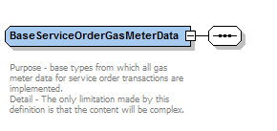

<xsd:complexType name="BaseServiceOrderGasMeterData" abstract="true">
<xsd:annotation>
<xsd:documentation>
Purpose - base types from which all gas meter data for service order transactions are implemented.
Detail - The only limitation made by this definition is that the content will be complex.
</xsd:documentation>
</xsd:annotation>
<xsd:sequence/>
</xsd:complexType>

BaseMultiMeterReadDataType
With corresponding elements. i.e. AdjustmentReasonCode, ConsumedEnergy etc
Purpose - base types from which all gas meter standing data are implemented.
Detail - The only limitation made by this definition is that the content will be complex. This is done to
allow NSW/ACT Meters to have specific attributes for meters such as Hot Water Meter.

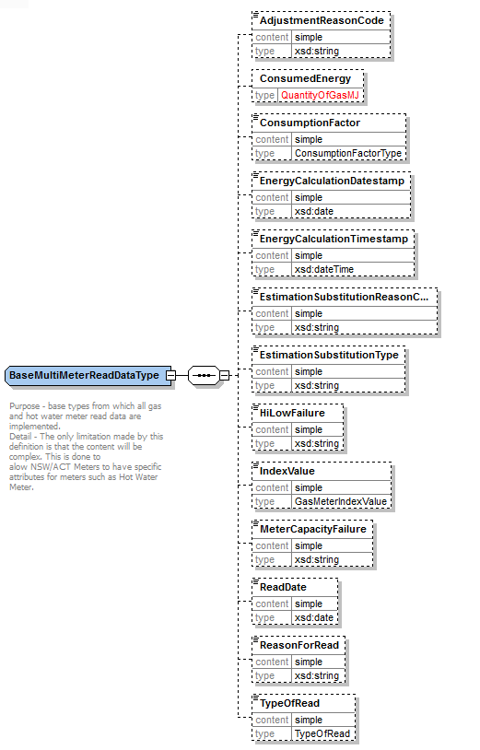

<xsd:complexType name="BaseMultiMeterReadDataType" abstract="true">
<xsd:annotation>
<xsd:documentation>
Purpose - base types from which all gas and hot water meter read data are implemented.
Detail - The only limitation made by this definition is that the content will be complex. This is done to
alow NSW/ACT Meters to have specific attributes for meters such as Hot Water Meter.
</xsd:documentation>
</xsd:annotation>
<xsd:sequence>
<xsd:element name="AdjustmentReasonCode" type="xsd:string" minOccurs="0"/>
<xsd:element name="ConsumedEnergy" type="QuantityOfGasMJ" minOccurs="0"/>
<xsd:element name="ConsumptionFactor" type="ConsumptionFactorType" minOccurs="0"/>
<xsd:element name="EnergyCalculationDatestamp" type="xsd:date" minOccurs="0"/>
<xsd:element name="EnergyCalculationTimestamp" type="xsd:dateTime" minOccurs="0"/>
<xsd:element name="EstimationSubstitutionReasonCode" type="xsd:string" minOccurs="0"/>
<xsd:element name="EstimationSubstitutionType" type="xsd:string" minOccurs="0"/>
<xsd:element name="HiLowFailure" type="xsd:string" minOccurs="0"/>
<xsd:element name="IndexValue" type="GasMeterIndexValue" nillable="true" minOccurs="0"/>
<xsd:element name="MeterCapacityFailure" type="xsd:string" minOccurs="0"/>
<xsd:element name="ReadDate" type="xsd:date" nillable="true" minOccurs="0"/>
<xsd:element name="ReasonForRead" type="xsd:string" minOccurs="0"/>
<xsd:element name="TypeOfRead" type="TypeOfRead" nillable="true" minOccurs="0"/>
</xsd:sequence>
</xsd:complexType>

New Complex Types

ServiceOrderMultiMeterData
Extend from base BaseServiceOrderGasMeterData

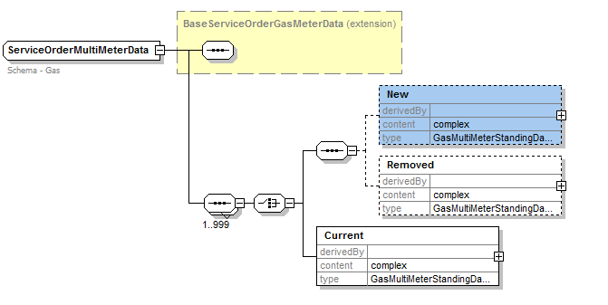

<xsd:complexType name="ServiceOrderMultiMeterData">
<xsd:annotation>
<xsd:documentation>Schema - Gas</xsd:documentation>
</xsd:annotation>
<xsd:complexContent>
<xsd:extension base="BaseServiceOrderGasMeterData">
<xsd:sequence maxOccurs="999">
<xsd:choice>
<xsd:sequence>
<xsd:element name="New" type="GasMultiMeterStandingDataType" minOccurs="0"/>
<xsd:element name="Removed" type="GasMultiMeterStandingDataType" minOccurs="0"/>
</xsd:sequence>
<xsd:element name="Current" type="GasMultiMeterStandingDataType"/>
</xsd:choice>
</xsd:sequence>
</xsd:extension>
</xsd:complexContent>
</xsd:complexType>

GasMultiMeterReadDataType (extend from BaseMultiMeterReadDataType)

Addition of items specific to Gas Meters in NSW/ACT
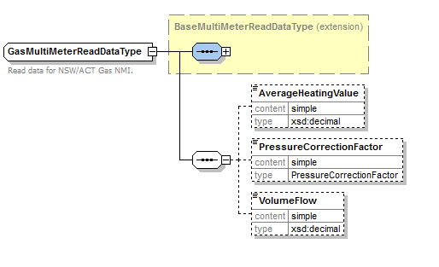

<xsd:complexType name="GasMultiMeterReadDataType">
<xsd:annotation>
<xsd:documentation>Read data for NSW/ACT Gas NMI.</xsd:documentation>
</xsd:annotation>
<xsd:complexContent>
<xsd:extension base="BaseMultiMeterReadDataType">
<xsd:sequence>
<xsd:element name="AverageHeatingValue" type="xsd:decimal" minOccurs="0"/>
<xsd:element name="PressureCorrectionFactor" type="PressureCorrectionFactor" minOccurs="0"/>
<xsd:element name="VolumeFlow" type="xsd:decimal" minOccurs="0"/>
</xsd:sequence>
</xsd:extension>
</xsd:complexContent>
</xsd:complexType>

HWMultiMeterReadDataType (extend from BaseMultiMeterReadDataType)

Addition of items specific to Water Meters (used for heating) in NSW/ACT

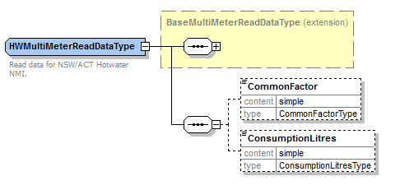
<xsd:complexType name="HWMultiMeterReadDataType">
<xsd:annotation>
<xsd:documentation>Read data for NSW/ACT Hotwater NMI.</xsd:documentation>
</xsd:annotation>
<xsd:complexContent>
<xsd:extension base="BaseMultiMeterReadDataType">
<xsd:sequence>
<xsd:element name="CommonFactor" type="CommonFactorType"
minOccurs="0"/>
<xsd:element name="ConsumptionLitres" type="ConsumptionLitresType"
minOccurs="0"/>
</xsd:sequence>
</xsd:extension>
</xsd:complexContent>
</xsd:complexType>

GasMultiMeterMasterStandingDataType

with associated std data elements
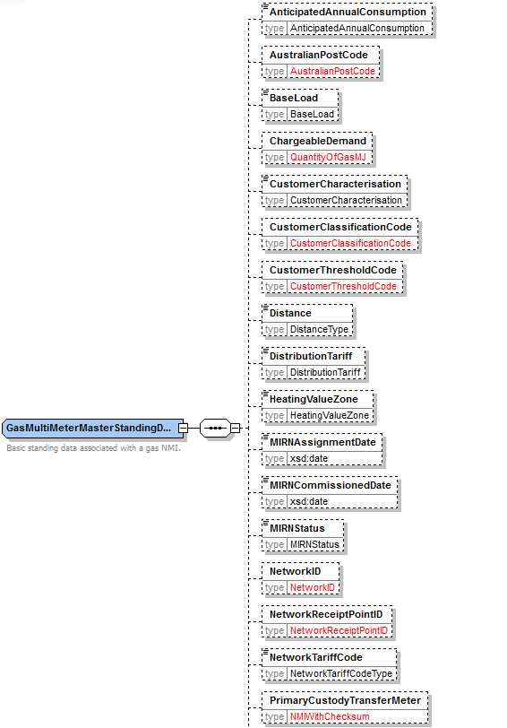

<xsd:complexType name="GasMultiMeterMasterStandingDataType">
<xsd:annotation>
<xsd:documentation>Basic standing data associated with a gas NMI.</xsd:documentation>
</xsd:annotation>
<xsd:sequence>
<xsd:element name="AnticipatedAnnualConsumption" type="AnticipatedAnnualConsumption"
minOccurs="0"/>
<xsd:element name="AustralianPostCode" type="AustralianPostCode" nillable="true"
minOccurs="0"/>
<xsd:element name="BaseLoad" type="BaseLoad" nillable="true" minOccurs="0"/>
<xsd:element name="ChargeableDemand" type="QuantityOfGasMJ" minOccurs="0"/>
<xsd:element name="CustomerCharacterisation" type="CustomerCharacterisation"
minOccurs="0"/>
<xsd:element name="CustomerClassificationCode" type="CustomerClassificationCode"
nillable="true" minOccurs="0"/>
<xsd:element name="CustomerThresholdCode" type="CustomerThresholdCode" nillable="true"
minOccurs="0"/>
<xsd:element name="Distance" type="DistanceType" minOccurs="0"/>
<xsd:element name="DistributionTariff" type="DistributionTariff" minOccurs="0"/>
<xsd:element name="HeatingValueZone" type="HeatingValueZone" minOccurs="0"/>
<xsd:element name="MIRNAssignmentDate" type="xsd:date" nillable="true" minOccurs="0"/>
<xsd:element name="MIRNCommissionedDate" type="xsd:date" minOccurs="0"/>
<xsd:element name="MIRNStatus" type="MIRNStatus" minOccurs="0"/>
<xsd:element name="NetworkID" type="NetworkID" minOccurs="0"/>
<xsd:element name="NetworkReceiptPointID" type="NetworkReceiptPointID" minOccurs="0"/>
<xsd:element name="NetworkTariffCode" type="NetworkTariffCodeType" minOccurs="0"/>
<xsd:element name="PrimaryCustodyTransferMeter" type="NMIWithChecksum" minOccurs="0"/>
<xsd:element name="SmallUseCustomer" type="xsd:boolean" minOccurs="0"/>
<xsd:element name="TemperatureSensitivityFactor" type="TemperatureSensitivityFactor"
nillable="true" minOccurs="0"/>
<xsd:element name="TransmissionZone" type="TransmissionZone" minOccurs="0"/>
</xsd:sequence>
</xsd:complexType>

GasBasicMultiMeterStandingData

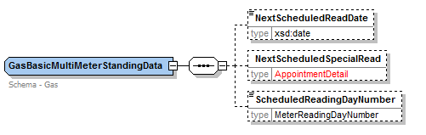

<xsd:complexType name="GasBasicMultiMeterStandingData">
<xsd:annotation>
<xsd:documentation>Schema - Gas</xsd:documentation>
</xsd:annotation>
<xsd:sequence>
<xsd:element name="NextScheduledReadDate" type="xsd:date" minOccurs="0"/>
<xsd:element name="NextScheduledSpecialRead" type="AppointmentDetail" minOccurs="0"/>
<xsd:element name="ScheduledReadingDayNumber" type="MeterReadingDayNumber"
minOccurs="0"/>
</xsd:sequence>
</xsd:complexType>

GasMultiMeterStandingDataType

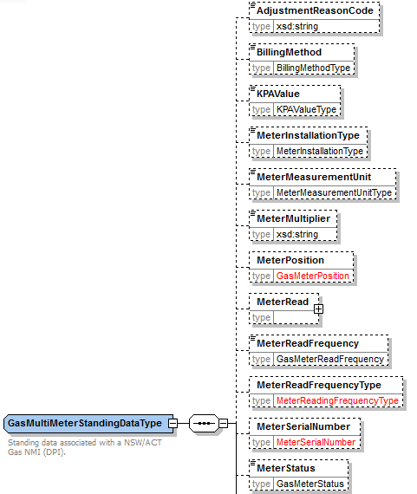
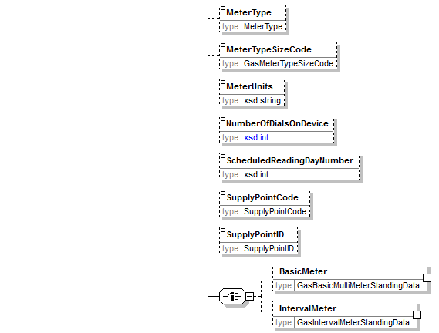

<xsd:complexType name="GasMultiMeterStandingDataType">
<xsd:annotation>
<xsd:documentation>Standing data associated with a NSW/ACT Gas NMI
(DPI).
</xsd:documentation>
</xsd:annotation>
<xsd:sequence>
<xsd:element name="AdjustmentReasonCode" type="xsd:string" minOccurs="0"/>
<xsd:element name="BillingMethod" type="BillingMethodType" minOccurs="0"/>
<xsd:element name="KPAValue" type="KPAValueType" minOccurs="0"/>
<xsd:element name="MeterInstallationType" type="MeterInstallationType" minOccurs="0"/>
<xsd:element name="MeterMeasurementUnit" type="MeterMeasurementUnitType"
minOccurs="0"/>
<xsd:element name="MeterMultiplier" type="xsd:string" minOccurs="0"/>
<xsd:element name="MeterPosition" type="GasMeterPosition" minOccurs="0"/>
<xsd:element name="MeterRead" minOccurs="0">
<xsd:complexType>
<xsd:sequence>
<xsd:element name="Current" type="BaseMultiMeterReadDataType"
minOccurs="0"/>
<xsd:element name="Previous" type="BaseMultiMeterReadDataType"
minOccurs="0"/>
</xsd:sequence>
</xsd:complexType>
</xsd:element>
<xsd:element name="MeterReadFrequency" type="GasMeterReadFrequency" minOccurs="0"/>
<xsd:element name="MeterReadFrequencyType" type="MeterReadingFrequencyType"
minOccurs="0"/>
<xsd:element name="MeterSerialNumber" type="MeterSerialNumber" minOccurs="0"/>
<xsd:element name="MeterStatus" type="GasMeterStatus" minOccurs="0"/>
<xsd:element name="MeterType" type="MeterType" minOccurs="0"/>
<xsd:element name="MeterTypeSizeCode" type="GasMeterTypeSizeCode" minOccurs="0"/>
<xsd:element name="MeterUnits" type="xsd:string" minOccurs="0"/>
<xsd:element name="NumberOfDialsOnDevice" minOccurs="0">
<xsd:simpleType>
<xsd:restriction base="xsd:int">
<xsd:totalDigits value="2"/>
</xsd:restriction>
</xsd:simpleType>
</xsd:element>
<xsd:element name="ScheduledReadingDayNumber" type="xsd:int" minOccurs="0"/>
<xsd:element name="SupplyPointCode" type="SupplyPointCode" minOccurs="0"/>
<xsd:element name="SupplyPointID" type="SupplyPointID" minOccurs="0"/>
<xsd:choice>
<xsd:element name="BasicMeter" type="GasBasicMultiMeterStandingData"
minOccurs="0"/>
<xsd:element name="IntervalMeter" type="GasIntervalMeterStandingData"
minOccurs="0"/>
</xsd:choice>
</xsd:sequence>
</xsd:complexType>

GasMultiMeterStandingData
Versioned element!

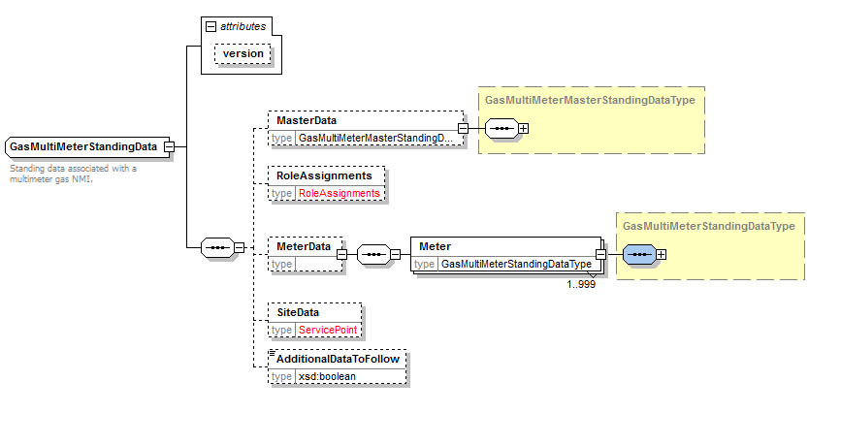

<xsd:complexType name="GasMultiMeterStandingData">
<xsd:annotation>
<xsd:documentation>Standing data associated with a multimeter gas NMI.</xsd:documentation>
</xsd:annotation>
<xsd:complexContent>
<xsd:extension base="NMIStandingData">
<xsd:sequence>
<xsd:element name="MasterData"
type="GasMultiMeterMasterStandingDataType" minOccurs="0"/>
<xsd:element name="RoleAssignments" type="RoleAssignments"
minOccurs="0"/>
<xsd:element name="MeterData" minOccurs="0">
<xsd:complexType>
<xsd:sequence>
<xsd:element name="Meter"
type="GasMultiMeterStandingDataType"
maxOccurs="999"/>
</xsd:sequence>
</xsd:complexType>
</xsd:element>
<xsd:element name="SiteData" type="ServicePoint" minOccurs="0"/>
<xsd:element name="AdditionalDataToFollow" type="xsd:boolean"
minOccurs="0"/>
</xsd:sequence>
<xsd:attribute name="version" type="r34" use="optional" default="r34"/>
</xsd:extension>
</xsd:complexContent>
</xsd:complexType>

GasMultiMeterStandingDataUpdate

To allow for StandingData update transaction to work with multimeter standing data

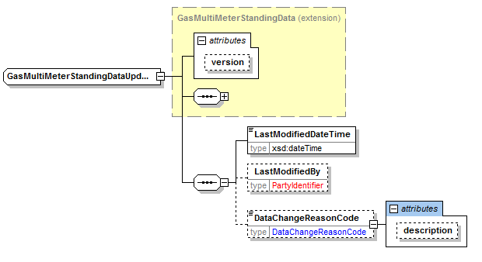

<xsd:complexType name="GasMultiMeterStandingDataUpdate">
<xsd:complexContent>
<xsd:extension base="GasMultiMeterStandingData">
<xsd:sequence>
<xsd:element name="LastModifiedDateTime" type="xsd:dateTime"/>
<xsd:element name="LastModifiedBy" type="PartyIdentifier"
minOccurs="0"/>
<xsd:element name="DataChangeReasonCode" minOccurs="0">
<xsd:complexType>
<xsd:simpleContent>
<xsd:extension
base="DataChangeReasonCode">
<xsd:attribute name="description"
type="xsd:string"/>
</xsd:extension>
</xsd:simpleContent>
</xsd:complexType>
</xsd:element>
</xsd:sequence>
</xsd:extension>
</xsd:complexContent>
</xsd:complexType>

GasMeterVerifyRequestWithMSNData

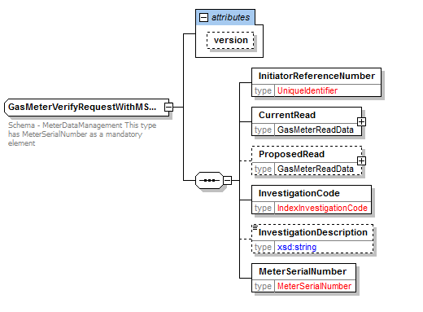

<xsd:complexType name="GasMeterVerifyRequestWithMSNData">
<xsd:annotation>
<xsd:documentation>Schema - MeterDataManagement This type has MeterSerialNumber as a
mandatory element
</xsd:documentation>
</xsd:annotation>
<xsd:complexContent>
<xsd:extension base="NMITransactionBase">
<xsd:sequence>
<xsd:element name="InitiatorReferenceNumber" type="UniqueIdentifier"/>
<xsd:element name="CurrentRead" type="GasMeterReadData"/>
<xsd:element name="ProposedRead" type="GasMeterReadData"
minOccurs="0"/>
<xsd:element name="InvestigationCode" type="IndexInvestigationCode"/>
<xsd:element name="InvestigationDescription" minOccurs="0">
<xsd:simpleType>
<xsd:restriction base="xsd:string">
<xsd:maxLength value="100"/>
</xsd:restriction>
</xsd:simpleType>
</xsd:element>
<xsd:element name="MeterSerialNumber" type="MeterSerialNumber"/>
</xsd:sequence>
<xsd:attribute name="version" type="r34" use="optional" default="r34"/>
</xsd:extension>
</xsd:complexContent>
</xsd:complexType>

GasMeterVerifyResponseWithMSNData
Need Meter Serial Number (MSN) for NSW/ACT
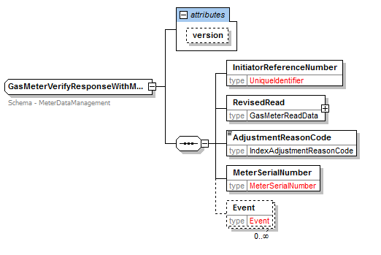
<xsd:complexType name="GasMeterVerifyResponseWithMSNData">
<xsd:annotation>
<xsd:documentation>Schema - MeterDataManagement</xsd:documentation>
</xsd:annotation>
<xsd:complexContent>
<xsd:extension base="NMITransactionBase">
<xsd:sequence>
<xsd:element name="InitiatorReferenceNumber" type="UniqueIdentifier"/>
<xsd:element name="RevisedRead" type="GasMeterReadData"/>
<xsd:element name="AdjustmentReasonCode"
type="IndexAdjustmentReasonCode"/>
<xsd:element name="MeterSerialNumber" type="MeterSerialNumber"/>
<xsd:element name="Event" type="Event" minOccurs="0"
maxOccurs="unbounded"/>
</xsd:sequence>
<xsd:attribute name="version" type="r34" use="optional" default="r34"/>
</xsd:extension>
</xsd:complexContent>
</xsd:complexType>

Enumerations.xsd
Update to annotation to indicate version 7.0 of the file

Addition of simple Type MarketReportNamesType which is used to convey the report names of the CSV Market Reports. This will enable new reports to be added without upgrading the version of the schema as it’s only CSV content.

<!--NSW Report Names-->
<xsd:simpleType name="MarketReportNamesType">
<xsd:annotation>
<xsd:documentation>
Purpose - Define the Name of any report that accepts CSV Report in the generic CSVReport format.
Element MarketReportNames has been restricted to 80 characters. This was added to v7.0 of this file.
</xsd:documentation>
</xsd:annotation>
<xsd:restriction base="xsd:string">
<xsd:maxLength value="80"/>
<xsd:enumeration value="DPRExtractRpt"/>
<xsd:enumeration value="BasicConsumptionRpt"/>
<xsd: enumeration value="MeterReadingToUserRpt"/>
<xsd:enumeration value="MeterReadingToUserNonSTTMRpt"/>
<xsd:enumeration value="ChangeOfStandingDataRpt"/>
<xsd:enumeration value="CustomerChurnRpt"/>
<xsd:enumeration value="EstimationResultsToUserRpt"/>
<xsd:enumeration value="RevisedEstimationResultsToUserRpt"/>
<xsd:enumeration value="ReconciliationResultsRpt"/>
<xsd:enumeration value="ForecastingDataRpt"/>
<xsd:enumeration value="ApportionmentPercentageRpt"/>
<xsd:enumeration value="DailyNSLRpt"/>
<xsd:enumeration value="STTMPipelineAllocationDataRpt"/>
<xsd:enumeration value="DailyToSTTMRpt"/>
<xsd:enumeration value="DailyToUserRpt"/>
<xsd:enumeration value="WeeklyToSTTMRpt"/>
<xsd:enumeration value="MonthlyToSTTMRpt"/>
<xsd:enumeration value="PreMonthlyToSTTMRpt"/>
<xsd:enumeration value="FinMonthlyToSTTMRpt"/>
<xsd:enumeration value="RevMonthlyToSTTMRpt"/>
<xsd:enumeration value="MonthlyToUserRpt"/>
<xsd:enumeration value="TotalGasInjectedRpt"/>
<xsd:enumeration value="WeeklyToUserRpt"/>
<xsd:enumeration value="EstimationResultsToNWORpt"/>
<xsd:enumeration value="RevisedEstimationResultsToNWORpt"/>
<xsd:enumeration value="MatchedImbalanceTradeRpt"/>
<xsd:enumeration value="ExpiredImbalanceTradeRpt"/>
<xsd:enumeration value="ParticipantImbalanceAmountRpt"/>
<xsd:enumeration value="RevisedImbalanceRpt"/>
<xsd:enumeration value="T298NewStreetListingRpt"/>
<xsd:enumeration value="T299CompleteMIRNListingRpt"/>
<xsd:enumeration value="T900CustomerSiteDetailsMonthlyRpt"/>
<xsd:enumeration value="T2125AncillaryChargeListingRpt"/>
<xsd:enumeration value="T2130HeatingValueDailyRpt"/>
<xsd:enumeration value="T2131PublishedHeatingValueDailyRpt"/>
<xsd:enumeration value="T2145HaulageRightsRpt"/>
<xsd:enumeration value="T2270TotalCLPRpt"/>
<xsd:enumeration value="T2275TotalCLPRpt"/>
<xsd:enumeration value="T2305EffectiveDegreeDayRpt"/>
<xsd:enumeration value="T2420QuotationStatusRpt"/>
<xsd:enumeration value="T2421QuotationSubmissionRpt"/>
<xsd:enumeration value="T2422QuotationNotificationRpt"/>
<xsd:enumeration value="T2423QuotationAcceptedRpt"/>
<xsd:enumeration value="T2424QuotationAvailableRpt"/>
</xsd:restriction>
</xsd:simpleType>

Events_r34.xsd

Addition of simple type r34 for this release as follows

<xsd:simpleType name="r34">
<xsd:annotation>
<xsd:documentation>Purpose - Release r34 identifier.</xsd:documentation>
</xsd:annotation>
<xsd:restriction base="ReleaseIdentifier">
<xsd:enumeration value="r34"/>
</xsd:restriction>
</xsd:simpleType>

Common_r34.xsd

Addition of simple type NetworkID to be resused.
Note this has changed to be a Max length of 15 char. Previously this was fixed length of 2. This means the schema is forwards compatable but not backwards compatable in relation this the use of this element

<xsd:simpleType name="NetworkID">
<xsd:annotation>
<xsd:documentation>Network ID has been included in several reports and as a part of meter standing data</xsd:documentation>
</xsd:annotation>
<xsd:restriction base="xsd:string">
<xsd:maxLength value="15"/>
<xsd:minLength value="2"/>
</xsd:restriction>
</xsd:simpleType>

Update to Simple type IndexInvestigationCode as highlighted

<xsd:simpleType name="IndexInvestigationCode">
<xsd:annotation>
<xsd:documentation>Schema - Gas</xsd:documentation>
</xsd:annotation>
<xsd:restriction base="xsd:string">
<xsd:enumeration value="Confirm Reading For Vacant Site"/>
<xsd:enumeration value="Confirm Zero Consumption"/>
<xsd:enumeration value="Incomplete Data"/>
<xsd:enumeration value="Invalid MDFF Data"/>
<xsd:enumeration value="Invalid Standing Data"/>
<xsd:enumeration value="Missing Datastream"/>
<xsd:enumeration value="Require Actual Reading or Substitute"/>
<xsd:enumeration value="Require Final Substitute"/>
<xsd:enumeration value="Require Latest Version"/>
<xsd:enumeration value="Scheduled Reading Required"/>
<xsd:enumeration value="Service Order Reading Required"/>
<xsd:enumeration value="Verify High Reading"/>
<xsd:enumeration value="Verify Low Reading"/>
<xsd:enumeration value="Customer Away"/>
<xsd:enumeration value="Customer Query"/>
<xsd:enumeration value="Customer Read"/>
<xsd:enumeration value="High Account"/>
<xsd:enumeration value="Zero Consumption"/>
<xsd:enumeration value="Recipient Not Responsible For The NMI"/>
<xsd:enumeration value="Other"/>
<xsd:enumeration value="Cross Meter"/>
<xsd:enumeration value="MDL Out of Alignment"/>
</xsd:restriction>
</xsd:simpleType>

Reports_r34.xsd

New Simple types:

ReportType

<xsd:simpleType name="ReportType">
<xsd:annotation>
<xsd:documentation>The type reports.
PRE- Preliminary
REV-Revision
FIN-Final
</xsd:documentation>
</xsd:annotation>
<xsd:restriction base="xsd:string">
<xsd:length value="3"/>
<xsd:enumeration value="PRE"/>
<xsd:enumeration value="REV"/>
<xsd:enumeration value="FIN"/>
</xsd:restriction>
</xsd:simpleType>

PipelineID

<xsd:simpleType name="PipelineID">
<xsd:annotation>
<xsd:documentation>A unique identifier for a Pipeline</xsd:documentation>
</xsd:annotation>
<xsd:restriction base="xsd:string">
<xsd:minLength value="1"/>
<xsd:maxLength value="12"/>
</xsd:restriction>
</xsd:simpleType>

New complex types

MRBlockParameterType

To allow for “chunking of CSV reports if they are to large to send as an individual file in one transaction across the HUB.
ReplicationSequenceNumber has a restriction of being a non negative number

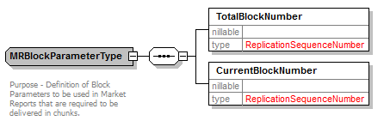

<xsd:complexType name="MRBlockParameterType">
<xsd:annotation>
<xsd:documentation>
Purpose - Definition of Block Parameters to be used in Market Reports that are required to be delivered in chunks.
</xsd:documentation>
</xsd:annotation>
<xsd:sequence>
<xsd:element name="TotalBlockNumber" type="ReplicationSequenceNumber"/>
<xsd:element name="CurrentBlockNumber" type="ReplicationSequenceNumber"/>
</xsd:sequence>
</xsd:complexType>

MRMissingBlockParameters

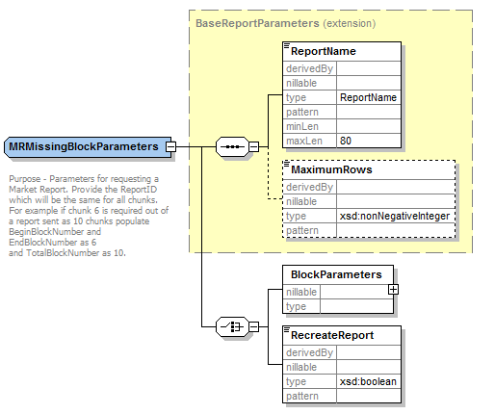

<xsd:complexType name="MRMissingBlockParameters">
<xsd:annotation>
<xsd:documentation>
Purpose - Parameters for requesting a Market Report. Provide the ReportID which will be the same for all chunks.
For example if chunk 6 is required out of a report sent as 10 chunks populate BeginBlockNumber and EndBlockNumber as 6
and TotalBlockNumber as 10.
</xsd:documentation>
</xsd:annotation>
<xsd:complexContent>
<xsd:extension base="BaseReportParameters">
<xsd:choice>
<xsd:element name="BlockParameters">
<xsd:complexType>
<xsd:sequence>
<xsd:element name="ReportID" type="UniqueIdentifier"/>
<xsd:element name="BeginBlockNumber" type="ReplicationSequenceNumber"/>
<xsd:element name="EndBlockNumber" type="ReplicationSequenceNumber"/>
<xsd:element name="TotalBlockNumber" minOccurs="0"/>
</xsd:sequence>
</xsd:complexType>
</xsd:element>
<xsd:element name="RecreateReport" type="xsd:boolean"/>
</xsd:choice>
</xsd:extension>
</xsd:complexContent>
</xsd:complexType>

MarketReport

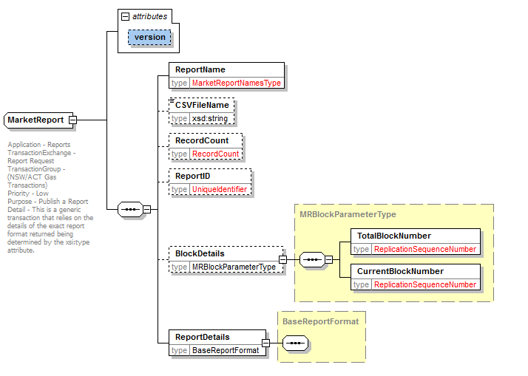

<xsd:complexType name="MarketReport">
<xsd:annotation>
<xsd:documentation>
Application - Reports
TransactionExchange - Report Request
TransactionGroup - (NSW/ACT Gas Transactions)
Priority - Low
Purpose - Publish a Report
Detail - This is a generic transaction that relies on the details of the exact report format returned being determined by the xsi:type attribute.
</xsd:documentation>
</xsd:annotation>
<xsd:sequence>
<xsd:element name="ReportName" type="MarketReportNamesType"/>
<xsd:element name="CSVFileName" type="xsd:string" minOccurs="0"/>
<xsd:element name="RecordCount" type="RecordCount" minOccurs="0"/>
<xsd:element name="ReportID" type="UniqueIdentifier" minOccurs="0"/>
<xsd:element name="BlockDetails" type="MRBlockParameterType" minOccurs="0"/>
<xsd:element name="ReportDetails" type="BaseReportFormat"/>
</xsd:sequence>
<xsd:attribute name="version" type="r34" use="optional" default="r34"/>
</xsd:complexType>

EstimationResultsRpt

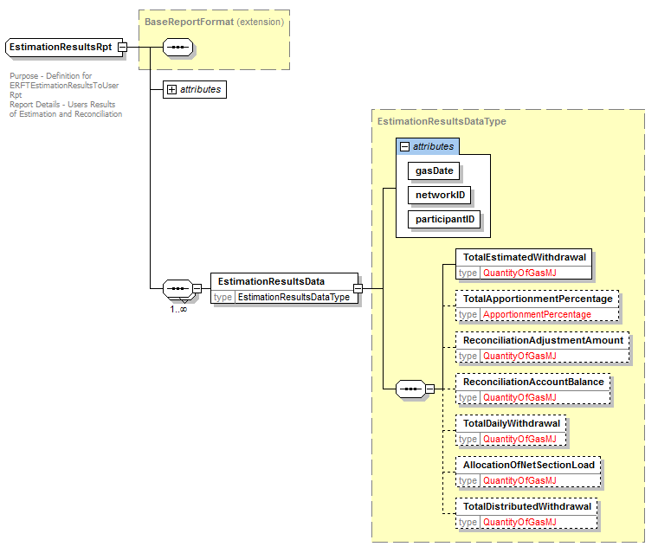

<xsd:complexType name="EstimationResultsRpt">
<xsd:annotation>
<xsd:documentation>
Purpose - Definition for ERFTEstimationResultsToUserRpt
Report Details - Users Results of Estimation and Reconciliation
</xsd:documentation>
</xsd:annotation>
<xsd:complexContent>
<xsd:extension base="BaseReportFormat">
<xsd:sequence maxOccurs="unbounded">
<xsd:element name="EstimationResultsData" type="EstimationResultsDataType"/>
</xsd:sequence>
<xsd:attribute name="reportType" type="ReportType" use="optional"/>
<xsd:attribute name="version" type="r34" use="optional" default="r34"/>
</xsd:extension>
</xsd:complexContent>
</xsd:complexType>

MatchedImbalanceTradeRpt

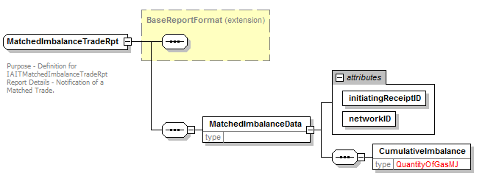

<xsd:complexType name="MatchedImbalanceTradeRpt">
<xsd:annotation>
<xsd:documentation>
Purpose - Definition for IAITMatchedImbalanceTradeRpt
Report Details - Notification of a Matched Trade.
</xsd:documentation>
</xsd:annotation>
<xsd:complexContent>
<xsd:extension base="BaseReportFormat">
<xsd:sequence>
<xsd:element name="MatchedImbalanceData">
<xsd:complexType>
<xsd:sequence>
<xsd:element name="CumulativeImbalance" type="QuantityOfGasMJ"/>
</xsd:sequence>
<xsd:attribute name="initiatingReceiptID" type="ReceiptIdentifier" use="required"/>
<xsd:attribute name="networkID" type="NetworkID" use="required"/>
</xsd:complexType>
</xsd:element>
</xsd:sequence>
</xsd:extension>
</xsd:complexContent>
</xsd:complexType>

ExpiredImbalanceTradeRpt

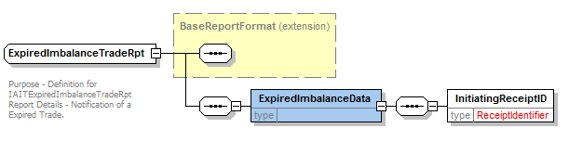

<xsd:complexType name="ExpiredImbalanceTradeRpt">
<xsd:annotation>
<xsd:documentation>
Purpose - Definition for IAITExpiredImbalanceTradeRpt
Report Details - Notification of a Expired Trade.
</xsd:documentation>
</xsd:annotation>
<xsd:complexContent>
<xsd:extension base="BaseReportFormat">
<xsd:sequence>
<xsd:element name="ExpiredImbalanceData">
<xsd:complexType>
<xsd:sequence>
<xsd:element name="InitiatingReceiptID" type="ReceiptIdentifier"/>
</xsd:sequence>
</xsd:complexType>
</xsd:element>
</xsd:sequence>
</xsd:extension>
</xsd:complexContent>
</xsd:complexType>

ParticipantImbalanceAmountRpt

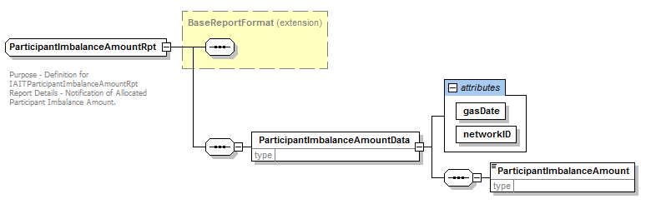

<xsd:complexType name="ParticipantImbalanceAmountRpt">
<xsd:annotation>
<xsd:documentation>
Purpose - Definition for IAITParticipantImbalanceAmountRpt
Report Details - Notification of Allocated Participant Imbalance Amount.
</xsd:documentation>
</xsd:annotation>
<xsd:complexContent>
<xsd:extension base="BaseReportFormat">
<xsd:sequence>
<xsd:element name="ParticipantImbalanceAmountData">
<xsd:complexType>
<xsd:sequence>
<xsd:element name="ParticipantImbalanceAmount"/>
</xsd:sequence>
<xsd:attribute name="gasDate" use="required"/>
<xsd:attribute name="networkID" use="required"/>
</xsd:complexType>
</xsd:element>
</xsd:sequence>
</xsd:extension>
</xsd:complexContent>
</xsd:complexType>

RevisedImbalanceRpt

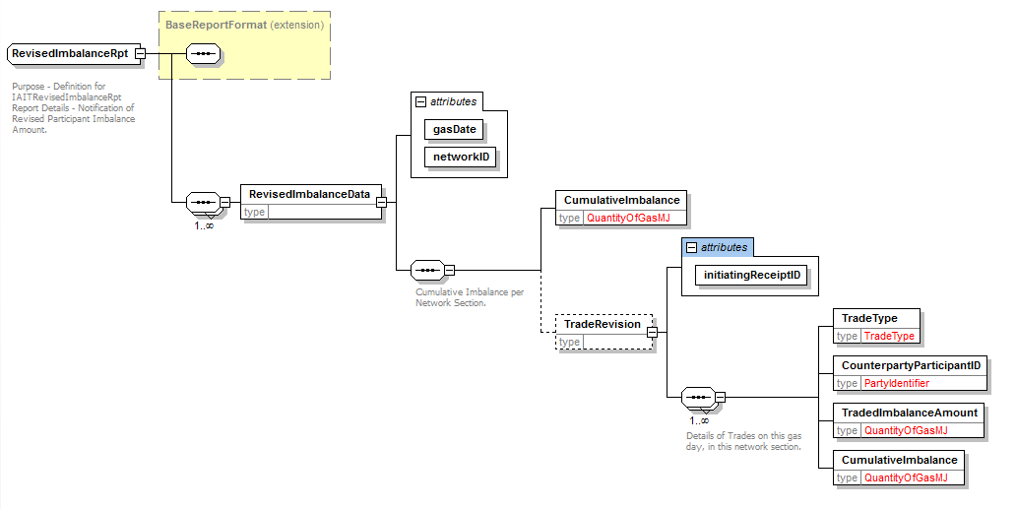

<xsd:complexType name="RevisedImbalanceRpt">
<xsd:annotation>
<xsd:documentation>
Purpose - Definition for IAITRevisedImbalanceRpt
Report Details - Notification of Revised Participant Imbalance Amount.
</xsd:documentation>
</xsd:annotation>
<xsd:complexContent>
<xsd:extension base="BaseReportFormat">
<xsd:sequence maxOccurs="unbounded">
<xsd:element name="RevisedImbalanceData">
<xsd:complexType>
<xsd:sequence>
<xsd:annotation>
<xsd:documentation>Cumulative Imbalance per Network Section.</xsd:documentation>
</xsd:annotation>
<xsd:element name="CumulativeImbalance" type="QuantityOfGasMJ"/>
<xsd:element name="TradeRevision" minOccurs="0">
<xsd:complexType>
<xsd:sequence maxOccurs="unbounded">
<xsd:annotation>
<xsd:documentation>Details of Trades on this gas day, in this network section.</xsd:documentation>
</xsd:annotation>
<xsd:element name="TradeType" type="TradeType"/>
<xsd:element name="CounterpartyParticipantID" type="PartyIdentifier"/>
<xsd:element name="TradedImbalanceAmount" type="QuantityOfGasMJ"/>
<xsd:element name="CumulativeImbalance" type="QuantityOfGasMJ"/>
</xsd:sequence>
<xsd:attribute name="initiatingReceiptID" use="required"/>
</xsd:complexType>
</xsd:element>
</xsd:sequence>
<xsd:attribute name="gasDate" type="xsd:date" use="required"/>
<xsd:attribute name="networkID" type="NetworkID" use="required"/>
</xsd:complexType>
</xsd:element>
</xsd:sequence>
</xsd:extension>
</xsd:complexContent>
</xsd:complexType>

EstimationResultsDataType

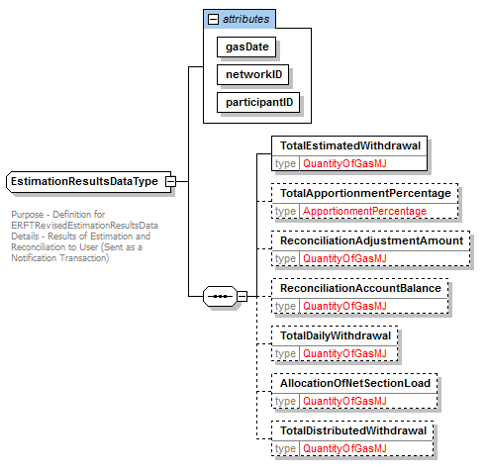

<xsd:complexType name="EstimationResultsDataType">
<xsd:annotation>
<xsd:documentation>
Purpose - Definition for ERFTRevisedEstimationResultsData
Details - Results of Estimation and Reconciliation to User (Sent as a Notification Transaction)
</xsd:documentation>
</xsd:annotation>
<xsd:sequence>
<xsd:element name="TotalEstimatedWithdrawal" type="QuantityOfGasMJ"/>
<xsd:element name="TotalApportionmentPercentage" type="ApportionmentPercentage" minOccurs="0"/>
<xsd:element name="ReconciliationAdjustmentAmount" type="QuantityOfGasMJ" minOccurs="0"/>
<xsd:element name="ReconciliationAccountBalance" type="QuantityOfGasMJ" minOccurs="0"/>
<xsd:element name="TotalDailyWithdrawal" type="QuantityOfGasMJ" minOccurs="0"/>
<xsd:element name="AllocationOfNetSectionLoad" type="QuantityOfGasMJ" minOccurs="0"/>
<xsd:element name="TotalDistributedWithdrawal" type="QuantityOfGasMJ" minOccurs="0"/>
</xsd:sequence>
<xsd:attribute name="gasDate" type="xsd:date" use="required"/>
<xsd:attribute name="networkID" type="NetworkID" use="required"/>
<xsd:attribute name="participantID" type="xsd:string" use="required"/>
</xsd:complexType>

Header_r34.xsd

Additional Enumerations
New Transaction Groups enumerations:
- ERFT
- IAIT
The are to be used for wholesale related reports.

<xsd:simpleType name="TransactionGroup">
<xsd:annotation>
<xsd:documentation>
Purpose - Provide the transaction group to which all the contained transactions or transaction acknowledgments belong
Detail - The target application is at liberty to reject any transactions within the message that do not belong to the stated TransactionGroup. Where only message acknowledgements are carried, a transaction group of "MSGS" should be used.
The following groups are B2B process related:
FLTS - Faults and Outages
SORD - Service order, planned works
NETB - Network billing
MTRD - Meter data
CUST - Customer related
NOTF - Notifications (broadcast)
MKTW - Wholesale market operations
HSMD - High Speed Monitoring system
OWNP - Own Way Notification
EMMS - Electricity Market Management System
ERFT-NSW-ACT Wholesale Transaction Type
IAIT-NSW-ACT Wholesale Transaction Type
</xsd:documentation>
</xsd:annotation>
<xsd:restriction base="xsd:string">
<xsd:enumeration value="CATS"/>
<xsd:enumeration value="MDMT"/>
<xsd:enumeration value="MSGS"/>
<xsd:enumeration value="NMID"/>
<xsd:enumeration value="FLTS"/>
<xsd:enumeration value="SORD"/>
<xsd:enumeration value="NETB"/>
<xsd:enumeration value="MTRD"/>
<xsd:enumeration value="CUST"/>
<xsd:enumeration value="NOTF"/>
<xsd:enumeration value="SITE"/>
<xsd:enumeration value="FLDW"/>
<xsd:enumeration value="OUTG"/>
<xsd:enumeration value="BAR"/>
<xsd:enumeration value="NMIF"/>
<xsd:enumeration value="MKTW"/>
<xsd:enumeration value="HSMD"/>
<xsd:enumeration value="OWNP"/>
<xsd:enumeration value="EMMS"/>
<xsd:enumeration value="ERFT"/>
<xsd:enumeration value="IAIT"/>
</xsd:restriction>
</xsd:simpleType>

New EnergyMarket enumeration NSWACTGAS to reflect the common market for NSW / ACT.
<xsd:simpleType name="EnergyMarket">
<xsd:annotation>
<xsd:documentation>
Purpose -Indicate the energy market to which the message belongs
Detail - Markets are currently defined for the National Electricity Market, the NSW Gas Market and the Victorian Gas Market.
</xsd:documentation>
</xsd:annotation>
<xsd:restriction base="xsd:string">
<xsd:enumeration value="AATELEC"/>
<xsd:enumeration value="ACTELEC"/>
<xsd:enumeration value="NEM"/>
<xsd:enumeration value="NSWELEC"/>
<xsd:enumeration value="NTELEC"/>
<xsd:enumeration value="QLDELEC"/>
<xsd:enumeration value="SAELEC"/>
<xsd:enumeration value="TASELEC"/>
<xsd:enumeration value="VICELEC"/>
<xsd:enumeration value="WAELEC"/>
<xsd:enumeration value="AATGAS"/>
<xsd:enumeration value="ACTGAS"/>
<xsd:enumeration value="NSWGAS"/>
<xsd:enumeration value="NTGAS"/>
<xsd:enumeration value="QLDGAS"/>
<xsd:enumeration value="SAGAS"/>
<xsd:enumeration value="TASGAS"/>
<xsd:enumeration value="VICGAS"/>
<xsd:enumeration value="WAGAS"/>
<xsd:enumeration value="NSWACTGAS"/>
</xsd:restriction>
</xsd:simpleType>

NetworkBilling _r34.xsd
New selections for NetworkDUoSBillingNotification:
- CSVNetworkDUoSDataTariffA
- CSVNetworkDUoSDataTariffB
Updated version attribute to r34 from r13

These are just CSV containers for the actual files.

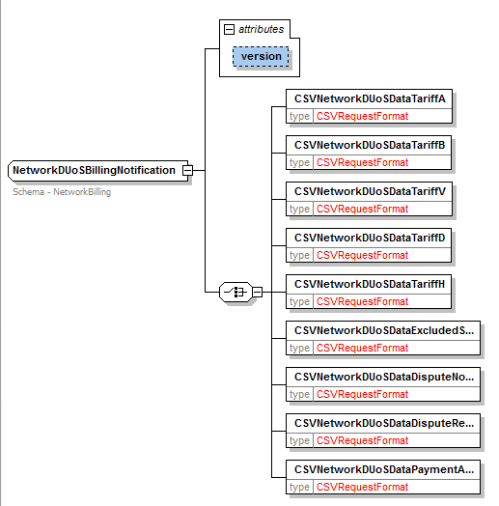

<xsd:complexType name="NetworkDUoSBillingNotification">
<xsd:annotation>
<xsd:documentation>Schema - NetworkBilling</xsd:documentation>
</xsd:annotation>
<xsd:choice>
<xsd:element name="CSVNetworkDUoSDataTariffA" type="CSVRequestFormat"/>
<xsd:element name="CSVNetworkDUoSDataTariffB" type="CSVRequestFormat"/>
<xsd:element name="CSVNetworkDUoSDataTariffV" type="CSVRequestFormat"/>
<xsd:element name="CSVNetworkDUoSDataTariffD" type="CSVRequestFormat"/>
<xsd:element name="CSVNetworkDUoSDataTariffH" type="CSVRequestFormat"/>
<xsd:element name="CSVNetworkDUoSDataExcludedServices" type="CSVRequestFormat"/>
<xsd:element name="CSVNetworkDUoSDataDisputeNotification" type="CSVRequestFormat"/>
<xsd:element name="CSVNetworkDUoSDataDisputeResolution" type="CSVRequestFormat"/>
<xsd:element name="CSVNetworkDUoSDataPaymentAdvice" type="CSVRequestFormat"/>
</xsd:choice>
<xsd:attribute name="version" type="r34" use="optional" default="r34"/>
</xsd:complexType>

CustomerDetails_r34.xsd

New Complex Type
MultiMeterSiteAccessDetails extended with base NMIStandingData. Also element Meter based on GasMultiMeterStandingDataType.

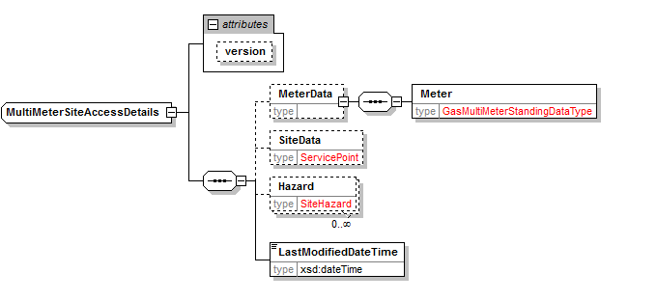

<xsd:complexType name="MultiMeterSiteAccessDetails">
<xsd:annotation>
<xsd:documentation> </xsd:documentation>
</xsd:annotation>
<xsd:complexContent>
<xsd:extension base="NMIStandingData">
<xsd:sequence>
<xsd:element name="MeterData" minOccurs="0">
<xsd:complexType>
<xsd:sequence>
<xsd:element name="Meter"
type="GasMultiMeterStandingDataType"/>
</xsd:sequence>
</xsd:complexType>
</xsd:element>
<xsd:element name="SiteData" type="ServicePoint" minOccurs="0"/>
<xsd:element name="Hazard" type="SiteHazard" minOccurs="0"
maxOccurs="unbounded"/>
<xsd:element name="LastModifiedDateTime" type="xsd:dateTime"/>
</xsd:sequence>
<xsd:attribute name="version" type="r34" use="optional" default="r34"/>
</xsd:extension>
</xsd:complexContent>
</xsd:complexType>

GasMarketWholesale_r34.xsd

New Simple Types

NetworkReceiptPointID

<xsd:simpleType name="NetworkReceiptPointID">
<xsd:annotation>
<xsd:documentation>
A unique identifier for a Network Receipt Point
</xsd:documentation>
</xsd:annotation>
<xsd:restriction base="xsd:string">
<xsd:maxLength value="15"/>
<xsd:minLength value="2"/>
</xsd:restriction>
</xsd:simpleType>

MeterReadingFrequencyTypeBase

<xsd:simpleType name="MeterReadingFrequencyTypeBase">
<xsd:annotation>
<xsd:documentation>
NSW/ACT Meter Reading Frequency Types
D - Daily
N - Non Daily
</xsd:documentation>
</xsd:annotation>
<xsd:restriction base="xsd:string">
<xsd:length value="1"/>
<xsd:enumeration value="D"/>
<xsd:enumeration value="N"/>
</xsd:restriction>
</xsd:simpleType>

ApportionmentPercentage

<xsd:simpleType name="ApportionmentPercentage">
<xsd:annotation>
<xsd:documentation>The Percentage of Net Section Load attributable to consumption by
a User's customers.
</xsd:documentation>
</xsd:annotation>
<xsd:restriction base="xsd:decimal">
<xsd:totalDigits value="10"/>
<xsd:fractionDigits value="7"/>
<xsd:maxInclusive value="100"/>
</xsd:restriction>
</xsd:simpleType>

TradeType

<xsd:simpleType name="TradeType">
<xsd:annotation>
<xsd:documentation>
The type of an imbalance trade.Types
B - Buy
S - Sell
</xsd:documentation>
</xsd:annotation>
<xsd:restriction base="xsd:string">
<xsd:length value="1"/>
<xsd:enumeration value="B"/>
<xsd:enumeration value="S"/>
</xsd:restriction>
</xsd:simpleType>

QuantityOfGasMJ

<xsd:simpleType name="QuantityOfGasMJ">
<xsd:annotation>
<xsd:documentation>A quantity of Gas measured in Megajoules.
Sometimes the corrections/adjustments could be negative.
</xsd:documentation>
</xsd:annotation>
<xsd:restriction base="xsd:integer">
<xsd:minInclusive value="-99999999999"/>
<xsd:maxInclusive value="99999999999"/>
</xsd:restriction>
</xsd:simpleType>

Description

<xsd:simpleType name="Description">
<xsd:annotation>
<xsd:documentation>Generic Type for descriptions</xsd:documentation>
</xsd:annotation>
<xsd:restriction base="xsd:string">
<xsd:maxLength value="100"/>
</xsd:restriction>
</xsd:simpleType>
</xsd:schema>

New Complex types:

TotalGasInjectedNotification

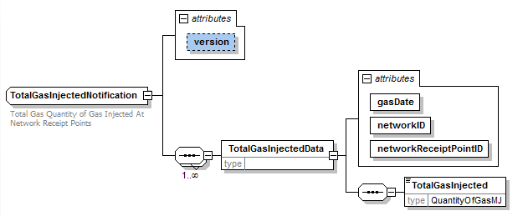

<xsd:complexType name="TotalGasInjectedNotification">
<xsd:annotation>
<xsd:documentation>Total Gas Quantity of Gas Injected At Network Receipt Points</xsd:documentation>
</xsd:annotation>
<xsd:sequence maxOccurs="unbounded">
<xsd:element name="TotalGasInjectedData">
<xsd:complexType>
<xsd:sequence>
<xsd:element name="TotalGasInjected" type="QuantityOfGasMJ"/>
</xsd:sequence>
<xsd:attribute name="gasDate" type="xsd:date" use="required"/>
<xsd:attribute name="networkID" type="NetworkID" use="required"/>
<xsd:attribute name="networkReceiptPointID" type="NetworkReceiptPointID" use="required"/>
</xsd:complexType>
</xsd:element>
</xsd:sequence>
<xsd:attribute name="version" type="r34" use="optional" default="r34"/>
</xsd:complexType>

LinepackAndUnaccountedForGasNotification

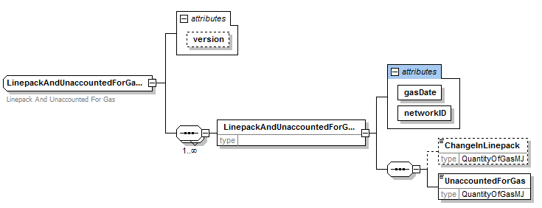

<xsd:complexType name="LinepackAndUnaccountedForGasNotification">
<xsd:annotation>
<xsd:documentation>Linepack And Unaccounted For Gas</xsd:documentation>
</xsd:annotation>
<xsd:sequence maxOccurs="unbounded">
<xsd:element name="LinepackAndUnaccountedForGasData">
<xsd:complexType>
<xsd:sequence>
<xsd:element name="ChangeInLinepack" type="QuantityOfGasMJ" minOccurs="0"/>
<xsd:element name="UnaccountedForGas" type="QuantityOfGasMJ"/>
</xsd:sequence>
<xsd:attribute name="gasDate" use="required"/>
<xsd:attribute name="networkID" use="required"/>
</xsd:complexType>
</xsd:element>
</xsd:sequence>
<xsd:attribute name="version" type="r34" use="optional" default="r34"/>
</xsd:complexType>

ParticipantCLPandUAGNotification

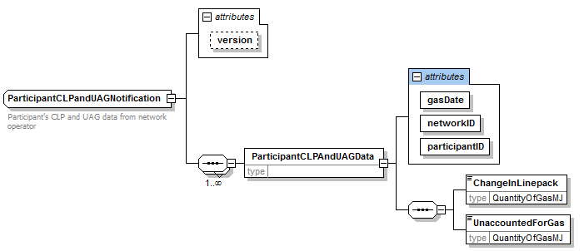

<xsd:complexType name="ParticipantCLPandUAGNotification">
<xsd:annotation>
<xsd:documentation>Participant's CLP and UAG data from network operator</xsd:documentation>
</xsd:annotation>
<xsd:sequence maxOccurs="unbounded">
<xsd:element name="ParticipantCLPAndUAGData">
<xsd:complexType>
<xsd:sequence>
<xsd:element name="ChangeInLinepack" type="QuantityOfGasMJ"/>
<xsd:element name="UnaccountedForGas" type="QuantityOfGasMJ"/>
</xsd:sequence>
<xsd:attribute name="gasDate" type="xsd:date" use="required"/>
<xsd:attribute name="networkID" type="NetworkID" use="required"/>
<xsd:attribute name="participantID" type="xsd:string" use="required"/>
</xsd:complexType>
</xsd:element>
</xsd:sequence>
<xsd:attribute name="version" type="r34" use="optional" default="r34"/>
</xsd:complexType>

MatchedAllocationsDataNotification

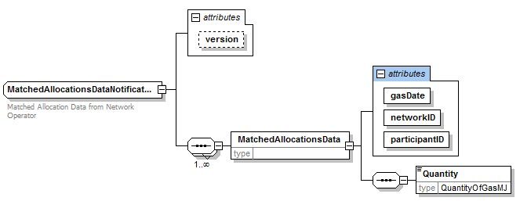

<xsd:complexType name="MatchedAllocationsDataNotification">
<xsd:annotation>
<xsd:documentation>Matched Allocation Data from Network Operator</xsd:documentation>
</xsd:annotation>
<xsd:sequence maxOccurs="unbounded">
<xsd:element name="MatchedAllocationsData">
<xsd:complexType>
<xsd:sequence>
<xsd:element name="Quantity" type="QuantityOfGasMJ"/>
</xsd:sequence>
<xsd:attribute name="gasDate" type="xsd:date" use="required"/>
<xsd:attribute name="networkID" type="NetworkID" use="required"/>
<xsd:attribute name="participantID" type="xsd:string" use="required"/>
</xsd:complexType>
</xsd:element>
</xsd:sequence>
<xsd:attribute name="version" type="r34" use="optional" default="r34"/>
</xsd:complexType>

DailyImbalanceNotification

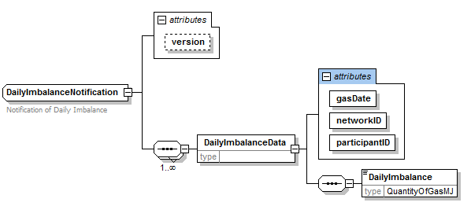

<xsd:complexType name="DailyImbalanceNotification">
<xsd:annotation>
<xsd:documentation>Notification of Daily Imbalance</xsd:documentation>
</xsd:annotation>
<xsd:sequence maxOccurs="unbounded">
<xsd:element name="DailyImbalanceData">
<xsd:complexType>
<xsd:sequence>
<xsd:element name="DailyImbalance" type="QuantityOfGasMJ"/>
</xsd:sequence>
<xsd:attribute name="gasDate" type="xsd:date" use="required"/>
<xsd:attribute name="networkID" type="NetworkID" use="required"/>
<xsd:attribute name="participantID" type="xsd:string" use="required"/>
</xsd:complexType>
</xsd:element>
</xsd:sequence>
<xsd:attribute name="version" type="r34" use="optional" default="r34"/>
</xsd:complexType>

ImbalanceTradeRequest

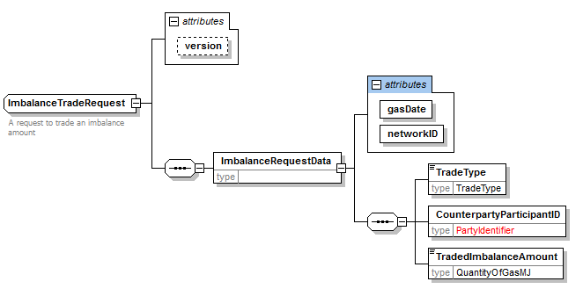

<xsd:complexType name="ImbalanceTradeRequest">
<xsd:annotation>
<xsd:documentation>A request to trade an imbalance amount</xsd:documentation>
</xsd:annotation>
<xsd:sequence>
<xsd:element name="ImbalanceRequestData">
<xsd:complexType>
<xsd:sequence>
<xsd:element name="TradeType" type="TradeType"/>
<xsd:element name="CounterpartyParticipantID"
type="PartyIdentifier"/>
<xsd:element name="TradedImbalanceAmount"
type="QuantityOfGasMJ"/>
</xsd:sequence>
<xsd:attribute name="gasDate" type="xsd:date" use="required"/>
<xsd:attribute name="networkID" type="NetworkID" use="required"/>
</xsd:complexType>
</xsd:element>
</xsd:sequence>
<xsd:attribute name="version" type="r34" use="optional" default="r34"/>
</xsd:complexType>

ParticipantImbalanceAmountRequest

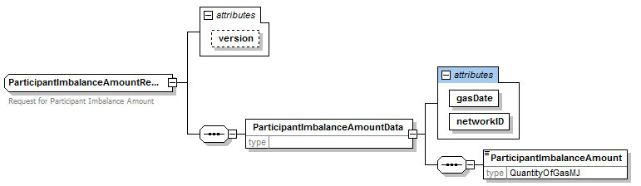

<xsd:complexType name="ParticipantImbalanceAmountRequest">
<xsd:annotation>
<xsd:documentation>Request for Participant Imbalance Amount</xsd:documentation>
</xsd:annotation>
<xsd:sequence>
<xsd:element name="ParticipantImbalanceAmountData">
<xsd:complexType>
<xsd:sequence>
<xsd:element name="ParticipantImbalanceAmount"
type="QuantityOfGasMJ"/>
</xsd:sequence>
<xsd:attribute name="gasDate" type="xsd:date" use="required"/>
<xsd:attribute name="networkID" type="NetworkID" use="required"/>
</xsd:complexType>
</xsd:element>
</xsd:sequence>
<xsd:attribute name="version" type="r34" use="optional" default="r34"/>
</xsd:complexType>

MeterReadingFrequencyType

<xsd:complexType name="MeterReadingFrequencyType">
<xsd:annotation>
<xsd:documentation>Identifies a Delivery Point Reading Frequency as Daily or Non Daily
</xsd:documentation>
</xsd:annotation>
<xsd:sequence>
<xsd:element name="MeterReadingFrequencyTypeCode"
type="MeterReadingFrequencyTypeBase"/>
<xsd:element name="Description" type="Description" minOccurs="0"/>
</xsd:sequence>
</xsd:complexType>

      - Transactions

Schema Manifest
The table below shows the schema files included in this release. Files that have been added, removed or modified for this release are marked.

File | Modified
Acknowledgements_r15.xsd
aseXML_r34.xsd | X
BAR_r31.xsd
BulkDataTool_r33.xsd
CATSReports_r33.xsd
CATSTableReplication_r33.xsd
ClientInformation_r15.xsd
Common_r34.xsd | X
CustomerDetails_r34.xsd | X
CustomerTransfer_r29.xsd
ElectricityHighSpeedMonitoring_r26.xsd
ElectricityMasterStandingData.xsd
ElectricityMMS_r33.xsd
Electricity_r25.xsd
Enumerations.xsd (ver 7.0) | X
Events_r34.xsd | X
HighSpeedMonitoring_r33.xsd
Faults_r33.xsd
GasMarketWholesale_r34.xsd | X
Gas_r34.xsd | X
Header_r34.xsd | X
HighSpeedMonitoring_r33.xsd
MarketWholesale_r20.xsd
MDMTReports_r33.xsd
MeterDataManagement_r33.xsd
NetworkBilling_r34.xsd | X
NMIDataAccess_r33.xsd
NOSAssessment_r28.xsd
NOSBooking_r33.xsd
NOSCommon_r28.xsd
NOSEquipment_r33.xsd
OneWayNotification_r33.xsd
Reports_r34.xsd | X
ServiceOrder_r33.xsd
TableReplication_r34.xsd | X

Schema Test

Test Platforms
The new schema has been tested using the following platforms:
- XMLSpy 2013

Test
The ASWG ensures that all recommended parsers on relevant platforms can successfully validate the proposed schema.

Test Platforms
Supplied samples have been tested using the following parsers:
- MSXML 6.0
- Xerces 2.2.1
- Xerces 2.9.1

Test Cases
Sample files included:

Test Process

- Traced transaction Modified in PBP5 to CR 57 and place in schema the change has been implemented. See tracability Document attached above in section 3.3
- Checked that all of the elements required exist in the schema.
- Created sample files for each of the transaction and included items specified in PBP5 and validated files work. These are prefixed with NSWGAS
- Where problems arose feed back to schema design for fix.
- Update sample to reflect any schema changes

Test Results
All OK on all Test Platforms, see section 6.2.1
- All test XML files intended to fail, typically with “Invalid” as part of the file name, failed as expected.
- All other test files passed with no parse error.

Character Classification
Pattern restriction is enforced by regular expressions in some places in aseXML schema. That makes knowing the precise set of classification of characters important. It is particularly important in the testing process. In some quick tests using simple Pattern class in JAVA – not fully fledged JAVA parsers – some differences vis-à-vis XML Spy were reported. These tests were performed to validate the data stored in database against aseXML type definitions. Some characters that were treated differently between JAVA Pattern class and XML Spy were $ + |. XML Spy accepted them as punctuation characters but JAVA Pattern class rejected. Note, these three characters are only a few examples of difference, not an exhaustive list. As explained below, further investigations revealed that XML Spy is correct as per the XML standard.

The XML standards depend upon Unicode specifications for the purpose of this classification. The complete list of classification of Unicode characters in various classes can be found at http://www.unicode.org/.

To download the classification for any particular version of classification, start from directory listing at http://www.unicode.org/Public and traverse down the tree of the concerned version to download the zip (usually named ucd.zip) which contains all the documents for that version. The zip for version 6.2.0 resides at http://www.unicode.org/Public/6.2.0/ucd/. The document in this zip, usually named UnicodeData.txt, contains entire classification of all Unicode characters, having a line per Unicode character, with semi-colon delimited fields in each line. Explanation of fields can be found in the documentation in the zip (UCD.html). To view this UnicodeData.txt document conveniently, start Excel and open the document. While opening the document Excel will ask for information about the file contents. In response specify the document to be semicolon delimited with each column of the document being text. The column C of the Excel spreadsheet specifies the character classification. Note, while opening the file in Excel if each column is not specified to be text then Excel may format some information incorrectly.

The classification of the extended ASCII characters for version 6.2.0 of Unicode is provided here in an Excel spreadsheet :

The classifications starting with L signify letters, starting with N signify digits, starting with P signify punctuations, starting with S signify symbols and those starting with C signify control characters. Note, the spread sheet does not contain all the fields (columns) from the UnicodeData.txt file.

ASWG Endorsement
With a quorum established the ASWG voted to endorse schema rX, with the included aseXML Change Requests. The voting results are forwarded to AEMO for approval. When 75% of those ASWG members vote to endorse a schema it represents an ASWG recommendation for that schema. AEMO will not reject an ASWG recommendation without first consulting with the ASWG.

The results of the ASWG vote for the final schema to be released are as follows:

Date of Vote: 13/2/2015
Option | # Votes | % Vote
For | 5 | 100%
Against | - | -
Abstained | - | -
Total Members Present | 5/6 | 80%

AEMO Approval

The schema approval and approval date are identified below

Status | Date | Authorised by
Approved – The schema has been approved by AEMO and is formally released for use

