|  |  |  |
| --- | --- | --- |
| POST CONTINGENT OVERLOAD ON THE 132 Kv TRANSMISSION LINES BETWEEN WATERLOO AND ROBERTSTOWN ON 4 MARCH 2015 | | |
|  | | |
| AN AEMO POWER SYSTEM OPERATING INCIDENT REPORT FOR THE NATIONAL ELECTRICTY MARKET | | |
| Published: **JUNE 2015** |  |  |

VERSION RELEASE HISTORY

|  |  |  |  |  |  |
| --- | --- | --- | --- | --- | --- |
| VERSION | DATE | BY | CHANGES | CHECKED BY | AUTHORISED BY |
| 1 | 02 June 2015 | M Ting | FINAL | J Lu | P Biddle |

INCIDENT CLASSIFICATIONS

|  |  |
| --- | --- |
|  |  |
| Time and date of incident | 1620 hrs Wednesday 4 March 2015 |
| Region of incident | South Australia |
| Affected regions | South Australia |
| Event type | Power System in a non-secure state for longer than 30 minutes |
| Generation Impact | No generator was disconnected or limited as a result of this incident |
| Customer Load Impact | No customer load was disconnected as a result of this incident |
| Associated reports | Nil |

ABBREVIATIONS

|  |  |
| --- | --- |
| Abbreviation | Term |
| AEMO | Australian Energy Market Operator |
| CA | Contingency Analysis |
| kV | Kilovolt |
| MW | Megawatt |
| NER | National Electricity Rules |
| Robertstown T2 | Robertstown transformer 2 |

Important Notice

#### Purpose

AEMO has prepared this document to provide information about this particular Power System Operating Incident.

#### Disclaimer

This document or the information in it may be subsequently updated or amended. This document does not constitute legal or business advice, and should not be relied on as a substitute for obtaining detailed advice about the National Electricity Law, the National Electricity Rules, or any other applicable laws, procedures or policies. AEMO has made every effort to ensure the quality of the information in this document but cannot guarantee its accuracy or completeness.

Accordingly, to the maximum extent permitted by law, AEMO and its officers, employees and consultants involved in the preparation of this document:

* make no representation or warranty, express or implied, as to the currency, accuracy, reliability or completeness of the information in this document; and
* are not liable (whether by reason of negligence or otherwise) for any statements or representations in this document, or any omissions from it, or for any use or reliance on the information in it.

Copyright 2014. Australian Energy Market Operator Limited. The material in this publication may be used in accordance with the copyright permissions on AEMO’s website.

# OVERVIEW

This report reviews a power system operating incident that occurred on Wednesday 4 March 2015 in South Australia. This incident involved the power system being operated in a non-secure state for greater than 30 minutes due to the:

* Post contingent overload[1] of Robertstown – MWPS#4 – Waterloo East 132 kV and Waterloo East - Waterloo 132 kV transmission line
  + - for the loss of Mokota - Robertstown 275 kV transmission line,
    - during a planned outage of
      * + the Robertstown transformer 2 (T2), and,
        + Canowie - Robertstown 275 kV transmission line.

AEMO is required under the National Electricity Rules (NER)[2] to assess power system security over the course of this incident. Specifically, AEMO is required to assess the adequacy of the provision and response of facilities and services and the appropriateness of actions taken to restore or maintain power system security[3].

AEMO concluded that the actions taken were not appropriate to restore the power system to a secure operating state within 30 minutes.

This report is based on information from ElectraNet and AEMO. National Electricity Market time (Australian Eastern Standard Time) is used in this report.

# the incident

On Wednesday 4 March 2015 the Canowie - Robertstown 275 kV line was out of service for line circuit breaker maintenance. As part of this outage, the Robertstown T2 was offloaded on the 132 kV side. At 1441 hours, AEMO’s contingency analysis (CA) indicated post-contingency overloading of the Robertstown – MWPS#4 – Waterloo East 132 kV line and Waterloo East - Waterloo 132 kV line for the trip of the Mokota – Robertstown 275 kV line. This meant that the power system was not in a secure operating state.

These contingency violations cleared at 1621 hours after AEMO invoked a constraint limiting the flow to Victoria on Murraylink to 40 MW. No load or generation was lost as a result of this incident. See Appendix 1 for a power system diagram illustrating the incident and Appendix 2 for a chronological log of the incident.

The reason for investigating this incident is that the power system was in a non-secure operating state for more than 30 minutes. AEMO should have taken actions to return the power system to a secure operating state within 30 minutes.

# AEMO investigation

AEMO investigated this incident and found two causes leading to the power system being in a non-secure operating state for more than 30 minutes.

## Outage Assessment

AEMO identified a procedural error in the outage assessment of Canowie - Robertstown 275 kV line and Robertstown T2. During the outage assessment process, AEMO identified potential overloading of Robertstown – MWPS#4 – Waterloo East 132 kV line and Waterloo East - Waterloo 132 kV for the trip of Mokota – Robertstown 275 kV line. This contingency would operate the Waterloo Windfarm Runback Scheme and reduce the windfarm output to 0 MW. This would further increase loading on the Waterloo East – Waterloo 132 kV line. To alleviate this, AEMO created a constraint that would limit the flow on Murraylink to prevent the overloading occurring. However, this constraint equation was accidently not included in the outage constraint set and was not invoked when the planned outage started. As a result, when flows on Murraylink increased, real-time CA showed the post contingent flows on the Robertstown - Waterloo 132 kV line would have exceeded the satisfactory level.

AEMO subsequently added the missing constraint equation to the outage constraint set.

## Murraylink Automatic Sever Trip Scheme

AEMO also identified a misunderstanding between AEMO and ElectraNet on the operation of the Murraylink Automatic Sever Trip Scheme[4]. At 1441 hours, after the CA first violated, AEMO contacted ElectraNet and both parties agreed that the Murraylink Automatic Sever Trip Scheme would operate to alleviate any post contingent overloading on the Robertstown – MWPS#4 – Waterloo East 132 kV line and Waterloo East - Waterloo 132 kV line. After further review of the documentation on the Murraylink Automatic Sever Trip Scheme, AEMO determined that the Murraylink Automatic Sever Trip Scheme would not operate for the loss of the Mokota – Robertstown 275 kV line. For the loss of this line, Robertstown T1 would be off loaded at the same time. While both transformers at Robertstown were off loaded (as Robertstown T2 was offloaded on the 132 kV side as part of the Canowie - Robertstown 275 kV line outage), the specific devices monitored to initiate the Automatic Sever Trip Scheme would not operate.

# power system security

This section assesses how power system security was managed over the course of the incident[5].

AEMO considered the use of the Constraint Automation tool, but determined this would not alleviate the potential overload. At 1620 hours, constraint set SVML_040 was invoked to limit the flow to Victoria on Murraylink to 40 MW. At 1621 hours, the CA violation cleared, approximately 100 minutes after the first CA violation occurred at 1441 hours.

This action returned the power system to a secure operating state.

AEMO issued Market Notice 48437 at 1712 hrs to notify the market of a constraint set being invoked at 1620 hours. The constraint set remained invoked for the duration of the Canowie - Robertstown 275kV line and Robertstown T2 outage.

# conclusions

AEMO concluded that the post contingent overload of a 132 kV transmission line for greater than 30 minutes was due to an error in following procedure during the outage assessment process, and also, misunderstanding of the Murraylink Automatic Sever Trip Scheme operations between AEMO and ElectraNet.

AEMO concluded that the actions taken were not appropriate to restore the power system to a secure operating state within 30 minutes.

# recommendations

AEMO has taken following actions to prevent this incident from occurring in the future:

* AEMO has reviewed and revised the outage assessment process, to ensure all relevant constraints are included in the outage constraint set.

1. – power system diagram

The power system during the incident

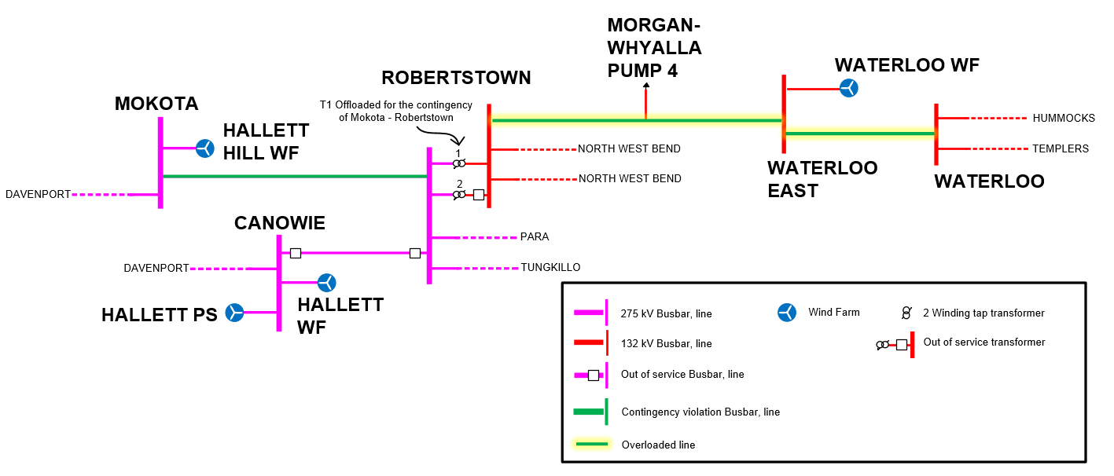

1. – incident event log
2. Incident Log

|  |  |
| --- | --- |
| Time and Date | Event |
| 0549 hrs 4 March 2015 | Canowie - Robertstown 275 kV line and Robertstown T2 (offloaded on the 132 kV side) outage started |
| 1441 hrs 4 March 2015 | Due to increase in Murraylink flow towards Victoria CA indicated overloading Robertstown – MWPS#4 – Waterloo East 132 kV line and Waterloo East - Waterloo 132 kV line (up to 137%) for the trip of Mokota - Robertstown 275 kV line |
| 1620 hrs 4 March 2015 | SVML_040 invoked |
| 1621 hrs 4 March 2015 | CA violation cleared |
| 1712 hrs 4 March 2015 | Market Notice 48437 issued advising constraint set SVML_040 invoked. |
| 1939 hrs 4 March 2015 | Outage completed and constraints associated with this outage including SVML_040 revoked |

1. The overload would only occur if the contingency occurred.
2. Clause 4.8.15(a)(1)(iv) and AEMC Reliability Panel Guidelines for Identifying Reviewable Operating Incidents.
3. NER Clause 4.8.15 (b)
4. Murraylink is a Direct Current (DC) transmission line that cannot supply an Alternating Current (AC) load at one end of the DC line. The Automatic Sever Trip Scheme is designed to trip Murraylink if the AC load at the SA end is islanded from the SA network. Robertstown circuits are registered as monitored elements under this scheme.
5. AEMO is responsible for power system security in the NEM and is required to operate the power system in a secure operating state (NER Clause 4.2.4 (a)). AEMO must thereby ensure that the power system is maintained in, or returned to, a secure operating state following a contingency event.